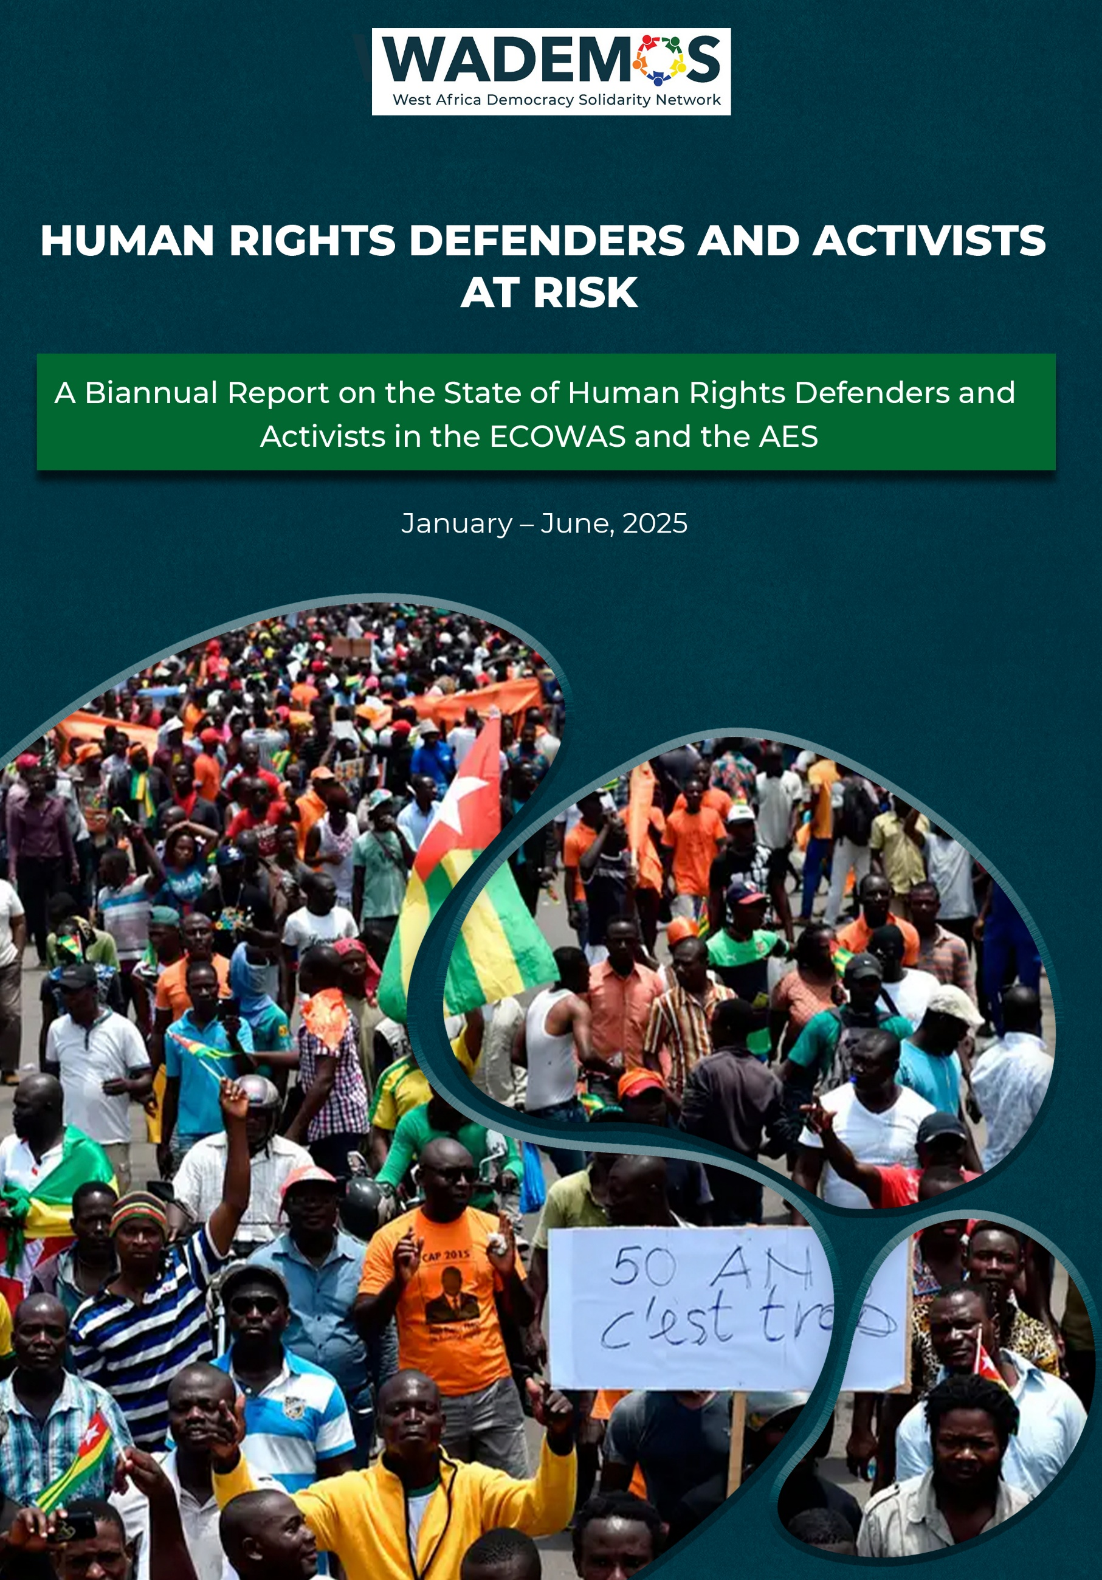
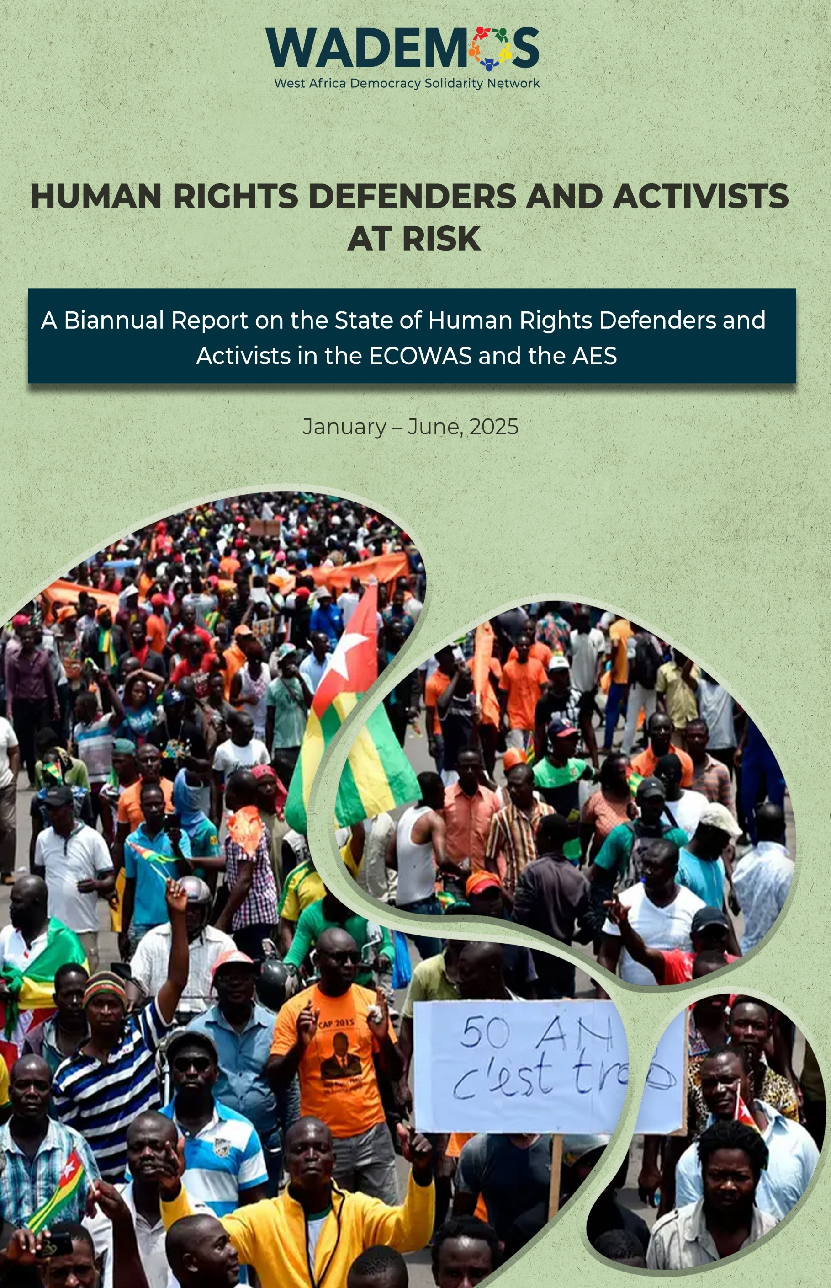
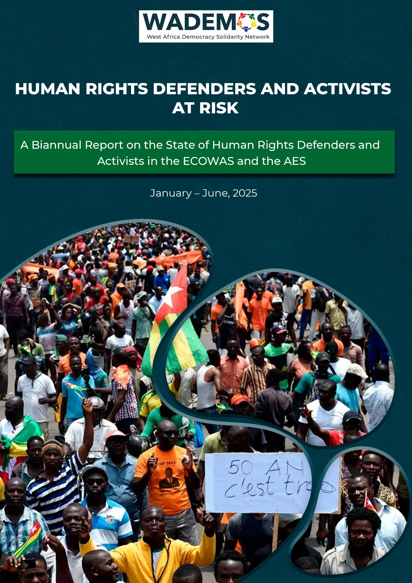
This report is a desk study by the West Africa Democracy Solidarity Network as part of its mechanism to constantly monitor and observe the state of human rights in the West African sub-region.

No part of this publication may be used or reproduced in any manner without prior permission of the Copyright holder except in the case of brief quotations and reviews duly acknowledged.

©West Africa Democracy Solidarity Network
All rights reserved

Address: No. 6 Quarcoo Lane,
North Airport Residential Area, Accra
Email: info@cddgh.org
Website: www.wademosnetwork.org

The views expressed in this publication are those of the authors and do not necessarily represent that of the WADEMOS Network, its Steering Committee or funding partners.

HUMAN RIGHTS DEFENDERS AND ACTIVISTS
@
RISK

A Biannual Report on the State of Human Rights Defenders and Activists in the ECOWAS and the AES

January – June, 2025

Table of Content

ACKNOWLEDGEMENT 4
OVERVIEW 5
1.0 INTRODUCTION 6
1.1 Summary of findings 10
2.0 COUNTRY BRIEFS 13
2.1 Burkina Faso 13
2.2 Mali 17
2.3 Niger 21
2.4 Nigeria 24
2.5 Togo 26
2.6 Guinea Bissau 29
2.7 Guinea 31
2.8 Sierra Leone 34
2.9 Benin 36
2.10 Liberia 38
2.11 Senegal 39
2.12 The Gambia 42
2.13 Ghana 44
3.0 RECOMMENDATIONS 47
3.1 Civil Society Organizations (CSOs) 47
3.2 ECOWAS 48
3.3 ECOWAS Member States: 50
3.4 The African Commission on Human and Peoples’ Rights (ACHPR) 50
3.5 United Nations & International Bodies 51
4.0 CONCLUSION 52
REFERENCES 52
52

ACKNOWLEDGEMENT

The West Africa Democracy Solidarity Network (WADEMOS Network) extends its appreciation to David Asante-Darko, Research Analyst, in charge of the human rights desk, at WADEMOS for compiling the report and Paul Osei-Kuffour, Program Manager at CDD-Ghana and the WADEMOS Network Coordinator, for providing technical support and supervision of the report.
Special thanks also go to Elikem Gadzekpo, Legal and Policy Officer at CDD-Ghana; Indira Correia Baldé, journalist and head of the Bissau-Guinean Union of Journalists and Social Communication Technicians in Guinea-Bisaau; and Isatou Ceesay, Senior Reporter at The Point Newspaper in The Gambia for their reviews and inputs.
The Network is also grateful to Jonah Eledi, Communications Team Lead (Acting) at CDD-Ghana and the Communications Officer at WADEMOS, for preparing the report for publication; and Austin Aigbe, Advocacy Officer for WADEMOS for his insights and contributions to the report.
We also extend our sincere gratitude to the members of the WADEMOS Network across the subregion who contributed to the report.

OVERVIEW
Defenders@Risk is a biannual overview of human rights defenders (HRDs) at risk across the West African subregion, compiled by the West Africa Democracy Solidarity Network (WADEMOS) to monitor the civic space specifically in the Economic Community of West African States (ECOWAS) and the Alliance of Sahel States (AES).
It offers insights into major happenings and trends in the civic space, and captures incidents involving human rights defenders (HRDs), activists and other civic actors as well as developments bordering on the freedoms of speech and expression, association and assembly within the countries under review. It equally interrogates political inclusion, political participation and government tolerance of criticism and dissent as fundamental attributes of democracy across the West African subregion.

Methodology
The data is drawn from both the WADEMOS Civic Space Monitor and Observatory that monitors state-sponsored repression of political rights and freedoms in West Africa, and reports received from the members of the WADEMOS network across the region. Facts and incidents recorded in each country have been checked and validated by members of the WADEMOS Network in their respective countries.
This report follows a related study published in 2024 by WADEMOS in collaboration with our partners that assessed the situation of HRDs in West Africa.

This edition documents the trajectory of political rights and civil freedoms in the civic space across the ECOWAS and the AES over the first half of 2025. Its coverage of events in certain countries may extend well into the third quarter of the year. This crucial year in the history of the ECOWAS and the AES, particularly highlighted the relevance of the civic space to democracy, in the wake of the most monumental fallout in the West African subregion in over two decades of recorded democratic backsliding.

1.0 INTRODUCTION

With the secession of the AES from ECOWAS, the socio-political and economic integration of the West African subregion faces its most formidable existential crisis and to safeguard the peace and stability of the subregion, governments must acknowledge the need for a deeper introspection and reflection towards the renewal of democratic norms and values. Over the past half year, a diverse array of HRDs have been innocent targets of various forms of attacks by their governments, merely for daring to question government action or prompt the government about its mounting pile of excesses, which has gained more momentum particularly in the AES countries. For instance, WADEMOS and its partners have issued numerous alerts and statements to condemn attacks on activists in these countries and across the region.
In line with the observations in this report, the Freedom in the World index by Freedom House, as well as the Press Freedom Index by Reporters Without Borders, both show a general decline in civil and political freedoms across the ECOWAS and AES subregions over the past five years. The minimal decline in scores over the past year does not necessarily signal hope in every case, as for a good number of these countries, any significant decline from the prevailing situation would imply descent into chaos and unrest.
In the past half-decade, the most drastic declines have been recorded in the four countries in the subregion currently run by military regimes. Burkina Faso has, for instance, seen its score on the Freedom in the World index decline from 54/100 in 2021 to 25/100 in 2025. Similar trends have been observed in Guinea, Mali and Niger in the wake of military coups, as the extant military regimes infiltrate and capture all state institutions. Additionally, the latest evaluation from the CIVICUS Monitor categorizes the civic space in 7 out of the 15 countries in the ECOWAS and the AES as repressed, while the civic space in an additional six countries each has been labelled ‘obstructed.’ Only one country, Cabo Verde, has a civic space that is marked as ‘open’ on the CIVICUS monitor. Dissenters and government critics have become exclusive targets of coordinated government resistance to accountability and scrutiny.
ECOWAS/AES Member Country Scores for Freedom of the World (FIW) Index and World Press Freedom (RSF) Index
Table 1: Country Scores for ECOWAS/AES member countries on Freedom of the World Index (FIW) and World Press Freedom Index (RSF)
Year | 2021 |  | 2022 |  | 2023 |  | 2024 |  | 2025
Country | FIW | RSF | FIW | RSF | FIW | RSF | FIW | RSF | FIW | RSF
Benin | 65 | 62 | 59 | 48 | 59 | 52 | 61 | 57 | 60 | 55
Burkina Faso | 54 | 77 | 53 | 73 | 30 | 68 | 27 | 58 | 25 | 52
Cabo Verde | 92 | 80 | 92 | 75 | 92 | 76 | 92 | 73 | 92 | 75
Côte d’Ivoire | 44 | 71 | 49 | 74 | 49 | 69 | 49 | 67 | 49 | 64
The Gambia | 46 | 69 | 47 | 69 | 48 | 71 | 50 | 66 | 50 | 65
Ghana | 80 | 79 | 82 | 67 | 80 | 66 | 80 | 68 | 80 | 67
Guinea | 38 | 65 | 34 | 60 | 30 | 60 | 30 | 60 | 30 | 53
Guinea-Bissau | 44 | 67 | 43 | 59 | 43 | 62 | 43 | 56 | 41 | 51
Liberia | 60 | 67 | 60 | 63 | 60 | 64 | 64 | 65 | 64 | 67
Mali | 33 | 67 | 32 | 54 | 29 | 52 | 26 | 51 | 24 | 48
Niger | 48 | 72 | 51 | 68 | 51 | 67 | 33 | 60 | 30 | 57
Nigeria | 44 | 60 | 45 | 47 | 43 | 50 | 44 | 51 | 44 | 47
Senegal | 71 | 75 | 68 | 63 | 68 | 56 | 67 | 55 | 69 | 59
Sierra Leone | 65 | 70 | 65 | 71 | 63 | 63 | 60 | 64 | 59 | 66
Togo | 43 | 70 | 42 | 57 | 42 | 63 | 42 | 51 | 41 | 48
NB: Scores for World Press Freedom Index (RSF) given here have been rounded off to the nearest whole number.
While the grievances and the rhetoric of HRDs across the ECOWAS and the AES subregions generally center on dissatisfaction with government’s delivery of democratic goods and services and the growing restriction of the civic space, HRD activism in countries that are battling the canker of terrorism – including Togo, Benin, Nigeria, Ivory Coast and the three member states of the AES, namely Mali, Burkina Faso and Niger – has been equally vocal about citizen dissatisfaction with government counterterrorism efforts. By voicing these concerns, HRDs across the West African subregion, risk physical assault, illegal arrests or abductions, forced disappearances, illegal detentions and even incarceration. Both in the ECOWAS and the AES, the judicialization of the authoritarian measures used to suppress and intimidate HRDs has not made the charges levelled against them or the sentences they are slapped with any less arbitrary. Even the release of forcibly disappeared and illegally detained HRDs has been equally arbitrary.
The shrinking of the civic space across the subregion should be accorded urgent attention, especially because countries hardly ever stagnate, but rather, over time, either become more democratic or more authoritarian. Unfortunately, current trends hardly demonstrate an inclination to growing tolerance of criticism and dissent and easing restrictions on the civic space. Not unlike the military regimes where unilateral and arbitrary decrees are invoked to enforce the government’s will, the recent adoption of repressive legislations such as the new Counterterrorism Act of 2024 in Sierra Leone provides wide-ranging executive powers that can be used to target HRDs and impose more restrictions on the civic space.
Recent examples of the threat posed by such repressive legislation to the civic space include the controversial terrorism database introduced by the Nigerien junta. A list defined by a very vague criteria, it underlined a decree by the junta last year which provisionally revoked Nigerien nationality from nine former senior officers under President Bazoum’s regime. Prominent rights activist and government critic, Moussa Tiangari, who criticized the government over the database and the suspension of the nationality of the nine persons, was arrested, detained and subsequently charged with advocating terrorism and criminal association in connection with terrorism.
A more recent example includes the cases of two Beninese journalists who were unceremoniously ripped from exile and bundled back to Benin, one, with the Ivorian state’s knowledge, the other, illegally. Known for his investigations into the Beninese authorities, Hugues Comlan Sossoukpè, a political refugee in Togo since 2021, was arrested in his hotel room in Abidjan, where he had been invited by the Ivorian authorities on a professional mission. He was deported on a private plane to Cotonou, where he was immediately incarcerated and arraigned before court to stand trial for commentary critical of the government. Steve Amoussou, a Beninese national who had gone into exile in Togo since 2019, was abducted in front of his Lomé residence by four individuals and sent back to Benin. Suspected of owning and running “Frère Hounvi,” a social media account that posted viral audio commentaries critical of the Talon administration to its 75,000 subscribers, he has been sentenced to two years in prison and slapped with a 2-million-franc fine for cyberbullying, incitement to rebellion, and spreading false news and insults against a political group. While a greater tolerance for dissent and criticism is needed on the part of the government, there is an equal need for HRDs to be circumspect and accurate with their information. Every precaution must be taken to safeguard the credibility of HRDs and diminish the avenue for reprisals by governments and individuals they criticize or blow the whistle on.
To ensure the safety of HRDs, it is recommended that emergency protection protocols for at-risk HRDs, including temporary relocation programs, should be enhanced across both ECOWAS and the AES. Secure funding as well as technical support should be extended to independent media operating within these jurisdictions to promote their activism. Across the entire West African subregion, there should be a coordinated and sustained push for the restoration of an independent judiciary. International and regional human rights organizations such as the ECOWAS and the African Commission on Human and People’s Rights (ACHPR) must engage extensively and, to the extent conditions allow, amicably with the military regimes to secure the release of all HRDs in detention or under conscription.
In a country like Sierra Leone, a detailed scrutiny and revision of the 2024 Counterterrorism Act is indispensable. Across the remaining ECOWAS subregion, there should be an aggressive push for the rule of law and a push against authoritarianism and legislation that can be weaponized to restrict the civic space. More importantly, the ECOWAS and the AU must be seen to be reimposing diplomatic interventions for conduct that compromises democracy. Pro-democracy and rights-based organizations have to deepen solidarity across borders to enhance their role as the guardrails and voice for actors in spaces where they continue to experience marginalization and extreme fragility.

1.1 Summary of findings
A combination of weaponized legislation, surveillance, arbitrary detention, targeted violence against HRDs, and impunity for perpetrators across the ECOWAS and the AES is bolstering widespread self-censorship and weakening civil society resilience.
- Use of security and counterterrorism as pretexts to restrict the civic space
The first half of 2025, like prior periods, has seen governments frequently invoking terrorism, security threats, or supposed infringements of national sovereignty to justify government excesses and restrictions on political participation and freedoms of speech, association, and assembly. Evidence of this is found in the deadly counterterrorism operations, mass killings and reprisals conducted in Mali and Burkina Faso and the promulgation of the 2024 Counterterrorism Act in Sierra Leone.

- Targeting of journalists and media outlets
Critical media continues to be repressed, suspended, banned, and harassed for media content that public officials or governments find unfavourable. Journalists have had their press cards revoked and continue to face arrests, forced disappearances, torture, or coerced conscription. Media outlets and personalities have been targeted in Burkina Faso, Niger, Guinea-Bissau, Guinea and Mali.

- Harassment and persecution of human rights defenders
In a bid by authorities to clamp down on criticism and dissent, human rights activists and civil society leaders continue to be abducted, detained without due process, or prosecuted on politically motivated charges, often in defiance of court orders. Though particularly pronounced in the AES member states, this observation has been equally noted in Benin, Togo, Guinea, Guinea-Bissau and Nigeria.

- Suppression of opposition and political participation
Across the AES and within countries like Togo, Guinea, Guinea-Bissau and the Ivory Coast, there is increasing evidence of attempts to suppress political opposition. In Burkina Faso, Mali, Niger and Guinea, political parties have been dissolved or suspended; opposition leaders continue to be harassed, disappeared, or barred from organizing. There has been increasing evidence of this amid the arbitrary oppressive measures by the four military regimes across the ECOWAS and the AES to extend the rule of the transitional governments indefinitely.

- Censorship and information control
Authorities continue to block protests, suspend social media accounts, and penalize publications critical of the government or its security operations. This has been seen in the case of Mali, Burkina Faso, Niger, Guinea, Benin, Togo and the Gambia.

- Judicial manipulation and intimidation
While in some cases, courts are sidelined, legal rulings ignored, and judges, lawyers, or opposition-linked defendants face reprisals, in other cases, the courts are co-opted to harass and oppress activists and human rights defenders, undermining judicial independence. Evidence of this has been noted in Burkina Faso, Niger, Togo, Benin and with Mali in the case of Etienne Sissoko.

- Criminalization of dissent through vague laws
Broad cybercrime, defamation, counterterrorism, and “public order” provisions are used to criminalize criticism, satire, or peaceful activism. The 2024 Counterterrorism Act in Sierra Leone and the prosecution of HRDs in Benin and Togo are examples of this.
- Forced exile and cross-border reprisals
Dissidents in exile are surveilled, abducted, or extradited back to their home countries for prosecution. There has been evidence of this in Burkina Faso and especially Benin, where two journalists living in exile in Togo, have both been dragged back to Benin and charged for commentary critical of the government.

- Protest bans and violent dispersals
Authorities impose blanket bans on demonstrations, violently break up protests, and use excessive force, leading to injuries, deaths, and mass arrests. This has been prevalent in countries under military regimes: Guinea, Mali, Burkina Faso and Niger, as well as Guinea-Bissau and Benin.

- Public shaming and coercion
Detainees are coerced into public apologies or forced confessions, often under duress, to discredit dissent and deter others. Evidence of this has been noted in apologies rendered by Sierra Leone’s Hawa Hunt and Togo’s rapper Aamron. It is alleged that Nigeria’s Dr. Ihekweme, who was arrested for criticizing the state governor, was released only after he was compelled under duress to sign a letter of apology addressed to the state governor, claiming that his allegations against him were lies and pledging to be of good behavior and not falsely attack the Imo Government and the Governor again.

- Impunity for perpetrators
Security forces and pro-government actors accused of abuses rarely face accountability, reinforcing cycles of repression. In Burkina Faso, Guinea, and Guinea-Bissau, there has been mounting evidence of this.

2.0 COUNTRY BRIEFS

2.1 Burkina Faso
In Burkina Faso the terrorist insurgency remains the major driver of the tensions between government and citizens, outside concerns over the banning of political parties and the stalled transition back to democracy. The allegations of civic space restriction and political repression levelled against the military juntas by civic actors, typically stem from hostile government response to the public criticisms of government excesses, including the inadequate counterterrorism efforts, extrajudicial killing of perceived civilian sympathizers of terrorists and the notorious conscriptions of opposition figures and government critics.
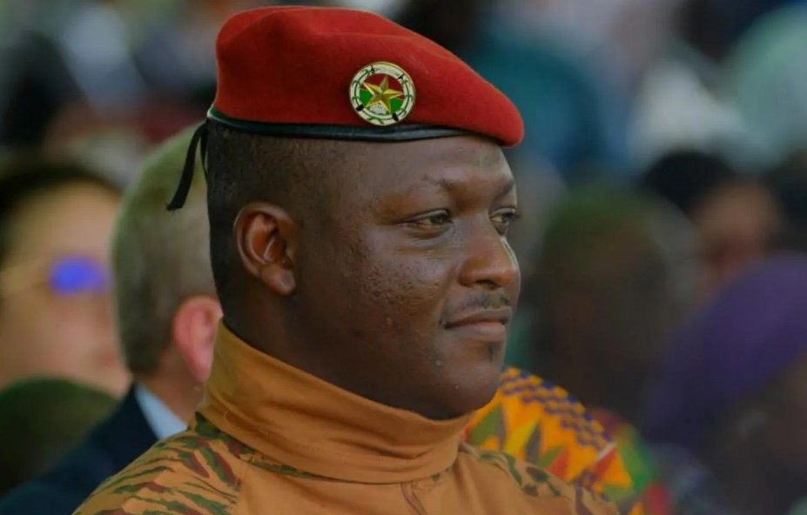
Amid reports of government-sanctioned massacres of innocent civilians, including the March 2025 massacre in which the Burkinabè army and pro-government militias killed more than 130 civilians, several journalists have been forcibly disappeared. This follows their condemnation of the extrajudicial killing of innocent civilians, their denunciation of the forced disappearance or conscription of fellow journalists and their calls for the unconditional release of detained, forcibly disappeared or conscripted human rights defenders. On July 17, 2025, the junta disbanded the country’s electoral commission, claiming it was too expensive, and tagging it as a move to reinforce the country’s “sovereign control on the electoral process” and “limit foreign influences.” It was reported that the interior ministry will handle all future elections.
Figure 1 Capt. Burkina Faso junta leader, Ibrahim Traoré forcefully took over power in 2022

Figure 2Capt. Burkina Faso junta leader, Ibrahim Traoré forcefully took over power in 2022

Figure 3Capt. Burkina Faso junta leader, Ibrahim Traoré forcefully took over power in 2022

Figure 4Capt. Burkina Faso junta leader, Ibrahim Traoré forcefully took over power in 2022

Figure 5Capt. Burkina Faso junta leader, Ibrahim Traoré forcefully took over power in 2022

Figure 6Capt. Burkina Faso junta leader, Ibrahim Traoré forcefully took over power in 2022

Figure 7Capt. Burkina Faso junta leader, Ibrahim Traoré forcefully took over power in 2022

Figure 8Capt. Burkina Faso junta leader, Ibrahim Traoré forcefully took over power in 2022

Figure 9Capt. Burkina Faso junta leader, Ibrahim Traoré forcefully took over power in 2022

Figure 10Capt. Burkina Faso junta leader, Ibrahim Traoré forcefully took over power in 2022

Figure 11Capt. Burkina Faso junta leader, Ibrahim Traoré forcefully took over power in 2022

Figure 12Capt. Burkina Faso junta leader, Ibrahim Traoré forcefully took over power in 2022

Figure 13Capt. Burkina Faso junta leader, Ibrahim Traoré forcefully took over power in 2022

Figure 14Capt. Burkina Faso junta leader, Ibrahim Traoré forcefully took over power in 2022

Figure 15Capt. Burkina Faso junta leader, Ibrahim Traoré forcefully took over power in 2022

Figure 16Capt. Burkina Faso junta leader, Ibrahim Traoré forcefully took over power in 2022

Figure 17Capt. Burkina Faso junta leader, Ibrahim Traoré forcefully took over power in 2022

Figure 18Capt. Burkina Faso junta leader, Ibrahim Traoré forcefully took over power in 2022

Figure 19Capt. Burkina Faso junta leader, Ibrahim Traoré forcefully took over power in 2022

Figure 20Capt. Burkina Faso junta leader, Ibrahim Traoré forcefully took over power in 2022

Figure 21Capt. Burkina Faso junta leader, Ibrahim Traoré forcefully took over power in 2022

Figure 22Capt. Burkina Faso junta leader, Ibrahim Traoré forcefully took over power in 2022

Figure 23Capt. Burkina Faso junta leader, Ibrahim Traoré forcefully took over power in 2022

Figure 24Capt. Burkina Faso junta leader, Ibrahim Traoré forcefully took over power in 2022

Figure 25Capt. Burkina Faso junta leader, Ibrahim Traoré forcefully took over power in 2022

Figure 26Capt. Burkina Faso junta leader, Ibrahim Traoré forcefully took over power in 2022

Figure 27Capt. Burkina Faso junta leader, Ibrahim Traoré forcefully took over power in 2022

Figure 28Capt. Burkina Faso junta leader, Ibrahim Traoré forcefully took over power in 2022

Figure 29Capt. Burkina Faso junta leader, Ibrahim Traoré forcefully took over power in 2022

Figure 30Capt. Burkina Faso junta leader, Ibrahim Traoré forcefully took over power in 2022

Figure 31Capt. Burkina Faso junta leader, Ibrahim Traoré forcefully took over power in 2022

Figure 32Capt. Burkina Faso junta leader, Ibrahim Traoré forcefully took over power in 2022

Figure 33 Capt. Burkina Faso junta leader, Ibrahim Traoré forcefully took over power in 2022

Figure 34Capt. Burkina Faso junta leader, Ibrahim Traoré forcefully took over power in 2022

Figure 35Capt. Burkina Faso junta leader, Ibrahim Traoré forcefully took over power in 2022

Figure 36Capt. Burkina Faso junta leader, Ibrahim Traoré forcefully took over power in 2022

Figure 37Capt. Burkina Faso junta leader, Ibrahim Traoré forcefully took over power in 2022

Figure 38Capt. Burkina Faso junta leader, Ibrahim Traoré forcefully took over power in 2022

Figure 39Capt. Burkina Faso junta leader, Ibrahim Traoré forcefully took over power in 2022

Figure 40Capt. Burkina Faso junta leader, Ibrahim Traoré forcefully took over power in 2022

Figure 41Capt. Burkina Faso junta leader, Ibrahim Traoré forcefully took over power in 2022

Figure 42Capt. Burkina Faso junta leader, Ibrahim Traoré forcefully took over power in 2022

Figure 43Capt. Burkina Faso junta leader, Ibrahim Traoré forcefully took over power in 2022

Figure 44Capt. Burkina Faso junta leader, Ibrahim Traoré forcefully took over power in 2022

Figure 45Capt. Burkina Faso junta leader, Ibrahim Traoré forcefully took over power in 2022

Figure 46Capt. Burkina Faso junta leader, Ibrahim Traoré forcefully took over power in 2022

Figure 47Capt. Burkina Faso junta leader, Ibrahim Traoré forcefully took over power in 2022

Figure 48Capt. Burkina Faso junta leader, Ibrahim Traoré forcefully took over power in 2022

Figure 49Capt. Burkina Faso junta leader, Ibrahim Traoré forcefully took over power in 2022

Figure 50Capt. Burkina Faso junta leader, Ibrahim Traoré forcefully took over power in 2022

Figure 51Capt. Burkina Faso junta leader, Ibrahim Traoré forcefully took over power in 2022

Figure 52Capt. Burkina Faso junta leader, Ibrahim Traoré forcefully took over power in 2022

Figure 53Capt. Burkina Faso junta leader, Ibrahim Traoré forcefully took over power in 2022

Figure 54Capt. Burkina Faso junta leader, Ibrahim Traoré forcefully took over power in 2022

Figure 55Capt. Burkina Faso junta leader, Ibrahim Traoré forcefully took over power in 2022

Figure 56Capt. Burkina Faso junta leader, Ibrahim Traoré forcefully took over power in 2022

Figure 57Capt. Burkina Faso junta leader, Ibrahim Traoré forcefully took over power in 2022

Figure 58Capt. Burkina Faso junta leader, Ibrahim Traoré forcefully took over power in 2022

Figure 59Capt. Burkina Faso junta leader, Ibrahim Traoré forcefully took over power in 2022

Figure 60Capt. Burkina Faso junta leader, Ibrahim Traoré forcefully took over power in 2022

Figure 61Capt. Burkina Faso junta leader, Ibrahim Traoré forcefully took over power in 2022

Figure 62Capt. Burkina Faso junta leader, Ibrahim Traoré forcefully took over power in 2022

Figure 63Capt. Burkina Faso junta leader, Ibrahim Traoré forcefully took over power in 2022

Figure 64Capt. Burkina Faso junta leader, Ibrahim Traoré forcefully took over power in 2022

Figure 1 Capt. Burkina Faso junta leader, Ibrahim Traoré forcefully took over power in 2022

Figure 2Capt. Burkina Faso junta leader, Ibrahim Traoré forcefully took over power in 2022

Figure 3Capt. Burkina Faso junta leader, Ibrahim Traoré forcefully took over power in 2022

Figure 4Capt. Burkina Faso junta leader, Ibrahim Traoré forcefully took over power in 2022

Figure 5Capt. Burkina Faso junta leader, Ibrahim Traoré forcefully took over power in 2022

Figure 6Capt. Burkina Faso junta leader, Ibrahim Traoré forcefully took over power in 2022

Figure 7Capt. Burkina Faso junta leader, Ibrahim Traoré forcefully took over power in 2022

Figure 8Capt. Burkina Faso junta leader, Ibrahim Traoré forcefully took over power in 2022

Figure 9Capt. Burkina Faso junta leader, Ibrahim Traoré forcefully took over power in 2022

Figure 10Capt. Burkina Faso junta leader, Ibrahim Traoré forcefully took over power in 2022

Figure 11Capt. Burkina Faso junta leader, Ibrahim Traoré forcefully took over power in 2022

Figure 12Capt. Burkina Faso junta leader, Ibrahim Traoré forcefully took over power in 2022

Figure 13Capt. Burkina Faso junta leader, Ibrahim Traoré forcefully took over power in 2022

Figure 14Capt. Burkina Faso junta leader, Ibrahim Traoré forcefully took over power in 2022

Figure 15Capt. Burkina Faso junta leader, Ibrahim Traoré forcefully took over power in 2022

Figure 16Capt. Burkina Faso junta leader, Ibrahim Traoré forcefully took over power in 2022

Figure 17Capt. Burkina Faso junta leader, Ibrahim Traoré forcefully took over power in 2022

Figure 18Capt. Burkina Faso junta leader, Ibrahim Traoré forcefully took over power in 2022

Figure 19Capt. Burkina Faso junta leader, Ibrahim Traoré forcefully took over power in 2022

Figure 20Capt. Burkina Faso junta leader, Ibrahim Traoré forcefully took over power in 2022

Figure 21Capt. Burkina Faso junta leader, Ibrahim Traoré forcefully took over power in 2022

Figure 22Capt. Burkina Faso junta leader, Ibrahim Traoré forcefully took over power in 2022

Figure 23Capt. Burkina Faso junta leader, Ibrahim Traoré forcefully took over power in 2022

Figure 24Capt. Burkina Faso junta leader, Ibrahim Traoré forcefully took over power in 2022

Figure 25Capt. Burkina Faso junta leader, Ibrahim Traoré forcefully took over power in 2022

Figure 26Capt. Burkina Faso junta leader, Ibrahim Traoré forcefully took over power in 2022

Figure 27Capt. Burkina Faso junta leader, Ibrahim Traoré forcefully took over power in 2022

Figure 28Capt. Burkina Faso junta leader, Ibrahim Traoré forcefully took over power in 2022

Figure 29Capt. Burkina Faso junta leader, Ibrahim Traoré forcefully took over power in 2022

Figure 30Capt. Burkina Faso junta leader, Ibrahim Traoré forcefully took over power in 2022

Figure 31Capt. Burkina Faso junta leader, Ibrahim Traoré forcefully took over power in 2022

Figure 32Capt. Burkina Faso junta leader, Ibrahim Traoré forcefully took over power in 2022

Figure 33 Capt. Burkina Faso junta leader, Ibrahim Traoré forcefully took over power in 2022

Figure 34Capt. Burkina Faso junta leader, Ibrahim Traoré forcefully took over power in 2022

Figure 35Capt. Burkina Faso junta leader, Ibrahim Traoré forcefully took over power in 2022

Figure 36Capt. Burkina Faso junta leader, Ibrahim Traoré forcefully took over power in 2022

Figure 37Capt. Burkina Faso junta leader, Ibrahim Traoré forcefully took over power in 2022

Figure 38Capt. Burkina Faso junta leader, Ibrahim Traoré forcefully took over power in 2022

Figure 39Capt. Burkina Faso junta leader, Ibrahim Traoré forcefully took over power in 2022

Figure 40Capt. Burkina Faso junta leader, Ibrahim Traoré forcefully took over power in 2022

Figure 41Capt. Burkina Faso junta leader, Ibrahim Traoré forcefully took over power in 2022

Figure 42Capt. Burkina Faso junta leader, Ibrahim Traoré forcefully took over power in 2022

Figure 43Capt. Burkina Faso junta leader, Ibrahim Traoré forcefully took over power in 2022

Figure 44Capt. Burkina Faso junta leader, Ibrahim Traoré forcefully took over power in 2022

Figure 45Capt. Burkina Faso junta leader, Ibrahim Traoré forcefully took over power in 2022

Figure 46Capt. Burkina Faso junta leader, Ibrahim Traoré forcefully took over power in 2022

Figure 47Capt. Burkina Faso junta leader, Ibrahim Traoré forcefully took over power in 2022

Figure 48Capt. Burkina Faso junta leader, Ibrahim Traoré forcefully took over power in 2022

Figure 49Capt. Burkina Faso junta leader, Ibrahim Traoré forcefully took over power in 2022

Figure 50Capt. Burkina Faso junta leader, Ibrahim Traoré forcefully took over power in 2022

Figure 51Capt. Burkina Faso junta leader, Ibrahim Traoré forcefully took over power in 2022

Figure 52Capt. Burkina Faso junta leader, Ibrahim Traoré forcefully took over power in 2022

Figure 53Capt. Burkina Faso junta leader, Ibrahim Traoré forcefully took over power in 2022

Figure 54Capt. Burkina Faso junta leader, Ibrahim Traoré forcefully took over power in 2022

Figure 55Capt. Burkina Faso junta leader, Ibrahim Traoré forcefully took over power in 2022

Figure 56Capt. Burkina Faso junta leader, Ibrahim Traoré forcefully took over power in 2022

Figure 57Capt. Burkina Faso junta leader, Ibrahim Traoré forcefully took over power in 2022

Figure 58Capt. Burkina Faso junta leader, Ibrahim Traoré forcefully took over power in 2022

Figure 59Capt. Burkina Faso junta leader, Ibrahim Traoré forcefully took over power in 2022

Figure 60Capt. Burkina Faso junta leader, Ibrahim Traoré forcefully took over power in 2022

Figure 61Capt. Burkina Faso junta leader, Ibrahim Traoré forcefully took over power in 2022

Figure 62Capt. Burkina Faso junta leader, Ibrahim Traoré forcefully took over power in 2022

Figure 63Capt. Burkina Faso junta leader, Ibrahim Traoré forcefully took over power in 2022

Figure 64Capt. Burkina Faso junta leader, Ibrahim Traoré forcefully took over power in 2022
On August 18, 2025, the transitional government expelled the top United Nations representative in the country, Carol Flore-Smereczniak, declaring her “persona non grata” following a new UN report on violations against children in the country. The report, which documents the effects of conflict on children in Burkina Faso, highlights trends and patterns of what it says are the six grave violations against Burkinabè children, namely. the recruitment and use of children, the killing and maiming of children, rape and other forms of sexual violence against children, attacks on schools, hospitals and protected persons in relation to schools and/or hospitals,a the abduction of children and the denial of humanitarian access. This marks the second time since the September 2022 coup that the top United Nations representative in the country has been expelled.
On September 1, 2025, as part of a broader reform of the "Code of Persons and Families," the Transitional Legislative Assembly passed a law that criminalizes same-sex conduct in the country. Under this new law, which is the first law ever in the country criminalizing same-sex relationships, and was unanimously adopted by the legislative assembly’s 71 members, individuals convicted of same-sex relations face prison sentences of between two and five years, as well as fines.
Idrissa Barry: On Tuesday, March 18, the well-known political activist and journalist Idrissa Barry was arrested by men claiming to be gendarmes in Burkina Faso’s capital, Ouagadougou, sparking fears he had been forcibly disappeared. His arrest came four days after the opposition political group Servir et Non se Servir (SENS), for which Barry serves as national secretary, issued a statement denouncing the “deadly attacks” by government forces and allied militias, known as Volontaires pour la Défense de la Patrie (Volunteers for the Defense of the Homeland, or VDPs), against civilians around Solenzo, in western Burkina Faso, on March 11.
Guezouma Sanogo, Boukari Ouoba and Luc Pagbelguem: On March 24, 2025, Guezouma Sanogo, head of the Journalists’ Association of Burkina Faso (AJB), and also a journalist with Radio Télévision du Burkina (RTB) was arrested alongside Boukari Ouoba, investigative journalist and vice-president of AJB. They were arrested by individuals claiming to be from the National Intelligence Service and taken to an unknown destination. Luc Pagbelguem, another journalist working for the private channel BF1, was taken away in the afternoon of March 24 by “two agents of the National Security Council” (CNS), according to his media outlet.
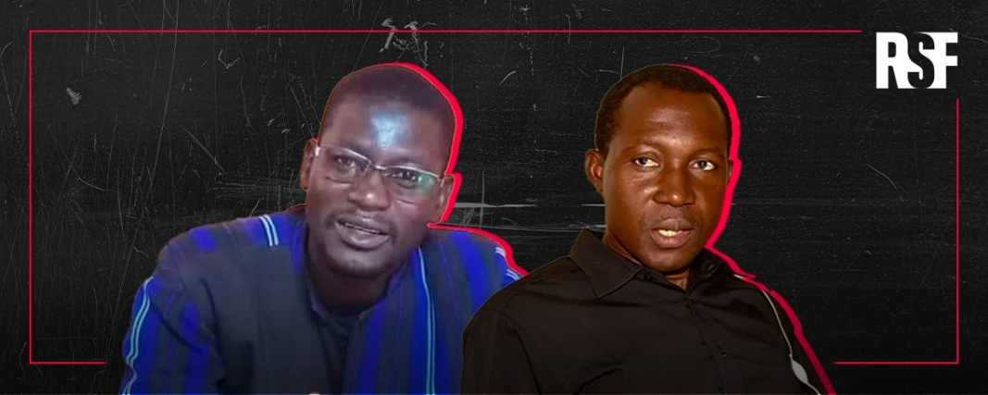
The arrest of the three followed Sanogo’s condemnation of the deteriorating quality of press freedom in Burkina Faso at the March 21 Extraordinary Congress of the AJB, which Pagbelguem had reported on. The condemnation came amid calls for the release of the four journalists and columnists who had been requisitioned and reported missing since the beginning of 2024. The military authorities dissolved the Journalists’ Association of Burkina Faso a day following their arrest, claiming the organization had failed to comply with Law No. 064-2015/CNT of 20 October 2015 regulating associations and consequently, had been legally non-existent at least since 2019. Since then a video of the three in military uniform in an undisclosed location has surfaced online, reinforcing fears that they had been conscripted into the army, a similar fate to what had befallen 3 of 4 other journalists in the country since June last year.
Figure 2 Images of two journalists detained by the junta. Picture credit: RSF

Figure 2 Images of two journalists detained by the junta. Picture credit: RSF
Four journalists and columnists, Serge Oulon, Adama Bayala, Kalifara Séré, and Alain Traoré, also known as ‘Alain Alain’, were abducted in June and July 2024. In October 2024, the authorities, who previously withheld information on their whereabouts, announced that the first three had been conscripted into the army under the general mobilization decree. Presently, the fate of the fourth abductee remains unknown. Following the release of Kalifara Séré on July 14, 2025, Guezouma Sanogo, Boukari Ouoba, Phil Roland Zongo and Luc Pagbelguem have all been released and reunited with their families.
Miphal Ousmane Lankoandé and Amadou Sawadogo: On Sunday, March 30, 2025, Miphal Ousmane Lankoandé was abducted in front of his home in the Karpala district of Ouagadougou in the late hours of the morning. The incident followed his return from Cotonou, Benin, where he participated in the first edition of the School of Activism organized by the Innovation Foundation for Democracy from March 24 to March 28. He was abducted in front of his wife by armed men claiming to be gendarmes. Despite repeated attempts by lawyers, there is still no information of his whereabouts.
Ten days before the arrest of Ousmane Lankoandé, on Thursday, March 20, 2025, Amadou Sawadogo was summoned to the regional State Security Service in Ouagadougou, the capital of Burkina Faso, over his criticism of the Burkinabe government on Facebook. He was interrogated and forced to reveal the homes of two other activists who are currently in hiding. The next day, Monday, March 21, 2025, after responding to a second summons on the same matter, he was reported missing. To date, the authorities have not provided any information on his location.
Hermann Yameogo: On the afternoon of July 26, 2025, Hermann Yameogo, President of the National Union for Democracy and Development (UNDD) and son of Maurice Yameogo, the first president of Burkina Faso, was taken by armed men in plain clothes who raided his home. They took telephones, all the computers and several documents from his home. This followed his publication of a critical essay on the country’s social and political situation that has been trending on social media. In his essay, Yameogo wrote that “an objective, lucid, and courageous analysis of the national situation can only conclude that our country finds itself, for the first time in its contemporary history, suspended over a void.” At the old age of 77, Yameogo is feared to have been conscripted into the VDP. His abductors did not allow him to take his medication, though he was ill at the time of his arrest.
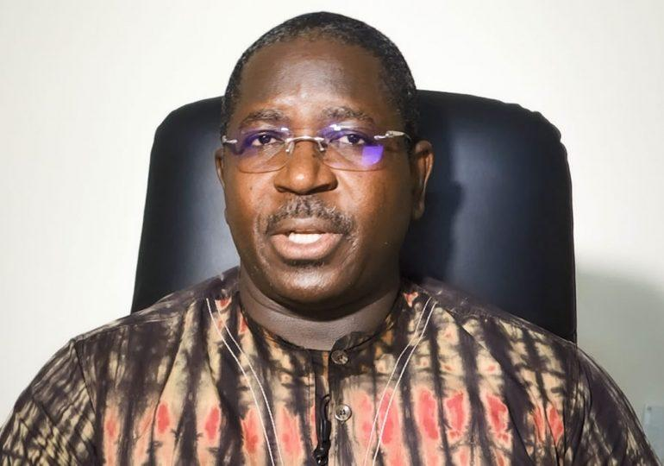
Balai Citoyen: The detention and conscription of HRDs persists despite rulings by the administrative courts in Burkina Faso to the effect that they are illegal. Following his initial arrest on January 24, 2024, prominent lawyer, civil rights activist and co-founder of the civil society collective, Balai Citoyen, Guy Herve Kam, was recurrently re-arrested, charged and placed in detention. This was in spite of repeated unsuccessful appeals against the orders for his release, which in each instance, yielded a ruling by the administrative court to the effect that his detention was illegal. After being re-arrested and charged the last time, he remains in detention because this time around, the military judicial authorities have refrained from scheduling his case as they systematically do for all his requests. Fellow Balai Citoyen activists Rasmane Zinaba and Bassirou Badjoe, remain forcibly disappeared and are suspected to have been conscripted by the Burkinabe army despite a ruling by the administrative court in Burkina Faso which held that their conscription is illegal.
Figure 3 Guy Herve Kam, Co-founder, Balai Citoyen

Figure 65 Guy Herve Kam, Co-founder, Balai Citoyen

Figure 66 Guy Herve Kam, Co-founder, Balai Citoyen

Figure 67 Guy Herve Kam, Co-founder, Balai Citoyen

Figure 68 Guy Herve Kam, Co-founder, Balai Citoyen

Figure 69 Guy Herve Kam, Co-founder, Balai Citoyen

Figure 70 Guy Herve Kam, Co-founder, Balai Citoyen

Figure 71 Guy Herve Kam, Co-founder, Balai Citoyen

Figure 72 Guy Herve Kam, Co-founder, Balai Citoyen

Figure 73 Guy Herve Kam, Co-founder, Balai Citoyen

Figure 74 Guy Herve Kam, Co-founder, Balai Citoyen

Figure 75 Guy Herve Kam, Co-founder, Balai Citoyen

Figure 76 Guy Herve Kam, Co-founder, Balai Citoyen

Figure 77 Guy Herve Kam, Co-founder, Balai Citoyen

Figure 78 Guy Herve Kam, Co-founder, Balai Citoyen

Figure 79 Guy Herve Kam, Co-founder, Balai Citoyen

Guy Herve Kam, Co-founder, Balai Citoyen

Figure 80 Guy Herve Kam, Co-founder, Balai Citoyen

Figure 81 Guy Herve Kam, Co-founder, Balai Citoyen

Figure 82 Guy Herve Kam, Co-founder, Balai Citoyen

Figure 83 Guy Herve Kam, Co-founder, Balai Citoyen

Figure 84 Guy Herve Kam, Co-founder, Balai Citoyen

Figure 85 Guy Herve Kam, Co-founder, Balai Citoyen

Figure 86 Guy Herve Kam, Co-founder, Balai Citoyen

Figure 87 Guy Herve Kam, Co-founder, Balai Citoyen

Figure 88 Guy Herve Kam, Co-founder, Balai Citoyen

Figure 89 Guy Herve Kam, Co-founder, Balai Citoyen

Figure 90 Guy Herve Kam, Co-founder, Balai Citoyen

Figure 91 Guy Herve Kam, Co-founder, Balai Citoyen

Figure 92 Guy Herve Kam, Co-founder, Balai Citoyen

Figure 93 Guy Herve Kam, Co-founder, Balai Citoyen

Figure 94 Guy Herve Kam, Co-founder, Balai Citoyen

Figure 95 Guy Herve Kam, Co-founder, Balai Citoyen

Figure 96 Guy Herve Kam, Co-founder, Balai Citoyen

Figure 97 Guy Herve Kam, Co-founder, Balai Citoyen

Figure 98 Guy Herve Kam, Co-founder, Balai Citoyen

Figure 99 Guy Herve Kam, Co-founder, Balai Citoyen

Figure 100 Guy Herve Kam, Co-founder, Balai Citoyen

Figure 101 Guy Herve Kam, Co-founder, Balai Citoyen

Figure 102 Guy Herve Kam, Co-founder, Balai Citoyen

Figure 103 Guy Herve Kam, Co-founder, Balai Citoyen

Figure 104 Guy Herve Kam, Co-founder, Balai Citoyen

Figure 105 Guy Herve Kam, Co-founder, Balai Citoyen

Figure 106 Guy Herve Kam, Co-founder, Balai Citoyen

Figure 107 Guy Herve Kam, Co-founder, Balai Citoyen

Figure 108 Guy Herve Kam, Co-founder, Balai Citoyen

Figure 109 Guy Herve Kam, Co-founder, Balai Citoyen

Figure 110 Guy Herve Kam, Co-founder, Balai Citoyen

Guy Herve Kam, Co-founder, Balai Citoyen

Figure 111 Guy Herve Kam, Co-founder, Balai Citoyen

Figure 112 Guy Herve Kam, Co-founder, Balai Citoyen

Figure 113 Guy Herve Kam, Co-founder, Balai Citoyen

Figure 114 Guy Herve Kam, Co-founder, Balai Citoyen

Figure 115 Guy Herve Kam, Co-founder, Balai Citoyen

Figure 116 Guy Herve Kam, Co-founder, Balai Citoyen

Figure 117 Guy Herve Kam, Co-founder, Balai Citoyen

Figure 118 Guy Herve Kam, Co-founder, Balai Citoyen

Figure 119 Guy Herve Kam, Co-founder, Balai Citoyen

Figure 120 Guy Herve Kam, Co-founder, Balai Citoyen

Figure 121 Guy Herve Kam, Co-founder, Balai Citoyen

Figure 122 Guy Herve Kam, Co-founder, Balai Citoyen

Figure 123 Guy Herve Kam, Co-founder, Balai Citoyen

Figure 124 Guy Herve Kam, Co-founder, Balai Citoyen

Figure 125 Guy Herve Kam, Co-founder, Balai Citoyen

Figure 3 Guy Herve Kam, Co-founder, Balai Citoyen

Figure 65 Guy Herve Kam, Co-founder, Balai Citoyen

Figure 66 Guy Herve Kam, Co-founder, Balai Citoyen

Figure 67 Guy Herve Kam, Co-founder, Balai Citoyen

Figure 68 Guy Herve Kam, Co-founder, Balai Citoyen

Figure 69 Guy Herve Kam, Co-founder, Balai Citoyen

Figure 70 Guy Herve Kam, Co-founder, Balai Citoyen

Figure 71 Guy Herve Kam, Co-founder, Balai Citoyen

Figure 72 Guy Herve Kam, Co-founder, Balai Citoyen

Figure 73 Guy Herve Kam, Co-founder, Balai Citoyen

Figure 74 Guy Herve Kam, Co-founder, Balai Citoyen

Figure 75 Guy Herve Kam, Co-founder, Balai Citoyen

Figure 76 Guy Herve Kam, Co-founder, Balai Citoyen

Figure 77 Guy Herve Kam, Co-founder, Balai Citoyen

Figure 78 Guy Herve Kam, Co-founder, Balai Citoyen

Figure 79 Guy Herve Kam, Co-founder, Balai Citoyen

Guy Herve Kam, Co-founder, Balai Citoyen

Figure 80 Guy Herve Kam, Co-founder, Balai Citoyen

Figure 81 Guy Herve Kam, Co-founder, Balai Citoyen

Figure 82 Guy Herve Kam, Co-founder, Balai Citoyen

Figure 83 Guy Herve Kam, Co-founder, Balai Citoyen

Figure 84 Guy Herve Kam, Co-founder, Balai Citoyen

Figure 85 Guy Herve Kam, Co-founder, Balai Citoyen

Figure 86 Guy Herve Kam, Co-founder, Balai Citoyen

Figure 87 Guy Herve Kam, Co-founder, Balai Citoyen

Figure 88 Guy Herve Kam, Co-founder, Balai Citoyen

Figure 89 Guy Herve Kam, Co-founder, Balai Citoyen

Figure 90 Guy Herve Kam, Co-founder, Balai Citoyen

Figure 91 Guy Herve Kam, Co-founder, Balai Citoyen

Figure 92 Guy Herve Kam, Co-founder, Balai Citoyen

Figure 93 Guy Herve Kam, Co-founder, Balai Citoyen

Figure 94 Guy Herve Kam, Co-founder, Balai Citoyen

Figure 95 Guy Herve Kam, Co-founder, Balai Citoyen

Figure 96 Guy Herve Kam, Co-founder, Balai Citoyen

Figure 97 Guy Herve Kam, Co-founder, Balai Citoyen

Figure 98 Guy Herve Kam, Co-founder, Balai Citoyen

Figure 99 Guy Herve Kam, Co-founder, Balai Citoyen

Figure 100 Guy Herve Kam, Co-founder, Balai Citoyen

Figure 101 Guy Herve Kam, Co-founder, Balai Citoyen

Figure 102 Guy Herve Kam, Co-founder, Balai Citoyen

Figure 103 Guy Herve Kam, Co-founder, Balai Citoyen

Figure 104 Guy Herve Kam, Co-founder, Balai Citoyen

Figure 105 Guy Herve Kam, Co-founder, Balai Citoyen

Figure 106 Guy Herve Kam, Co-founder, Balai Citoyen

Figure 107 Guy Herve Kam, Co-founder, Balai Citoyen

Figure 108 Guy Herve Kam, Co-founder, Balai Citoyen

Figure 109 Guy Herve Kam, Co-founder, Balai Citoyen

Figure 110 Guy Herve Kam, Co-founder, Balai Citoyen

Guy Herve Kam, Co-founder, Balai Citoyen

Figure 111 Guy Herve Kam, Co-founder, Balai Citoyen

Figure 112 Guy Herve Kam, Co-founder, Balai Citoyen

Figure 113 Guy Herve Kam, Co-founder, Balai Citoyen

Figure 114 Guy Herve Kam, Co-founder, Balai Citoyen

Figure 115 Guy Herve Kam, Co-founder, Balai Citoyen

Figure 116 Guy Herve Kam, Co-founder, Balai Citoyen

Figure 117 Guy Herve Kam, Co-founder, Balai Citoyen

Figure 118 Guy Herve Kam, Co-founder, Balai Citoyen

Figure 119 Guy Herve Kam, Co-founder, Balai Citoyen

Figure 120 Guy Herve Kam, Co-founder, Balai Citoyen

Figure 121 Guy Herve Kam, Co-founder, Balai Citoyen

Figure 122 Guy Herve Kam, Co-founder, Balai Citoyen

Figure 123 Guy Herve Kam, Co-founder, Balai Citoyen

Figure 124 Guy Herve Kam, Co-founder, Balai Citoyen

Figure 125 Guy Herve Kam, Co-founder, Balai Citoyen
Meanwhile the judiciary in Burkina Faso has been increasingly undermined by the military authorities. Judges risk conscription by the Burkinabé army for prosecuting individuals aligned with the junta. Recently, six judges who were conscripted following their prosecution of supporters of the junta, were detained. They have since been released but since then, the message that supporters of the junta are above the law is well understood.

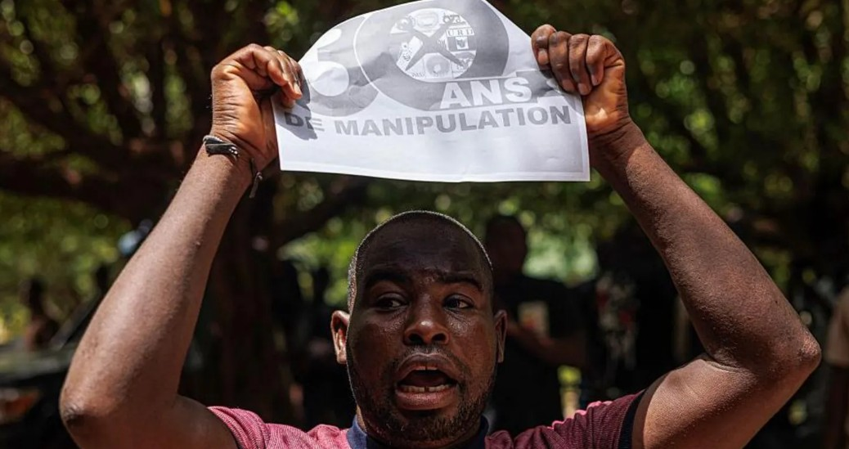
2.2 Mali
Figure 4 Activities of Political parties and civil society organizations have been restricted in Mali. Photo credit: AFP

Figure 126 Activities of Political parties and civil society organizations have been restricted in Mali. Photo credit: AFP

Figure 127 Activities of Political parties and civil society organizations have been restricted in Mali. Photo credit: AFP

Figure 128 Activities of Political parties and civil society organizations have been restricted in Mali. Photo credit: AFP

Figure 129 Activities of Political parties and civil society organizations have been restricted in Mali. Photo credit: AFP

Figure 130 Activities of Political parties and civil society organizations have been restricted in Mali. Photo credit: AFP

Figure 131 Activities of Political parties and civil society organizations have been restricted in Mali. Photo credit: AFP

Figure 132 Activities of Political parties and civil society organizations have been restricted in Mali. Photo credit: AFP

Figure 133 Activities of Political parties and civil society organizations have been restricted in Mali. Photo credit: AFP

Figure 134 Activities of Political parties and civil society organizations have been restricted in Mali. Photo credit: AFP

Figure 135 Activities of Political parties and civil society organizations have been restricted in Mali. Photo credit: AFP

Figure 136 Activities of Political parties and civil society organizations have been restricted in Mali. Photo credit: AFP

Figure 137 Activities of Political parties and civil society organizations have been restricted in Mali. Photo credit: AFP

Figure 138 Activities of Political parties and civil society organizations have been restricted in Mali. Photo credit: AFP

Figure 139 Activities of Political parties and civil society organizations have been restricted in Mali. Photo credit: AFP

Figure 140 Activities of Political parties and civil society organizations have been restricted in Mali. Photo credit: AFP

Figure 141 Activities of Political parties and civil society organizations have been restricted in Mali. Photo credit: AFP

Figure 142 Activities of Political parties and civil society organizations have been restricted in Mali. Photo credit: AFP

Figure 143 Activities of Political parties and civil society organizations have been restricted in Mali. Photo credit: AFP

Figure 144 Activities of Political parties and civil society organizations have been restricted in Mali. Photo credit: AFP

Figure 145 Activities of Political parties and civil society organizations have been restricted in Mali. Photo credit: AFP

Figure 146 Activities of Political parties and civil society organizations have been restricted in Mali. Photo credit: AFP

Figure 147 Activities of Political parties and civil society organizations have been restricted in Mali. Photo credit: AFP

Figure 148 Activities of Political parties and civil society organizations have been restricted in Mali. Photo credit: AFP

Figure 149 Activities of Political parties and civil society organizations have been restricted in Mali. Photo credit: AFP

Figure 150 Activities of Political parties and civil society organizations have been restricted in Mali. Photo credit: AFP

Figure 151 Activities of Political parties and civil society organizations have been restricted in Mali. Photo credit: AFP

Figure 152 Activities of Political parties and civil society organizations have been restricted in Mali. Photo credit: AFP

Figure 153 Activities of Political parties and civil society organizations have been restricted in Mali. Photo credit: AFP

Figure 154 Activities of Political parties and civil society organizations have been restricted in Mali. Photo credit: AFP

Figure 155 Activities of Political parties and civil society organizations have been restricted in Mali. Photo credit: AFP

Figure 156 Activities of Political parties and civil society organizations have been restricted in Mali. Photo credit: AFP

Figure 157 Activities of Political parties and civil society organizations have been restricted in Mali. Photo credit: AFP

Figure 158 Activities of Political parties and civil society organizations have been restricted in Mali. Photo credit: AFP

Figure 159 Activities of Political parties and civil society organizations have been restricted in Mali. Photo credit: AFP

Figure 160 Activities of Political parties and civil society organizations have been restricted in Mali. Photo credit: AFP

Figure 161 Activities of Political parties and civil society organizations have been restricted in Mali. Photo credit: AFP

Figure 162 Activities of Political parties and civil society organizations have been restricted in Mali. Photo credit: AFP

Figure 163 Activities of Political parties and civil society organizations have been restricted in Mali. Photo credit: AFP

Figure 164 Activities of Political parties and civil society organizations have been restricted in Mali. Photo credit: AFP

Figure 165 Activities of Political parties and civil society organizations have been restricted in Mali. Photo credit: AFP

Figure 166 Activities of Political parties and civil society organizations have been restricted in Mali. Photo credit: AFP

Figure 167 Activities of Political parties and civil society organizations have been restricted in Mali. Photo credit: AFP

Figure 168 Activities of Political parties and civil society organizations have been restricted in Mali. Photo credit: AFP

Figure 169 Activities of Political parties and civil society organizations have been restricted in Mali. Photo credit: AFP

Figure 170 Activities of Political parties and civil society organizations have been restricted in Mali. Photo credit: AFP

Figure 171 Activities of Political parties and civil society organizations have been restricted in Mali. Photo credit: AFP

Figure 172 Activities of Political parties and civil society organizations have been restricted in Mali. Photo credit: AFP

Figure 173 Activities of Political parties and civil society organizations have been restricted in Mali. Photo credit: AFP

Figure 174 Activities of Political parties and civil society organizations have been restricted in Mali. Photo credit: AFP

Figure 175 Activities of Political parties and civil society organizations have been restricted in Mali. Photo credit: AFP

Figure 176 Activities of Political parties and civil society organizations have been restricted in Mali. Photo credit: AFP

Figure 177 Activities of Political parties and civil society organizations have been restricted in Mali. Photo credit: AFP

Figure 178 Activities of Political parties and civil society organizations have been restricted in Mali. Photo credit: AFP

Figure 179 Activities of Political parties and civil society organizations have been restricted in Mali. Photo credit: AFP

Figure 180 Activities of Political parties and civil society organizations have been restricted in Mali. Photo credit: AFP

Figure 181 Activities of Political parties and civil society organizations have been restricted in Mali. Photo credit: AFP

Figure 182 Activities of Political parties and civil society organizations have been restricted in Mali. Photo credit: AFP

Figure 183 Activities of Political parties and civil society organizations have been restricted in Mali. Photo credit: AFP

Figure 184 Activities of Political parties and civil society organizations have been restricted in Mali. Photo credit: AFP

Figure 185 Activities of Political parties and civil society organizations have been restricted in Mali. Photo credit: AFP

Figure 186 Activities of Political parties and civil society organizations have been restricted in Mali. Photo credit: AFP

Figure 187 Activities of Political parties and civil society organizations have been restricted in Mali. Photo credit: AFP

Figure 188 Activities of Political parties and civil society organizations have been restricted in Mali. Photo credit: AFP

Figure 4 Activities of Political parties and civil society organizations have been restricted in Mali. Photo credit: AFP

Figure 126 Activities of Political parties and civil society organizations have been restricted in Mali. Photo credit: AFP

Figure 127 Activities of Political parties and civil society organizations have been restricted in Mali. Photo credit: AFP

Figure 128 Activities of Political parties and civil society organizations have been restricted in Mali. Photo credit: AFP

Figure 129 Activities of Political parties and civil society organizations have been restricted in Mali. Photo credit: AFP

Figure 130 Activities of Political parties and civil society organizations have been restricted in Mali. Photo credit: AFP

Figure 131 Activities of Political parties and civil society organizations have been restricted in Mali. Photo credit: AFP

Figure 132 Activities of Political parties and civil society organizations have been restricted in Mali. Photo credit: AFP

Figure 133 Activities of Political parties and civil society organizations have been restricted in Mali. Photo credit: AFP

Figure 134 Activities of Political parties and civil society organizations have been restricted in Mali. Photo credit: AFP

Figure 135 Activities of Political parties and civil society organizations have been restricted in Mali. Photo credit: AFP

Figure 136 Activities of Political parties and civil society organizations have been restricted in Mali. Photo credit: AFP

Figure 137 Activities of Political parties and civil society organizations have been restricted in Mali. Photo credit: AFP

Figure 138 Activities of Political parties and civil society organizations have been restricted in Mali. Photo credit: AFP

Figure 139 Activities of Political parties and civil society organizations have been restricted in Mali. Photo credit: AFP

Figure 140 Activities of Political parties and civil society organizations have been restricted in Mali. Photo credit: AFP

Figure 141 Activities of Political parties and civil society organizations have been restricted in Mali. Photo credit: AFP

Figure 142 Activities of Political parties and civil society organizations have been restricted in Mali. Photo credit: AFP

Figure 143 Activities of Political parties and civil society organizations have been restricted in Mali. Photo credit: AFP

Figure 144 Activities of Political parties and civil society organizations have been restricted in Mali. Photo credit: AFP

Figure 145 Activities of Political parties and civil society organizations have been restricted in Mali. Photo credit: AFP

Figure 146 Activities of Political parties and civil society organizations have been restricted in Mali. Photo credit: AFP

Figure 147 Activities of Political parties and civil society organizations have been restricted in Mali. Photo credit: AFP

Figure 148 Activities of Political parties and civil society organizations have been restricted in Mali. Photo credit: AFP

Figure 149 Activities of Political parties and civil society organizations have been restricted in Mali. Photo credit: AFP

Figure 150 Activities of Political parties and civil society organizations have been restricted in Mali. Photo credit: AFP

Figure 151 Activities of Political parties and civil society organizations have been restricted in Mali. Photo credit: AFP

Figure 152 Activities of Political parties and civil society organizations have been restricted in Mali. Photo credit: AFP

Figure 153 Activities of Political parties and civil society organizations have been restricted in Mali. Photo credit: AFP

Figure 154 Activities of Political parties and civil society organizations have been restricted in Mali. Photo credit: AFP

Figure 155 Activities of Political parties and civil society organizations have been restricted in Mali. Photo credit: AFP

Figure 156 Activities of Political parties and civil society organizations have been restricted in Mali. Photo credit: AFP

Figure 157 Activities of Political parties and civil society organizations have been restricted in Mali. Photo credit: AFP

Figure 158 Activities of Political parties and civil society organizations have been restricted in Mali. Photo credit: AFP

Figure 159 Activities of Political parties and civil society organizations have been restricted in Mali. Photo credit: AFP

Figure 160 Activities of Political parties and civil society organizations have been restricted in Mali. Photo credit: AFP

Figure 161 Activities of Political parties and civil society organizations have been restricted in Mali. Photo credit: AFP

Figure 162 Activities of Political parties and civil society organizations have been restricted in Mali. Photo credit: AFP

Figure 163 Activities of Political parties and civil society organizations have been restricted in Mali. Photo credit: AFP

Figure 164 Activities of Political parties and civil society organizations have been restricted in Mali. Photo credit: AFP

Figure 165 Activities of Political parties and civil society organizations have been restricted in Mali. Photo credit: AFP

Figure 166 Activities of Political parties and civil society organizations have been restricted in Mali. Photo credit: AFP

Figure 167 Activities of Political parties and civil society organizations have been restricted in Mali. Photo credit: AFP

Figure 168 Activities of Political parties and civil society organizations have been restricted in Mali. Photo credit: AFP

Figure 169 Activities of Political parties and civil society organizations have been restricted in Mali. Photo credit: AFP

Figure 170 Activities of Political parties and civil society organizations have been restricted in Mali. Photo credit: AFP

Figure 171 Activities of Political parties and civil society organizations have been restricted in Mali. Photo credit: AFP

Figure 172 Activities of Political parties and civil society organizations have been restricted in Mali. Photo credit: AFP

Figure 173 Activities of Political parties and civil society organizations have been restricted in Mali. Photo credit: AFP

Figure 174 Activities of Political parties and civil society organizations have been restricted in Mali. Photo credit: AFP

Figure 175 Activities of Political parties and civil society organizations have been restricted in Mali. Photo credit: AFP

Figure 176 Activities of Political parties and civil society organizations have been restricted in Mali. Photo credit: AFP

Figure 177 Activities of Political parties and civil society organizations have been restricted in Mali. Photo credit: AFP

Figure 178 Activities of Political parties and civil society organizations have been restricted in Mali. Photo credit: AFP

Figure 179 Activities of Political parties and civil society organizations have been restricted in Mali. Photo credit: AFP

Figure 180 Activities of Political parties and civil society organizations have been restricted in Mali. Photo credit: AFP

Figure 181 Activities of Political parties and civil society organizations have been restricted in Mali. Photo credit: AFP

Figure 182 Activities of Political parties and civil society organizations have been restricted in Mali. Photo credit: AFP

Figure 183 Activities of Political parties and civil society organizations have been restricted in Mali. Photo credit: AFP

Figure 184 Activities of Political parties and civil society organizations have been restricted in Mali. Photo credit: AFP

Figure 185 Activities of Political parties and civil society organizations have been restricted in Mali. Photo credit: AFP

Figure 186 Activities of Political parties and civil society organizations have been restricted in Mali. Photo credit: AFP

Figure 187 Activities of Political parties and civil society organizations have been restricted in Mali. Photo credit: AFP

Figure 188 Activities of Political parties and civil society organizations have been restricted in Mali. Photo credit: AFP

While freedoms of speech and association have come under serious attack in Mali, innocent civilians remain targeted in brutal and fatal crackdowns by security forces as part of government counterterrorism efforts. Critical and dissenting voices continue to face government repression. Opposition figures continue to be targeted by government suppression and intimidation efforts. A six-month suspension placed on media outlet Joliba TV in November, 2024 recently expired and has been lifted. Brewing tensions ahead of a decree by the junta dissolving all political parties in the country, sparked the first prodemocracy protest in the country in years. On July 8, 2025, the military junta enacted a revised Transitional Charter that sets the duration of the transitional mandate at five years, renewable without limit, until national pacification is achieved.
Extrajudicial killings: In late April, several dozen decomposing bodies, suspected to be of those arrested in Sebabougou on 12 April 2025, were found scattered on the outskirts of the Kwala military camp by citizens searching for their relatives. On May 16, the chief of staff of the Malian armed forces announced a gendarmerie investigation into extrajudicial executions of at least 22 men, who were taken into military custody on May 12, 2025, in the town of Diafarabé. Residents who saw the bodies three days later said the victims were in two shallow mass graves with their throats slit.
UN experts have expressed outrage at the alleged summary executions and enforced disappearances of others. They have warned that these unlawful killings may amount to war crimes, and that the enforced disappearances may constitute crimes against humanity if they are part of widespread or systematic attacks against civilians.
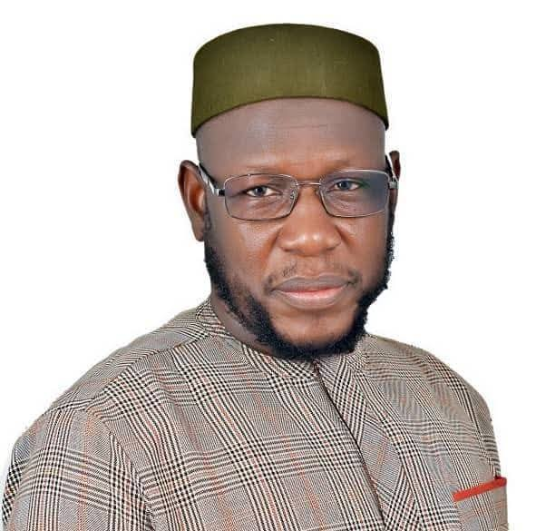
Daouda Magassa: In the evening on Wednesday, February 5, 2025, Daouda Magassa, a key figure in the movement supporting the return of exiled cleric Imam Mahmoud Dicko, was taken by men in civilian clothes in Bamako, and held by state security. His detention was believed to be part of an effort to thwart Imam Dicko’s planned return to Mali on Friday, February 14. Dicko, a vocal critic of the junta, has been living in exile in Algeria for over a year. His return has been widely anticipated, with Magassa, leading his supporters in actively mobilizing for his homecoming. Intelligence services were reportedly seeking information about Dicko’s return, including details about his sources of funds and network of collaborators.
Figure 5 Daouda Dicko was arrested but later released

Figure 5 Daouda Dicko was arrested but later released
In early March, Daouda was released, amid fears that his release might signal deeper tensions ahead of the upcoming new national consultations.
Alfousseini Togo: On April 9, Alfousseini Togo, the editor of the weekly Le Canard de la Venise, was arrested by Mali’s Judicial Unit Against Cybercrime and detained following his article published a day before, entitled “Malian justice or the evil of the century: the blunder of Minister Mamoudou Kassogué.” In it, he criticised the judiciary’s lack of independence and questioned a claim by the Minister of Justice. The Minister had claimed that public confidence in the judiciary had risen from 30% to 72% in 2024, according to a survey on public trust in Mali’s judiciary conducted by the Friedrich Ebert Foundation.
Initially summoned on charges relating to the law on cybercrime, the journalist is now being prosecuted for “undermining the credibility of the justice system,” “disturbing the peace,” and “defamation”, according to a colleague.
On May 12, 2025, he was released on bail of CFA 500, 000. His case was heard on June 12 and judgment was reserved until a verdict on July 28, declared him guilty of defamation, disturbing public order, and “undermining the credibility of the judiciary,” charges for which he was handed an eight-month suspended prison sentence and fined 500,000 CFA francs (about USD 881) by Mali’s National Cybercrime Unit. Since his conviction, Media Foundation West Africa (MFWA) has called for the reversal of his conviction, citing the chilling message his conviction sends to all journalists who dare to question official narratives.
Dissolution of political parties: Following its suspension of all political activities last year, the military authorities in Mali, signed into effect a decree dissolving all political parties in Mali, in line with the recommendations of the new national consultations on the Charter of Political Parties with Mali’s vital forces in April. Additionally, the decree named junta leader, General Assimi Goïta, as President until 2030.
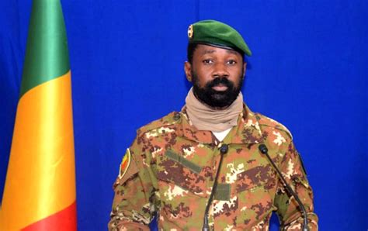
Ahead of the new national consultations, political parties in Mali launched a strong opposition, questioning the need for new national consultations. Meanwhile, the government had previously initiated national consultations with political parties in December 2024 to review Law No. 05-047 on the Charter of Political Parties. The initial consultation had already been endorsed by the State and integrated into the Strategic Framework for the Rebuilding of the State. They expressed fears that the new consultations would be used to marginalize or suspend them, as was the case in Burkina Faso and Niger. They questioned the legitimacy of the new national consultations given the prior ANR resolutions, which were recognized as priorities within the institutional framework of the transition.
Figure 6 Colonel Assimi Goita, Mali's interim junta leader

Figure 189 Colonel Assimi Goita, Mali's interim junta leader

Figure 190 Colonel Assimi Goita, Mali's interim junta leader

Figure 191 Colonel Assimi Goita, Mali's interim junta leader

Figure 192 Colonel Assimi Goita, Mali's interim junta leader

Figure 193 Colonel Assimi Goita, Mali's interim junta leader

Figure 194 Colonel Assimi Goita, Mali's interim junta leader

Figure 195 Colonel Assimi Goita, Mali's interim junta leader

Figure 196 Colonel Assimi Goita, Mali's interim junta leader

Figure 197 Colonel Assimi Goita, Mali's interim junta leader

Figure 198 Colonel Assimi Goita, Mali's interim junta leader

Figure 199 Colonel Assimi Goita, Mali's interim junta leader

Figure 200 Colonel Assimi Goita, Mali's interim junta leader

Figure 201 Colonel Assimi Goita, Mali's interim junta leader

Figure 202 Colonel Assimi Goita, Mali's interim junta leader

Figure 203 Colonel Assimi Goita, Mali's interim junta leader

Figure 204 Colonel Assimi Goita, Mali's interim junta leader

Figure 205 Colonel Assimi Goita, Mali's interim junta leader

Figure 206 Colonel Assimi Goita, Mali's interim junta leader

Figure 207 Colonel Assimi Goita, Mali's interim junta leader

Figure 208 Colonel Assimi Goita, Mali's interim junta leader

Figure 209 Colonel Assimi Goita, Mali's interim junta leader

Figure 210 Colonel Assimi Goita, Mali's interim junta leader

Figure 211 Colonel Assimi Goita, Mali's interim junta leader

Figure 212 Colonel Assimi Goita, Mali's interim junta leader

Figure 213 Colonel Assimi Goita, Mali's interim junta leader

Figure 214 Colonel Assimi Goita, Mali's interim junta leader

Figure 215 Colonel Assimi Goita, Mali's interim junta leader

Figure 216 Colonel Assimi Goita, Mali's interim junta leader

Figure 217 Colonel Assimi Goita, Mali's interim junta leader

Figure 218 Colonel Assimi Goita, Mali's interim junta leader

Figure 219 Colonel Assimi Goita, Mali's interim junta leader

Figure 220 Colonel Assimi Goita, Mali's interim junta leader

Figure 221 Colonel Assimi Goita, Mali's interim junta leader

Figure 222 Colonel Assimi Goita, Mali's interim junta leader

Figure 223 Colonel Assimi Goita, Mali's interim junta leader

Figure 224 Colonel Assimi Goita, Mali's interim junta leader

Figure 225 Colonel Assimi Goita, Mali's interim junta leader

Figure 226 Colonel Assimi Goita, Mali's interim junta leader

Figure 227 Colonel Assimi Goita, Mali's interim junta leader

Figure 228 Colonel Assimi Goita, Mali's interim junta leader

Figure 229 Colonel Assimi Goita, Mali's interim junta leader

Figure 230 Colonel Assimi Goita, Mali's interim junta leader

Figure 231 Colonel Assimi Goita, Mali's interim junta leader

Figure 232 Colonel Assimi Goita, Mali's interim junta leader

Figure 233 Colonel Assimi Goita, Mali's interim junta leader

Figure 234 Colonel Assimi Goita, Mali's interim junta leader

Figure 235 Colonel Assimi Goita, Mali's interim junta leader

Figure 236 Colonel Assimi Goita, Mali's interim junta leader

Figure 237 Colonel Assimi Goita, Mali's interim junta leader

Figure 238 Colonel Assimi Goita, Mali's interim junta leader

Figure 239 Colonel Assimi Goita, Mali's interim junta leader

Figure 240 Colonel Assimi Goita, Mali's interim junta leader

Figure 241 Colonel Assimi Goita, Mali's interim junta leader

Figure 242 Colonel Assimi Goita, Mali's interim junta leader

Figure 243 Colonel Assimi Goita, Mali's interim junta leader

Figure 244 Colonel Assimi Goita, Mali's interim junta leader

Figure 245 Colonel Assimi Goita, Mali's interim junta leader

Figure 246 Colonel Assimi Goita, Mali's interim junta leader

Figure 247 Colonel Assimi Goita, Mali's interim junta leader

Figure 248 Colonel Assimi Goita, Mali's interim junta leader

Figure 249 Colonel Assimi Goita, Mali's interim junta leader

Figure 250 Colonel Assimi Goita, Mali's interim junta leader

Figure 251 Colonel Assimi Goita, Mali's interim junta leader

Figure 6 Colonel Assimi Goita, Mali's interim junta leader

Figure 189 Colonel Assimi Goita, Mali's interim junta leader

Figure 190 Colonel Assimi Goita, Mali's interim junta leader

Figure 191 Colonel Assimi Goita, Mali's interim junta leader

Figure 192 Colonel Assimi Goita, Mali's interim junta leader

Figure 193 Colonel Assimi Goita, Mali's interim junta leader

Figure 194 Colonel Assimi Goita, Mali's interim junta leader

Figure 195 Colonel Assimi Goita, Mali's interim junta leader

Figure 196 Colonel Assimi Goita, Mali's interim junta leader

Figure 197 Colonel Assimi Goita, Mali's interim junta leader

Figure 198 Colonel Assimi Goita, Mali's interim junta leader

Figure 199 Colonel Assimi Goita, Mali's interim junta leader

Figure 200 Colonel Assimi Goita, Mali's interim junta leader

Figure 201 Colonel Assimi Goita, Mali's interim junta leader

Figure 202 Colonel Assimi Goita, Mali's interim junta leader

Figure 203 Colonel Assimi Goita, Mali's interim junta leader

Figure 204 Colonel Assimi Goita, Mali's interim junta leader

Figure 205 Colonel Assimi Goita, Mali's interim junta leader

Figure 206 Colonel Assimi Goita, Mali's interim junta leader

Figure 207 Colonel Assimi Goita, Mali's interim junta leader

Figure 208 Colonel Assimi Goita, Mali's interim junta leader

Figure 209 Colonel Assimi Goita, Mali's interim junta leader

Figure 210 Colonel Assimi Goita, Mali's interim junta leader

Figure 211 Colonel Assimi Goita, Mali's interim junta leader

Figure 212 Colonel Assimi Goita, Mali's interim junta leader

Figure 213 Colonel Assimi Goita, Mali's interim junta leader

Figure 214 Colonel Assimi Goita, Mali's interim junta leader

Figure 215 Colonel Assimi Goita, Mali's interim junta leader

Figure 216 Colonel Assimi Goita, Mali's interim junta leader

Figure 217 Colonel Assimi Goita, Mali's interim junta leader

Figure 218 Colonel Assimi Goita, Mali's interim junta leader

Figure 219 Colonel Assimi Goita, Mali's interim junta leader

Figure 220 Colonel Assimi Goita, Mali's interim junta leader

Figure 221 Colonel Assimi Goita, Mali's interim junta leader

Figure 222 Colonel Assimi Goita, Mali's interim junta leader

Figure 223 Colonel Assimi Goita, Mali's interim junta leader

Figure 224 Colonel Assimi Goita, Mali's interim junta leader

Figure 225 Colonel Assimi Goita, Mali's interim junta leader

Figure 226 Colonel Assimi Goita, Mali's interim junta leader

Figure 227 Colonel Assimi Goita, Mali's interim junta leader

Figure 228 Colonel Assimi Goita, Mali's interim junta leader

Figure 229 Colonel Assimi Goita, Mali's interim junta leader

Figure 230 Colonel Assimi Goita, Mali's interim junta leader

Figure 231 Colonel Assimi Goita, Mali's interim junta leader

Figure 232 Colonel Assimi Goita, Mali's interim junta leader

Figure 233 Colonel Assimi Goita, Mali's interim junta leader

Figure 234 Colonel Assimi Goita, Mali's interim junta leader

Figure 235 Colonel Assimi Goita, Mali's interim junta leader

Figure 236 Colonel Assimi Goita, Mali's interim junta leader

Figure 237 Colonel Assimi Goita, Mali's interim junta leader

Figure 238 Colonel Assimi Goita, Mali's interim junta leader

Figure 239 Colonel Assimi Goita, Mali's interim junta leader

Figure 240 Colonel Assimi Goita, Mali's interim junta leader

Figure 241 Colonel Assimi Goita, Mali's interim junta leader

Figure 242 Colonel Assimi Goita, Mali's interim junta leader

Figure 243 Colonel Assimi Goita, Mali's interim junta leader

Figure 244 Colonel Assimi Goita, Mali's interim junta leader

Figure 245 Colonel Assimi Goita, Mali's interim junta leader

Figure 246 Colonel Assimi Goita, Mali's interim junta leader

Figure 247 Colonel Assimi Goita, Mali's interim junta leader

Figure 248 Colonel Assimi Goita, Mali's interim junta leader

Figure 249 Colonel Assimi Goita, Mali's interim junta leader

Figure 250 Colonel Assimi Goita, Mali's interim junta leader

Figure 251 Colonel Assimi Goita, Mali's interim junta leader
In response to this gross violation of civil and political rights, political parties registered their opposition to these measures with two protests, the first on May 3 by a coalition of political parties and civil society at the Palais de la Culture in Bamako, and the second on May 4 by young political party leaders at the Maison de la Presse. At least 80 political parties and 2 civil society organizations drafted a declaration calling for the junta to return Mali to civilian rule by December 31, 2025, create a timetable for the return to the constitutional order, and release political prisoners. A third protest scheduled for May 9, was called off following a government press release announcing the suspension of all political activities until further notice.
In the wake of the upheaval over the new national consultations and the dissolution of political parties in the country, there has been a worrying series of arrests targeting opposition figures. On July 8, 2025, a revised Transitional Charter was enacted, which sets the duration of the transitional mandate at five years, renewable without limit, until national pacification is achieved.
Abba Alhassane and El Bachir Thiam: On May 8, Abba Alhassane, 68, secretary general of the opposition party Convergence for the Development of Mali (Convergence pour le développement du Mali, or CODEM) was arrested at his home in the capital, Bamako, by three armed masked gunmen claiming to be gendarmes. He was taken away “in a car with black tinted windows and no license plate.” According to party members and local media, on the same day, El Bachir Thiam, a leader of The Change party (Le changement, or YELEMA) was taken by unidentified men who were traveling in a gray Toyota V8 4x4 vehicle with tinted windows and no license plate. They are suspected of being Malian intelligence agents – more specifically from the Agence Nationale de la Sécurité d'Etat (ANSE) – or elements of the Bamako gendarmerie du Camp I – off the streets of Kati town, about 15 kilometers from Bamako. The parties of both leaders were involved in a large gathering organized by Mali’s political opposition on May 3 to protest the military junta’s April 30 decision to dissolve all political parties and name the junta’s leader, General Assimi Goïta, as president until 2030.
Colleagues of both men searched for them in police and gendarmerie stations across Bamako and Kati to no avail. Authorities neither provided any information on their whereabouts nor indicated if their cases were being investigated.
On June 5, 2025, Abba Alhassane was dropped off along a road in Mali’s capital, Bamako, according to Alhousseini Jannatta Alassane, his son, who also indicated that he believed the intelligence services were behind his father’s kidnapping. Till date, no authority has confirmed their involvement. It is not in the nature of Mali’s intelligence services to engage the public on such cases. The whereabouts of El Bachir Thiam, however, remain unknown. Recently experts at the United Nations have called on authorities in Mali to disclose his fate and whereabouts, four months following his disappearance.

Abdoul Karim Traoré: On May 11, Abdoul Karim Traoré, also known as “Exo,” vice-president of the youth office of the Convergence for the Development of Mali (CODEM), and member of the Jigya Kura coalition was arrested along with Abdrahamane Diarra, president of the Mouvement des Jeunes de l’URD. Both individuals were arrested without due process and Abdoul Karim Traoré’s arrest followed his denunciation of the abduction and forced disappearance of the secretary-general of his party, Alhassane Abba. While the Abdrahamane Diarra was released the following day without any official clarification, Traoré, was feared to have been forcibly disappeared after Mali’s security ministry did not respond to a request for comment and his relatives remained unaware of their whereabouts. Following calls for his release by the Media Foundation West Africa (MFWA) among others, on June 6, family members confirmed that he had returned home. His release was made without any official statement by his abductors.
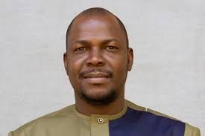
The release of Professor Etienne Sissoko: On March 27, 2025, Malian author, activist, and university professor Etienne Sissoko was released from prison, after spending a year in arbitrary detention. He was convicted of “harming the reputation of the state,” “defamation,” and “dissemination of false news” for his publication Propaganda, Agitation and Harassment – Government Communication During the Transition in Mali. The book, which was published in December 2023, detailed several human rights violations by the military junta. On May 20, 2025, he was sentenced to two years in prison—with one year suspended—and fined XOF 3 million (approximately $7,200).
Figure 7 Professor Etienne Sissoko released from jail

Figure 252 Professor Etienne Sissoko released from jail

Figure 253 Professor Etienne Sissoko released from jail

Figure 254 Professor Etienne Sissoko released from jail

Figure 255 Professor Etienne Sissoko released from jail

Figure 256 Professor Etienne Sissoko released from jail

Figure 257 Professor Etienne Sissoko released from jail

Figure 258 Professor Etienne Sissoko released from jail

Figure 259 Professor Etienne Sissoko released from jail

Figure 260 Professor Etienne Sissoko released from jail

Figure 261 Professor Etienne Sissoko released from jail

Figure 262 Professor Etienne Sissoko released from jail

Figure 263 Professor Etienne Sissoko released from jail

Figure 264 Professor Etienne Sissoko released from jail

Figure 265 Professor Etienne Sissoko released from jail

Figure 266 Professor Etienne Sissoko released from jail

Figure 267 Professor Etienne Sissoko released from jail

Figure 268 Professor Etienne Sissoko released from jail

Figure 269 Professor Etienne Sissoko released from jail

Figure 270 Professor Etienne Sissoko released from jail

Figure 271 Professor Etienne Sissoko released from jail

Figure 272 Professor Etienne Sissoko released from jail

Figure 273 Professor Etienne Sissoko released from jail

Figure 274 Professor Etienne Sissoko released from jail

Figure 275 Professor Etienne Sissoko released from jail

Figure 276 Professor Etienne Sissoko released from jail

Figure 277 Professor Etienne Sissoko released from jail

Figure 278 Professor Etienne Sissoko released from jail

Figure 279 Professor Etienne Sissoko released from jail

Figure 280 Professor Etienne Sissoko released from jail

Figure 281 Professor Etienne Sissoko released from jail

Figure 282 Professor Etienne Sissoko released from jail

Figure 283 Professor Etienne Sissoko released from jail

Figure 284 Professor Etienne Sissoko released from jail

Figure 285 Professor Etienne Sissoko released from jail

Figure 286 Professor Etienne Sissoko released from jail

Figure 287 Professor Etienne Sissoko released from jail

Figure 288 Professor Etienne Sissoko released from jail

Figure 289 Professor Etienne Sissoko released from jail

Figure 290 Professor Etienne Sissoko released from jail

Figure 291 Professor Etienne Sissoko released from jail

Figure 292 Professor Etienne Sissoko released from jail

Figure 293 Professor Etienne Sissoko released from jail

Figure 294 Professor Etienne Sissoko released from jail

Figure 295 Professor Etienne Sissoko released from jail

Figure 296 Professor Etienne Sissoko released from jail

Figure 297 Professor Etienne Sissoko released from jail

Figure 298 Professor Etienne Sissoko released from jail

Figure 299 Professor Etienne Sissoko released from jail

Figure 300 Professor Etienne Sissoko released from jail

Figure 301 Professor Etienne Sissoko released from jail

Figure 302 Professor Etienne Sissoko released from jail

Figure 303 Professor Etienne Sissoko released from jail

Figure 304 Professor Etienne Sissoko released from jail

Figure 305 Professor Etienne Sissoko released from jail

Figure 306 Professor Etienne Sissoko released from jail

Figure 307 Professor Etienne Sissoko released from jail

Figure 308 Professor Etienne Sissoko released from jail

Figure 309 Professor Etienne Sissoko released from jail

Figure 310 Professor Etienne Sissoko released from jail

Figure 311 Professor Etienne Sissoko released from jail

Figure 312 Professor Etienne Sissoko released from jail

Figure 313 Professor Etienne Sissoko released from jail

Figure 314 Professor Etienne Sissoko released from jail

Figure 7 Professor Etienne Sissoko released from jail

Figure 252 Professor Etienne Sissoko released from jail

Figure 253 Professor Etienne Sissoko released from jail

Figure 254 Professor Etienne Sissoko released from jail

Figure 255 Professor Etienne Sissoko released from jail

Figure 256 Professor Etienne Sissoko released from jail

Figure 257 Professor Etienne Sissoko released from jail

Figure 258 Professor Etienne Sissoko released from jail

Figure 259 Professor Etienne Sissoko released from jail

Figure 260 Professor Etienne Sissoko released from jail

Figure 261 Professor Etienne Sissoko released from jail

Figure 262 Professor Etienne Sissoko released from jail

Figure 263 Professor Etienne Sissoko released from jail

Figure 264 Professor Etienne Sissoko released from jail

Figure 265 Professor Etienne Sissoko released from jail

Figure 266 Professor Etienne Sissoko released from jail

Figure 267 Professor Etienne Sissoko released from jail

Figure 268 Professor Etienne Sissoko released from jail

Figure 269 Professor Etienne Sissoko released from jail

Figure 270 Professor Etienne Sissoko released from jail

Figure 271 Professor Etienne Sissoko released from jail

Figure 272 Professor Etienne Sissoko released from jail

Figure 273 Professor Etienne Sissoko released from jail

Figure 274 Professor Etienne Sissoko released from jail

Figure 275 Professor Etienne Sissoko released from jail

Figure 276 Professor Etienne Sissoko released from jail

Figure 277 Professor Etienne Sissoko released from jail

Figure 278 Professor Etienne Sissoko released from jail

Figure 279 Professor Etienne Sissoko released from jail

Figure 280 Professor Etienne Sissoko released from jail

Figure 281 Professor Etienne Sissoko released from jail

Figure 282 Professor Etienne Sissoko released from jail

Figure 283 Professor Etienne Sissoko released from jail

Figure 284 Professor Etienne Sissoko released from jail

Figure 285 Professor Etienne Sissoko released from jail

Figure 286 Professor Etienne Sissoko released from jail

Figure 287 Professor Etienne Sissoko released from jail

Figure 288 Professor Etienne Sissoko released from jail

Figure 289 Professor Etienne Sissoko released from jail

Figure 290 Professor Etienne Sissoko released from jail

Figure 291 Professor Etienne Sissoko released from jail

Figure 292 Professor Etienne Sissoko released from jail

Figure 293 Professor Etienne Sissoko released from jail

Figure 294 Professor Etienne Sissoko released from jail

Figure 295 Professor Etienne Sissoko released from jail

Figure 296 Professor Etienne Sissoko released from jail

Figure 297 Professor Etienne Sissoko released from jail

Figure 298 Professor Etienne Sissoko released from jail

Figure 299 Professor Etienne Sissoko released from jail

Figure 300 Professor Etienne Sissoko released from jail

Figure 301 Professor Etienne Sissoko released from jail

Figure 302 Professor Etienne Sissoko released from jail

Figure 303 Professor Etienne Sissoko released from jail

Figure 304 Professor Etienne Sissoko released from jail

Figure 305 Professor Etienne Sissoko released from jail

Figure 306 Professor Etienne Sissoko released from jail

Figure 307 Professor Etienne Sissoko released from jail

Figure 308 Professor Etienne Sissoko released from jail

Figure 309 Professor Etienne Sissoko released from jail

Figure 310 Professor Etienne Sissoko released from jail

Figure 311 Professor Etienne Sissoko released from jail

Figure 312 Professor Etienne Sissoko released from jail

Figure 313 Professor Etienne Sissoko released from jail

Figure 314 Professor Etienne Sissoko released from jail
When the court granted him provisional release on October 14, 2024, the Prosecutor appealed the decision the same day, and he remained in Kéniéroba Prison, 75 km from Bamako — cut off from his family and legal team. Over the duration of his detention, human rights defenders, civil society and human rights organisations across the globe joined in solidarity with Malian HRDs and civil society to demand his release.

2.3 Niger
The terrorist insurgency continues to rip through Niger. The most significant incidents this year include the assault that took place during afternoon prayers in the southwestern village of Fombita, where 44 people were killed and 13 wounded. The attackers also set fire to a local market and several homes. A May 25 attack by the Islamic State of the Greater Sahara (ISGS) on two joint military camps in Eknewane, Tahoua region, which were manned by the Special Intervention Group (GIS) and the National Guard of Niger (GNN), elite troops of the Niger Armed Forces, resulted in 58 deaths. And an ambush of a patrolling unit of the Nigerian army by the Jamaʿat Nuṣrat al-Islām wal-Muslimīn (JNIM) group on May 26, killed 45 out of 71 soldiers out of 71.
As these insurgencies continue, the transitional authorities have deepened their crackdown on the civic space and human rights defenders, with an aggressive campaign to silence dissent, dismantle independent civil society, and shrink the public space for human rights work. Peaceful protests have been banned, media outlets shuttered, and journalists harassed or threatened for attempting to report on the situation. In the repressed environment that saw prison sentences reinstated for defamation by journalists, rights activist and government critic, Moussa Tiangari, who was arrested in December last year, remains in detention for criticizing the government over the establishment of a vaguely constituted terrorism database. He has been charged with advocating terrorism and criminal association in connection with terrorism. This database was later used to suspend the nationality of the nine former public officials all of whom served under the Bazoum regime.
In furtherance of the broader “Refondation” process, initiated after the military coup in 2023, the National Assembly Resolutions have seen the adoption of a new Refoundation Charter, which repeals Ordinance No. 2023-02 of 28 July 2023 and passes for a new constitution. The Refoundation Charter which redefines the country’s institutions and establishes an institutional framework adapted to the “socio-cultural realities” of Niger, has established a 5-year transition period, defined as a 60-month “refoundation period” for which General Abdourahamane Tiani has been appointed President of the Republic of the Niger for the duration of the transition. In accordance with this refoundation, Ordinance No. 2025-06 of March 26, 2025, has dissolved all political parties.
Article 39 of the Refoundation Charter, which prohibits the country's defence and security forces from exercising their right to organise, underlies an April 8 decree by the Ministry of Interior dissolving three unions representing official paramilitary forces involved in the fight against jihadists. In the wake of accusations of “interference in judicial affairs” levelled against the Nigerien authorities by labour unions in the justice sector, the Ministry of Justice and Human Rights announced the dissolution of four unions in the judicial sector, accusing them of having diverted from their mission of defending the general interest in favor of corporate and personal interests, thus compromising the proper functioning of the public justice service.
The arrest of Hamid Mahmoud, Massaouda Jaharou and Mahaman Sani: The pattern of censorship on security-related matters in the AES has again been exemplified with the arrest and detention of Hamid Mahmoud, Massaouda Jaharou, and Mahaman Sani, three journalists with the privately-owned Sahara FM radio station. They were arrested on May 7 and questioned over a broadcast about Niger’s deteriorating military cooperation with Russia. After they were released by a judge on May 9 without charge, they were re-arrested by the gendarmerie on the morning of May 10 and further questioned before being transferred to the brigade of the gendarmerie of Niamey.
Despite calls by human rights defenders and international rights organisations for their release, they remained in detention until June 13, 2025, when Massaouda Jaharou, was granted provisional release by the Niamey Military Court, allowing her to remain outside prison but requiring her to stay at the disposal of the judiciary, as legal proceedings continue. Her colleagues Hamid Mahmoud and Mahamane Sani were formally remanded into custody by the military court on the same day. The two journalists are being prosecuted for “undermining national defence” and “conspiracy against state authority” under the Nigerien Penal Code. They are currently being held at Kollo prison, about 30 km from Niamey, after being transferred from the Niamey State Prison.
Moussa Adamou Garba: On June 20, 2025, Moussa Garba, a journalist with Dounia Radio and Television, based in Maradi, the second largest city and economic capital of Niger, was arrested by the Criminal Investigation Police. His arrest took place after the publication of his article: "Maradi under tension: 4 young girls disappeared in one week and perhaps more..." In the article, he raised concerns about a disturbing incident involving four missing girls. Appearing before a judge on 23 June, the journalist was accused of “dissemination of data likely to disturb public order” and subsequently placed under a detention order and transferred to the Maradi Civil Prison. After over two weeks in detention, he was released on July 4, 2025 with all charges against him dropped.

2.4 Nigeria
While economic hardship remains endemic in the face of commendable economic reforms, Nigeria continues to grapple with banditry, intercommunal conflicts, deadly land disputes, and a terrorist insurgency that has taken on a new complexity as insurgents acquire weaponized drones and other sophisticated weapons. In February, the National Human Rights Commission of Nigeria (NHRC) reported a staggering 25% increase in complaints of human rights violations from 169,850 complaints in January to 205,364 in February. A subsequent report by the organisation claimed to have documented 1,485,307 complaints of rights violations between January and June 2025, the highest in the history of the commission. This comes at a moment when the country has witnessed an astronomical rise in gender-based violence and the withdrawal of Niger from the Multinational Joint Task Force (MNJTF) has sparked fears of increased terrorist attacks. The withdrawal of the member states of the AES from the ECOWAS has also had an adverse impact on movement and trade between Nigeria and Niger. A recent spike in violent clashes between farmers and nomadic herdsmen is not only worsening but increasingly taking a religious dimension.
Meanwhile, growing calls for government interventions in these and several other developments plaguing the country have seen the civic space subjected to severe restrictions. On January 6, the Nigerian Police Force, in a letter to Amnesty International, demanded an immediate retraction and public apology for a November 2024 article by Amnesty International, in which they condemn the Nigerian government’s violent crackdown on protesters during the #EndBadGovernance protests in August 2024. In response to this move by the police, 67 CSOs in a joint statement, condemned the “intimidation, harassment and threat against Amnesty International in Nigeria” citing the letter to Amnesty International in which Nigerian Police Force threatened legal action in the event that Amnesty International failed to comply with their demands.
In June President Tinubu posthumously pardoned the “Ogoni Nine,” – environmental activists who were executed under the dictatorship of General Sani Abacha. While Tinubu hailed them as national heroes, rights groups condemned the move as insulting, noting that a pardon implies guilt. There were calls instead for their full exoneration and restitution to the affected communities of the Niger Delta.
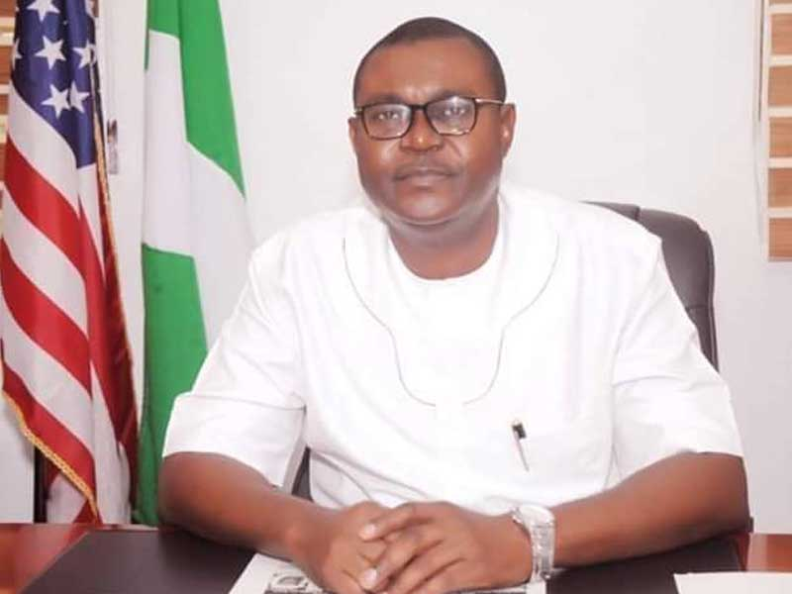
Dr Fabian Ihekweme: Former commissioner and vocal critic of Imo State Governor Hope Uzodinma, Dr Fabian Ihekweme was arrested in December 2024 by the Nigeria Police Force in Abuja following his criticism of the state governor. He was released from police custody in late January, after falling ill. According to family sources, Dr. Ihekweme suffered maltreatment during his detention, which lasted nearly two months, and after falling ill, he was not given proper treatment.
Figure 8 Dr Fabian Ihekweme was released after allegedly issuing an apology

Figure 315 Dr Fabian Ihekweme was released after allegedly issuing an apology

Figure 316 Dr Fabian Ihekweme was released after allegedly issuing an apology

Figure 317 Dr Fabian Ihekweme was released after allegedly issuing an apology

Figure 318 Dr Fabian Ihekweme was released after allegedly issuing an apology

Figure 319 Dr Fabian Ihekweme was released after allegedly issuing an apology

Figure 320 Dr Fabian Ihekweme was released after allegedly issuing an apology

Figure 321 Dr Fabian Ihekweme was released after allegedly issuing an apology

Figure 322 Dr Fabian Ihekweme was released after allegedly issuing an apology

Figure 323 Dr Fabian Ihekweme was released after allegedly issuing an apology

Figure 324 Dr Fabian Ihekweme was released after allegedly issuing an apology

Figure 325 Dr Fabian Ihekweme was released after allegedly issuing an apology

Figure 326 Dr Fabian Ihekweme was released after allegedly issuing an apology

Figure 327 Dr Fabian Ihekweme was released after allegedly issuing an apology

Figure 328 Dr Fabian Ihekweme was released after allegedly issuing an apology

Figure 329 Dr Fabian Ihekweme was released after allegedly issuing an apology

Figure 330 Dr Fabian Ihekweme was released after allegedly issuing an apology

Figure 331 Dr Fabian Ihekweme was released after allegedly issuing an apology

Figure 332 Dr Fabian Ihekweme was released after allegedly issuing an apology

Figure 333 Dr Fabian Ihekweme was released after allegedly issuing an apology

Figure 334 Dr Fabian Ihekweme was released after allegedly issuing an apology

Figure 335 Dr Fabian Ihekweme was released after allegedly issuing an apology

Figure 336 Dr Fabian Ihekweme was released after allegedly issuing an apology

Figure 337 Dr Fabian Ihekweme was released after allegedly issuing an apology

Figure 338 Dr Fabian Ihekweme was released after allegedly issuing an apology

Figure 339 Dr Fabian Ihekweme was released after allegedly issuing an apology

Figure 340 Dr Fabian Ihekweme was released after allegedly issuing an apology

Figure 341 Dr Fabian Ihekweme was released after allegedly issuing an apology

Figure 342 Dr Fabian Ihekweme was released after allegedly issuing an apology

Figure 343 Dr Fabian Ihekweme was released after allegedly issuing an apology

Figure 344 Dr Fabian Ihekweme was released after allegedly issuing an apology

Figure 345 Dr Fabian Ihekweme was released after allegedly issuing an apology

Figure 346 Dr Fabian Ihekweme was released after allegedly issuing an apology

Figure 347 Dr Fabian Ihekweme was released after allegedly issuing an apology

Figure 348 Dr Fabian Ihekweme was released after allegedly issuing an apology

Figure 349 Dr Fabian Ihekweme was released after allegedly issuing an apology

Figure 350 Dr Fabian Ihekweme was released after allegedly issuing an apology

Figure 351 Dr Fabian Ihekweme was released after allegedly issuing an apology

Figure 352 Dr Fabian Ihekweme was released after allegedly issuing an apology

Figure 353 Dr Fabian Ihekweme was released after allegedly issuing an apology

Figure 354 Dr Fabian Ihekweme was released after allegedly issuing an apology

Figure 355 Dr Fabian Ihekweme was released after allegedly issuing an apology

Figure 356 Dr Fabian Ihekweme was released after allegedly issuing an apology

Figure 357 Dr Fabian Ihekweme was released after allegedly issuing an apology

Figure 358 Dr Fabian Ihekweme was released after allegedly issuing an apology

Figure 359 Dr Fabian Ihekweme was released after allegedly issuing an apology

Figure 360 Dr Fabian Ihekweme was released after allegedly issuing an apology

Figure 361 Dr Fabian Ihekweme was released after allegedly issuing an apology

Figure 362 Dr Fabian Ihekweme was released after allegedly issuing an apology

Figure 363 Dr Fabian Ihekweme was released after allegedly issuing an apology

Figure 364 Dr Fabian Ihekweme was released after allegedly issuing an apology

Figure 365 Dr Fabian Ihekweme was released after allegedly issuing an apology

Figure 366 Dr Fabian Ihekweme was released after allegedly issuing an apology

Figure 367 Dr Fabian Ihekweme was released after allegedly issuing an apology

Figure 368 Dr Fabian Ihekweme was released after allegedly issuing an apology

Figure 369 Dr Fabian Ihekweme was released after allegedly issuing an apology

Figure 370 Dr Fabian Ihekweme was released after allegedly issuing an apology

Figure 371 Dr Fabian Ihekweme was released after allegedly issuing an apology

Figure 372 Dr Fabian Ihekweme was released after allegedly issuing an apology

Figure 373 Dr Fabian Ihekweme was released after allegedly issuing an apology

Figure 374 Dr Fabian Ihekweme was released after allegedly issuing an apology

Figure 375 Dr Fabian Ihekweme was released after allegedly issuing an apology

Figure 376 Dr Fabian Ihekweme was released after allegedly issuing an apology

Figure 377 Dr Fabian Ihekweme was released after allegedly issuing an apology

Figure 8 Dr Fabian Ihekweme was released after allegedly issuing an apology

Figure 315 Dr Fabian Ihekweme was released after allegedly issuing an apology

Figure 316 Dr Fabian Ihekweme was released after allegedly issuing an apology

Figure 317 Dr Fabian Ihekweme was released after allegedly issuing an apology

Figure 318 Dr Fabian Ihekweme was released after allegedly issuing an apology

Figure 319 Dr Fabian Ihekweme was released after allegedly issuing an apology

Figure 320 Dr Fabian Ihekweme was released after allegedly issuing an apology

Figure 321 Dr Fabian Ihekweme was released after allegedly issuing an apology

Figure 322 Dr Fabian Ihekweme was released after allegedly issuing an apology

Figure 323 Dr Fabian Ihekweme was released after allegedly issuing an apology

Figure 324 Dr Fabian Ihekweme was released after allegedly issuing an apology

Figure 325 Dr Fabian Ihekweme was released after allegedly issuing an apology

Figure 326 Dr Fabian Ihekweme was released after allegedly issuing an apology

Figure 327 Dr Fabian Ihekweme was released after allegedly issuing an apology

Figure 328 Dr Fabian Ihekweme was released after allegedly issuing an apology

Figure 329 Dr Fabian Ihekweme was released after allegedly issuing an apology

Figure 330 Dr Fabian Ihekweme was released after allegedly issuing an apology

Figure 331 Dr Fabian Ihekweme was released after allegedly issuing an apology

Figure 332 Dr Fabian Ihekweme was released after allegedly issuing an apology

Figure 333 Dr Fabian Ihekweme was released after allegedly issuing an apology

Figure 334 Dr Fabian Ihekweme was released after allegedly issuing an apology

Figure 335 Dr Fabian Ihekweme was released after allegedly issuing an apology

Figure 336 Dr Fabian Ihekweme was released after allegedly issuing an apology

Figure 337 Dr Fabian Ihekweme was released after allegedly issuing an apology

Figure 338 Dr Fabian Ihekweme was released after allegedly issuing an apology

Figure 339 Dr Fabian Ihekweme was released after allegedly issuing an apology

Figure 340 Dr Fabian Ihekweme was released after allegedly issuing an apology

Figure 341 Dr Fabian Ihekweme was released after allegedly issuing an apology

Figure 342 Dr Fabian Ihekweme was released after allegedly issuing an apology

Figure 343 Dr Fabian Ihekweme was released after allegedly issuing an apology

Figure 344 Dr Fabian Ihekweme was released after allegedly issuing an apology

Figure 345 Dr Fabian Ihekweme was released after allegedly issuing an apology

Figure 346 Dr Fabian Ihekweme was released after allegedly issuing an apology

Figure 347 Dr Fabian Ihekweme was released after allegedly issuing an apology

Figure 348 Dr Fabian Ihekweme was released after allegedly issuing an apology

Figure 349 Dr Fabian Ihekweme was released after allegedly issuing an apology

Figure 350 Dr Fabian Ihekweme was released after allegedly issuing an apology

Figure 351 Dr Fabian Ihekweme was released after allegedly issuing an apology

Figure 352 Dr Fabian Ihekweme was released after allegedly issuing an apology

Figure 353 Dr Fabian Ihekweme was released after allegedly issuing an apology

Figure 354 Dr Fabian Ihekweme was released after allegedly issuing an apology

Figure 355 Dr Fabian Ihekweme was released after allegedly issuing an apology

Figure 356 Dr Fabian Ihekweme was released after allegedly issuing an apology

Figure 357 Dr Fabian Ihekweme was released after allegedly issuing an apology

Figure 358 Dr Fabian Ihekweme was released after allegedly issuing an apology

Figure 359 Dr Fabian Ihekweme was released after allegedly issuing an apology

Figure 360 Dr Fabian Ihekweme was released after allegedly issuing an apology

Figure 361 Dr Fabian Ihekweme was released after allegedly issuing an apology

Figure 362 Dr Fabian Ihekweme was released after allegedly issuing an apology

Figure 363 Dr Fabian Ihekweme was released after allegedly issuing an apology

Figure 364 Dr Fabian Ihekweme was released after allegedly issuing an apology

Figure 365 Dr Fabian Ihekweme was released after allegedly issuing an apology

Figure 366 Dr Fabian Ihekweme was released after allegedly issuing an apology

Figure 367 Dr Fabian Ihekweme was released after allegedly issuing an apology

Figure 368 Dr Fabian Ihekweme was released after allegedly issuing an apology

Figure 369 Dr Fabian Ihekweme was released after allegedly issuing an apology

Figure 370 Dr Fabian Ihekweme was released after allegedly issuing an apology

Figure 371 Dr Fabian Ihekweme was released after allegedly issuing an apology

Figure 372 Dr Fabian Ihekweme was released after allegedly issuing an apology

Figure 373 Dr Fabian Ihekweme was released after allegedly issuing an apology

Figure 374 Dr Fabian Ihekweme was released after allegedly issuing an apology

Figure 375 Dr Fabian Ihekweme was released after allegedly issuing an apology

Figure 376 Dr Fabian Ihekweme was released after allegedly issuing an apology

Figure 377 Dr Fabian Ihekweme was released after allegedly issuing an apology
It is alleged that Dr. Ihekweme was released after he was compelled to sign a letter of apology addressed to the state governor under duress. The letter claimed that the allegations he levelled against the state governor were lies and that he pledged to be of good behavior and not falsely attack Imo Government and the Governor again.
Olamide Thomas: In early January, #EndSARS activist Abiodun Olamide Thomas, was detained in December 2024 for allegedly cursing President Bola Tinubu’s son, Seyi Tinubu, and Inspector General of Police (IGP) Kayode Egbetokun. She was released after meeting her bail conditions. She was granted a N10 million bail with one surety by an Abuja Federal High Court. In the middle of December 2024, Olamide Thomas was arrested following criticism of police brutality in Nigeria, which entailed vitriolic targeting of Seyi Tinubu and other prominent figures in law enforcement, including Inspector General of Police Kayode Egbetokun. Her arrest incited a great deal of public outrage after police denied the activist bail, claiming the IGP wanted her detained.
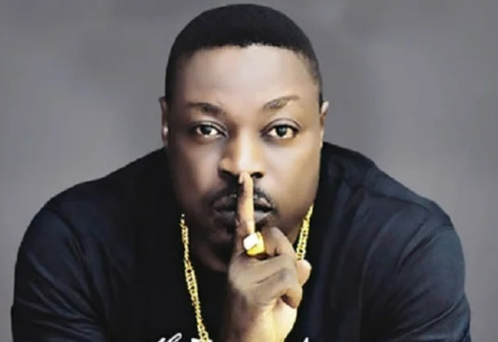
Eedris Abdulkareem: In early April, Nigerian artist Eedris Abdulkareem called on fans to stream his song “Tell Your Papa,” online, after authorities banned it from the airwaves for lyrics that were critical of President Tinubu’s management of the Nigerian economy. This development came two years into President Tinubu’s administration, which has seen major protests over rising inflation and fuel prices.
A memorandum sent to TV and radio stations by Nigeria’s National Broadcasting Commission described the content as “inappropriate for broadcast.” It also claimed the song violated a clause in the country’s broadcasting code that prohibits content that is in “breach of public decency.”
Figure 9 Eedris Abdulkareem is a Nigerian rapper

Figure 378 Eedris Abdulkareem is a Nigerian rapper

Figure 379 Eedris Abdulkareem is a Nigerian rapper

Figure 380 Eedris Abdulkareem is a Nigerian rapper

Figure 381 Eedris Abdulkareem is a Nigerian rapper

Figure 382 Eedris Abdulkareem is a Nigerian rapper

Figure 383 Eedris Abdulkareem is a Nigerian rapper

Figure 384 Eedris Abdulkareem is a Nigerian rapper

Figure 385 Eedris Abdulkareem is a Nigerian rapper

Figure 386 Eedris Abdulkareem is a Nigerian rapper

Figure 387 Eedris Abdulkareem is a Nigerian rapper

Figure 388 Eedris Abdulkareem is a Nigerian rapper

Figure 389 Eedris Abdulkareem is a Nigerian rapper

Figure 390 Eedris Abdulkareem is a Nigerian rapper

Figure 391 Eedris Abdulkareem is a Nigerian rapper

Figure 392 Eedris Abdulkareem is a Nigerian rapper

Figure 393 Eedris Abdulkareem is a Nigerian rapper

Figure 394 Eedris Abdulkareem is a Nigerian rapper

Figure 395 Eedris Abdulkareem is a Nigerian rapper

Figure 396 Eedris Abdulkareem is a Nigerian rapper

Figure 397 Eedris Abdulkareem is a Nigerian rapper

Figure 398 Eedris Abdulkareem is a Nigerian rapper

Figure 399 Eedris Abdulkareem is a Nigerian rapper

Figure 400 Eedris Abdulkareem is a Nigerian rapper

Figure 401 Eedris Abdulkareem is a Nigerian rapper

Figure 402 Eedris Abdulkareem is a Nigerian rapper

Figure 403 Eedris Abdulkareem is a Nigerian rapper

Figure 404 Eedris Abdulkareem is a Nigerian rapper

Figure 405 Eedris Abdulkareem is a Nigerian rapper

Figure 406 Eedris Abdulkareem is a Nigerian rapper

Figure 407 Eedris Abdulkareem is a Nigerian rapper

Figure 408 Eedris Abdulkareem is a Nigerian rapper

Figure 409 Eedris Abdulkareem is a Nigerian rapper

Figure 410 Eedris Abdulkareem is a Nigerian rapper

Figure 411 Eedris Abdulkareem is a Nigerian rapper

Figure 412 Eedris Abdulkareem is a Nigerian rapper

Figure 413 Eedris Abdulkareem is a Nigerian rapper

Figure 414 Eedris Abdulkareem is a Nigerian rapper

Figure 415 Eedris Abdulkareem is a Nigerian rapper

Figure 416 Eedris Abdulkareem is a Nigerian rapper

Figure 417 Eedris Abdulkareem is a Nigerian rapper

Figure 418 Eedris Abdulkareem is a Nigerian rapper

Figure 419 Eedris Abdulkareem is a Nigerian rapper

Figure 420 Eedris Abdulkareem is a Nigerian rapper

Figure 421 Eedris Abdulkareem is a Nigerian rapper

Figure 422 Eedris Abdulkareem is a Nigerian rapper

Figure 423 Eedris Abdulkareem is a Nigerian rapper

Figure 424 Eedris Abdulkareem is a Nigerian rapper

Figure 425 Eedris Abdulkareem is a Nigerian rapper

Figure 426 Eedris Abdulkareem is a Nigerian rapper

Figure 427 Eedris Abdulkareem is a Nigerian rapper

Figure 428 Eedris Abdulkareem is a Nigerian rapper

Figure 429 Eedris Abdulkareem is a Nigerian rapper

Figure 430 Eedris Abdulkareem is a Nigerian rapper

Figure 431 Eedris Abdulkareem is a Nigerian rapper

Figure 432 Eedris Abdulkareem is a Nigerian rapper

Figure 433 Eedris Abdulkareem is a Nigerian rapper

Figure 434 Eedris Abdulkareem is a Nigerian rapper

Figure 435 Eedris Abdulkareem is a Nigerian rapper

Figure 436 Eedris Abdulkareem is a Nigerian rapper

Figure 437 Eedris Abdulkareem is a Nigerian rapper

Figure 438 Eedris Abdulkareem is a Nigerian rapper

Figure 439 Eedris Abdulkareem is a Nigerian rapper

Figure 440 Eedris Abdulkareem is a Nigerian rapper

Figure 9 Eedris Abdulkareem is a Nigerian rapper

Figure 378 Eedris Abdulkareem is a Nigerian rapper

Figure 379 Eedris Abdulkareem is a Nigerian rapper

Figure 380 Eedris Abdulkareem is a Nigerian rapper

Figure 381 Eedris Abdulkareem is a Nigerian rapper

Figure 382 Eedris Abdulkareem is a Nigerian rapper

Figure 383 Eedris Abdulkareem is a Nigerian rapper

Figure 384 Eedris Abdulkareem is a Nigerian rapper

Figure 385 Eedris Abdulkareem is a Nigerian rapper

Figure 386 Eedris Abdulkareem is a Nigerian rapper

Figure 387 Eedris Abdulkareem is a Nigerian rapper

Figure 388 Eedris Abdulkareem is a Nigerian rapper

Figure 389 Eedris Abdulkareem is a Nigerian rapper

Figure 390 Eedris Abdulkareem is a Nigerian rapper

Figure 391 Eedris Abdulkareem is a Nigerian rapper

Figure 392 Eedris Abdulkareem is a Nigerian rapper

Figure 393 Eedris Abdulkareem is a Nigerian rapper

Figure 394 Eedris Abdulkareem is a Nigerian rapper

Figure 395 Eedris Abdulkareem is a Nigerian rapper

Figure 396 Eedris Abdulkareem is a Nigerian rapper

Figure 397 Eedris Abdulkareem is a Nigerian rapper

Figure 398 Eedris Abdulkareem is a Nigerian rapper

Figure 399 Eedris Abdulkareem is a Nigerian rapper

Figure 400 Eedris Abdulkareem is a Nigerian rapper

Figure 401 Eedris Abdulkareem is a Nigerian rapper

Figure 402 Eedris Abdulkareem is a Nigerian rapper

Figure 403 Eedris Abdulkareem is a Nigerian rapper

Figure 404 Eedris Abdulkareem is a Nigerian rapper

Figure 405 Eedris Abdulkareem is a Nigerian rapper

Figure 406 Eedris Abdulkareem is a Nigerian rapper

Figure 407 Eedris Abdulkareem is a Nigerian rapper

Figure 408 Eedris Abdulkareem is a Nigerian rapper

Figure 409 Eedris Abdulkareem is a Nigerian rapper

Figure 410 Eedris Abdulkareem is a Nigerian rapper

Figure 411 Eedris Abdulkareem is a Nigerian rapper

Figure 412 Eedris Abdulkareem is a Nigerian rapper

Figure 413 Eedris Abdulkareem is a Nigerian rapper

Figure 414 Eedris Abdulkareem is a Nigerian rapper

Figure 415 Eedris Abdulkareem is a Nigerian rapper

Figure 416 Eedris Abdulkareem is a Nigerian rapper

Figure 417 Eedris Abdulkareem is a Nigerian rapper

Figure 418 Eedris Abdulkareem is a Nigerian rapper

Figure 419 Eedris Abdulkareem is a Nigerian rapper

Figure 420 Eedris Abdulkareem is a Nigerian rapper

Figure 421 Eedris Abdulkareem is a Nigerian rapper

Figure 422 Eedris Abdulkareem is a Nigerian rapper

Figure 423 Eedris Abdulkareem is a Nigerian rapper

Figure 424 Eedris Abdulkareem is a Nigerian rapper

Figure 425 Eedris Abdulkareem is a Nigerian rapper

Figure 426 Eedris Abdulkareem is a Nigerian rapper

Figure 427 Eedris Abdulkareem is a Nigerian rapper

Figure 428 Eedris Abdulkareem is a Nigerian rapper

Figure 429 Eedris Abdulkareem is a Nigerian rapper

Figure 430 Eedris Abdulkareem is a Nigerian rapper

Figure 431 Eedris Abdulkareem is a Nigerian rapper

Figure 432 Eedris Abdulkareem is a Nigerian rapper

Figure 433 Eedris Abdulkareem is a Nigerian rapper

Figure 434 Eedris Abdulkareem is a Nigerian rapper

Figure 435 Eedris Abdulkareem is a Nigerian rapper

Figure 436 Eedris Abdulkareem is a Nigerian rapper

Figure 437 Eedris Abdulkareem is a Nigerian rapper

Figure 438 Eedris Abdulkareem is a Nigerian rapper

Figure 439 Eedris Abdulkareem is a Nigerian rapper

Figure 440 Eedris Abdulkareem is a Nigerian rapper
The Afrobeats track is addressed to the president’s son, Seyi Tinubu, who recently said his father was the greatest leader in Nigeria’s history. In the lyrics, Eedris Abdulkareem calls on him to tell his father that “people are dying” from economic hardship and insecurity caused by armed groups in Nigeria.

2.5 Togo
Gross human rights violations continue as tensions mount between the government and the opposition over the controversial new constitution that transitioned the Togolese state from a presidential to a parliamentary democracy. Independent media has been suppressed with suspensions, while journalists have been arrested, detained and prosecuted for publications deemed offensive by the government. Opposition figures and government critics wallow in detention for sentiments and ideas expressed online.
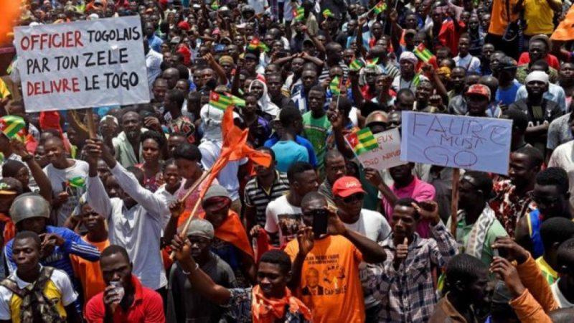
In popular protests that saw security forces kill at least 7 people, 10 by some counts, the government has assaulted, arrested and tortured scores of people including HRDs, opposition members, journalists, and ordinary protesters. The government maintains its crackdown on accusations of poor governance and suppression of opposition to the controversial constitutional reforms that effectively extended Faure Gnassingbé’s hold on power.
Figure 4410 Protestors troop to the streets of Lome, Togo to demand regime change
Monsieur Sokpor Sitsopé Honoré: On January 12, 2025, Mr. Sokpor Sitsopé Honoré, who also goes by Affectio or Koffi Agbenoxevi Godwin on Facebook, was assaulted and abducted by police officers in plainclothes at the “La Pampa” crossroads in Adidogomé. His assault and abduction was in connection to his critical social media posts, especially a poem titled “Do your part,” in which he urges Togolese citizens to take action to crack “the walls of this austere power and break the chains of injustice.” Despite passionate calls and protests for his release, he remains in detention as his trial proceeds.
The recent protests in Togo: Widespread and popular anger with the most recent effort by the Gnassingbé dynasty to extend its grip on power and subdue opposition, had been building since the announcement of the constitutional review in 2024. The success of that review saw Togo transition from a presidential to a parliamentary democracy. In a bid to contain the expected backlash, the government maintained severe restrictions on the civic space. Demonstrations have been rare in Togo since 2022, after they were banned in the country following a deadly attack at Lome’s main market. But a flamboyant $34m memorial service that was held for the late Eyadéma, at a time when most Togolese were struggling to make ends meet, combined with the swearing-in in May of Faure Gnassingbé under the new term-unlimited designation of President of the Council of Ministers, aggravated public outrage.
After rapper Aamron was arrested on May 26, following his calls for a protest to mark the president’s forthcoming birthday, people took to the streets to protest against a government crackdown on dissent and opposition, the cost-of-living crisis and a new constitution was that was designed to enable the current President of the Council of Ministers, Faure Gnassingbé, to maintain an indefinite grip on power. The protests were endorsed by large segments of Togolese society, including artists and bloggers, and protesters braved unlawful arrests, torture, and physical assault to demand change. A week following massive protests on June 5 and June 6, fifty-six of the protesters detained were released, while others were detained for prosecutorial purposes. Aamron was released on June 21.
Further protests re-echoing the protesters’ demands and calling for the release of their detained protesters took place on June 26, 27 and 28, in the wake of words of solidarity and encouragement from the Togolese diaspora encouragement to the protesters. In Lomé and other towns, including the opposition stronghold of Bè, protesters erected barricades, burned tyres, and chanted slogans like “Libérez Aamron!” and “Togo Libre!” In response, security forces descended on the crowd with tear gas in a heavy-handed crackdown, arresting dozens of demonstrators while military jeeps patrolled the capital. In a passive gesture that is said to have reflected both the fear of repression and solidarity with the protesters, many businesses and markets shut down. The arrests and assaults escalated following the protests on June 26, 27 and 28, with at least 3 people were reported dead. Eighteen of the protesters arrested on June 26, 27 and 28 had been released as of June 30, and 31 were still being held in custody following hearings before the public prosecutor.
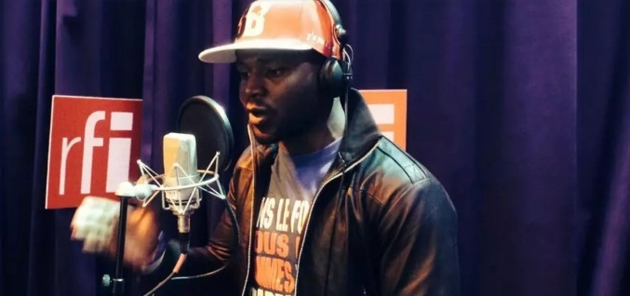
Aamron: According to several testimonies and press releases from civil society, between 9 p.m. and 11 p.m on the night of May 26, 2025, around fifty heavily armed security personnel barged into the home of Togolese rapper Aamron (real name Essowè Narcisse Tchalla), in Assiyéyé, a northern suburb of Lomé, and arrested him without a warrant. His arrest followed a social media rant which was typical of his usual criticism of the Gnassingbe regime. He called on the citizens of Togo to hand President Gnassingbe a special gift on his birthday by going on a protest. His arrest and detention, which saw no charges levelled against him, incited outrage that sparked massive protests on June 5 and 6 and saw the arrest of more than 80 people.
Figure 11442 Aamron is a popular Togolese rapper

Figure 443Aamron is a popular Togolese rapper

Figure 444Aamron is a popular Togolese rapper

Figure 445Aamron is a popular Togolese rapper

Figure 446Aamron is a popular Togolese rapper

Figure 447Aamron is a popular Togolese rapper

Figure 448Aamron is a popular Togolese rapper

Figure 449Aamron is a popular Togolese rapper

Figure 450Aamron is a popular Togolese rapper

Figure 451Aamron is a popular Togolese rapper

Figure 452Aamron is a popular Togolese rapper

Figure 453Aamron is a popular Togolese rapper

Figure 454Aamron is a popular Togolese rapper

Figure 455Aamron is a popular Togolese rapper

Figure 456Aamron is a popular Togolese rapper

Figure 457Aamron is a popular Togolese rapper

Figure 458Aamron is a popular Togolese rapper

Figure 459Aamron is a popular Togolese rapper

Figure 460Aamron is a popular Togolese rapper

Figure 461Aamron is a popular Togolese rapper

Figure 462Aamron is a popular Togolese rapper

Figure 463Aamron is a popular Togolese rapper

Figure 464Aamron is a popular Togolese rapper

Figure 465Aamron is a popular Togolese rapper

Figure 466Aamron is a popular Togolese rapper

Figure 467Aamron is a popular Togolese rapper

Figure 468Aamron is a popular Togolese rapper

Figure 469Aamron is a popular Togolese rapper

Figure 470Aamron is a popular Togolese rapper

Figure 471Aamron is a popular Togolese rapper

Figure 472Aamron is a popular Togolese rapper

Figure 473Aamron is a popular Togolese rapper

Figure 474Aamron is a popular Togolese rapper

Figure 475Aamron is a popular Togolese rapper

Figure 476Aamron is a popular Togolese rapper

Figure 477Aamron is a popular Togolese rapper

Figure 478Aamron is a popular Togolese rapper

Figure 479Aamron is a popular Togolese rapper

Figure 480Aamron is a popular Togolese rapper

Figure 481Aamron is a popular Togolese rapper

Figure 482Aamron is a popular Togolese rapper

Figure 483Aamron is a popular Togolese rapper

Figure 484Aamron is a popular Togolese rapper

Figure 485Aamron is a popular Togolese rapper

Figure 486Aamron is a popular Togolese rapper

Figure 487Aamron is a popular Togolese rapper

Figure 488Aamron is a popular Togolese rapper

Figure 489Aamron is a popular Togolese rapper

Figure 490Aamron is a popular Togolese rapper

Figure 491Aamron is a popular Togolese rapper

Figure 492Aamron is a popular Togolese rapper

Figure 493Aamron is a popular Togolese rapper

Figure 494Aamron is a popular Togolese rapper

Figure 495Aamron is a popular Togolese rapper

Figure 496Aamron is a popular Togolese rapper

Figure 497Aamron is a popular Togolese rapper

Figure 498Aamron is a popular Togolese rapper

Figure 499Aamron is a popular Togolese rapper

Figure 500Aamron is a popular Togolese rapper

Figure 501Aamron is a popular Togolese rapper

Figure 502Aamron is a popular Togolese rapper

Figure 503Aamron is a popular Togolese rapper

Figure 504Aamron is a popular Togolese rapper

Figure 505Aamron is a popular Togolese rapper

Figure 11442 Aamron is a popular Togolese rapper

Figure 443Aamron is a popular Togolese rapper

Figure 444Aamron is a popular Togolese rapper

Figure 445Aamron is a popular Togolese rapper

Figure 446Aamron is a popular Togolese rapper

Figure 447Aamron is a popular Togolese rapper

Figure 448Aamron is a popular Togolese rapper

Figure 449Aamron is a popular Togolese rapper

Figure 450Aamron is a popular Togolese rapper

Figure 451Aamron is a popular Togolese rapper

Figure 452Aamron is a popular Togolese rapper

Figure 453Aamron is a popular Togolese rapper

Figure 454Aamron is a popular Togolese rapper

Figure 455Aamron is a popular Togolese rapper

Figure 456Aamron is a popular Togolese rapper

Figure 457Aamron is a popular Togolese rapper

Figure 458Aamron is a popular Togolese rapper

Figure 459Aamron is a popular Togolese rapper

Figure 460Aamron is a popular Togolese rapper

Figure 461Aamron is a popular Togolese rapper

Figure 462Aamron is a popular Togolese rapper

Figure 463Aamron is a popular Togolese rapper

Figure 464Aamron is a popular Togolese rapper

Figure 465Aamron is a popular Togolese rapper

Figure 466Aamron is a popular Togolese rapper

Figure 467Aamron is a popular Togolese rapper

Figure 468Aamron is a popular Togolese rapper

Figure 469Aamron is a popular Togolese rapper

Figure 470Aamron is a popular Togolese rapper

Figure 471Aamron is a popular Togolese rapper

Figure 472Aamron is a popular Togolese rapper

Figure 473Aamron is a popular Togolese rapper

Figure 474Aamron is a popular Togolese rapper

Figure 475Aamron is a popular Togolese rapper

Figure 476Aamron is a popular Togolese rapper

Figure 477Aamron is a popular Togolese rapper

Figure 478Aamron is a popular Togolese rapper

Figure 479Aamron is a popular Togolese rapper

Figure 480Aamron is a popular Togolese rapper

Figure 481Aamron is a popular Togolese rapper

Figure 482Aamron is a popular Togolese rapper

Figure 483Aamron is a popular Togolese rapper

Figure 484Aamron is a popular Togolese rapper

Figure 485Aamron is a popular Togolese rapper

Figure 486Aamron is a popular Togolese rapper

Figure 487Aamron is a popular Togolese rapper

Figure 488Aamron is a popular Togolese rapper

Figure 489Aamron is a popular Togolese rapper

Figure 490Aamron is a popular Togolese rapper

Figure 491Aamron is a popular Togolese rapper

Figure 492Aamron is a popular Togolese rapper

Figure 493Aamron is a popular Togolese rapper

Figure 494Aamron is a popular Togolese rapper

Figure 495Aamron is a popular Togolese rapper

Figure 496Aamron is a popular Togolese rapper

Figure 497Aamron is a popular Togolese rapper

Figure 498Aamron is a popular Togolese rapper

Figure 499Aamron is a popular Togolese rapper

Figure 500Aamron is a popular Togolese rapper

Figure 501Aamron is a popular Togolese rapper

Figure 502Aamron is a popular Togolese rapper

Figure 503Aamron is a popular Togolese rapper

Figure 504Aamron is a popular Togolese rapper

Figure 505Aamron is a popular Togolese rapper
On June 5, a day before the president’s birthday, Aamron appeared in a video in which he apologized to the president, claiming his earlier call was as a result of severe depression for which he was being treated. He called on the youth to refrain from any actions that could land them in trouble with the law. But the video did not dissuade the protesters, who insist Aamron was of sound mind as at the time of his arrest and was forced into psychiatric internment. His comments in the video were believed to have been made under duress. Following the release of the vast majority of the protesters arrested during the June 5 and 6 protests, Aamron was released on June 21.
Dr Ayitevi Firmin Elom Hounou-Adossi: As part of several demonstrations held in Togo on June 6, 2025 – the birthday of President of the Council of Ministers, Faure Gnassingbe – to protest against the quality of governance and the economic conditions in Togo, members of the National Order of Physicians of Togo (ONMT), staged a demonstration demanding improved conditions of service for health workers across the country. Dr. Hounou-Adossi, who, ahead of the protests, had been very vocal about the poor conditions of service of health workers across the country, was arrested during the protest. He was detained, and charged alongside two other health professionals and several other protesters. Following further protests, health workers denounced his arrest and demanded his release and that of several others. He was released on June 9, 2025.

2.6 Guinea Bissau
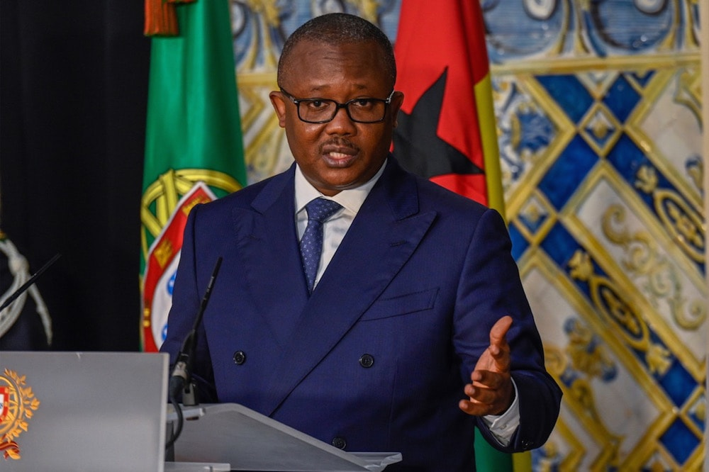
Amid the heightened political wrangling with the opposition and even members of his own cabinet, President Sissoco continues to preside over significant civic space restrictions, including government threats against protest organizers and rising repression of journalists. The Guinean Human Rights League (LGDH) reports that more than 120 people were tortured in Guinea Bissau in 2024, including activists, opposition figures and dissenters. A growing number of citizens have been observed leaving the country in recent years due to low pay and poor working conditions, coupled with the lack of employment policies for recent graduates.
Ahead of the general elections scheduled for November 23, 2025, recurrent physical attacks, believed to be politically motivated, have been reported to have been launched against perceived government critics and dissenters. A ban on protests instituted since January 2024 remains in force and the two most prominent civil society coalitions in the country were recently declared illegal. Their criminalisation comes following a protest that was planned by the two organisations: Pô di Terra and Frente Popular platforms. The protest was to call for democratic reforms ahead of the November 2025 general elections. Police prevented protesters from gathering and four activists were arrested and subsequently tortured.
Appointments to Guinea-Bissau’s Supreme Court of Justice are critical to the forthcoming general elections in the country. A series of controversial developments that marred elections to the Supreme Court are believed to be meant to tilt the results in the government’s favour. Opposition party leaders and civil society organizations have also accused sitting President Sissoco of using state resources to conduct a election campaign at a time when political parties are prohibited from holding events that gather large crowds. This comes in the wake of severe monetary challenges which confront the state and have adversely impacted critical sectors like health and education.
Meanwhile, a summary of the UN Human Rights Committee’s June 2025 review in Geneva, commended judicial reform laws while raising concerns over FGM, torture allegations by law enforcement, and weak enforcement in practice.

2.7 Guinea
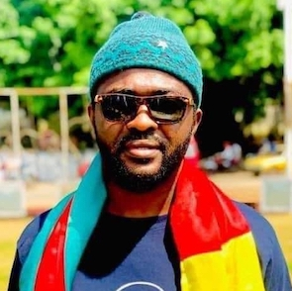
Civic space restrictions continue to escalate in Guinea following the enforced disappearances of prominent opposition activists Mamadou Billo Bah and Oumar Sylla last year. Severe restrictions on media have been accompanied by a vicious clampdown on criticism and dissent. These restrictions have seen several journalists assaulted and arrested during recent protests. In the wake of the failure of the military junta to hold elections and complete a democratic transition by the end of 2024, tensions with the opposition have been mounting, triggering protests that have disrupted stability in the resource-rich country. The imprisonment of opposition leader Aliou Bah for his criticism of the junta, depicts the repression that opposition figures continue to suffer under the transitional government. Reports by civil society and international rights organisations show a climate of fear that is marked by arbitrary detentions, harassment, and intimidation of rights defenders.
Figure 12 Oumar Sylla has not been seen since his disappearance

Figure 506 Oumar Sylla has not been seen since his disappearance

Figure 507 Oumar Sylla has not been seen since his disappearance

Figure 508 Oumar Sylla has not been seen since his disappearance

Figure 509 Oumar Sylla has not been seen since his disappearance

Figure 510 Oumar Sylla has not been seen since his disappearance

Figure 511 Oumar Sylla has not been seen since his disappearance

Figure 512 Oumar Sylla has not been seen since his disappearance

Figure 513 Oumar Sylla has not been seen since his disappearance

Figure 514 Oumar Sylla has not been seen since his disappearance

Figure 515 Oumar Sylla has not been seen since his disappearance

Figure 516 Oumar Sylla has not been seen since his disappearance

Figure 517 Oumar Sylla has not been seen since his disappearance

Figure 518 Oumar Sylla has not been seen since his disappearance

Figure 519 Oumar Sylla has not been seen since his disappearance

Figure 520 Oumar Sylla has not been seen since his disappearance

Figure 521 Oumar Sylla has not been seen since his disappearance

Figure 522 Oumar Sylla has not been seen since his disappearance

Figure 523 Oumar Sylla has not been seen since his disappearance

Figure 524 Oumar Sylla has not been seen since his disappearance

Figure 525 Oumar Sylla has not been seen since his disappearance

Figure 526 Oumar Sylla has not been seen since his disappearance

Figure 527 Oumar Sylla has not been seen since his disappearance

Figure 528 Oumar Sylla has not been seen since his disappearance

Figure 529 Oumar Sylla has not been seen since his disappearance

Figure 530 Oumar Sylla has not been seen since his disappearance

Figure 531 Oumar Sylla has not been seen since his disappearance

Figure 532 Oumar Sylla has not been seen since his disappearance

Figure 533 Oumar Sylla has not been seen since his disappearance

Figure 534 Oumar Sylla has not been seen since his disappearance

Figure 535 Oumar Sylla has not been seen since his disappearance

Figure 536 Oumar Sylla has not been seen since his disappearance

Figure 537 Oumar Sylla has not been seen since his disappearance

Figure 538 Oumar Sylla has not been seen since his disappearance

Figure 539 Oumar Sylla has not been seen since his disappearance

Figure 540 Oumar Sylla has not been seen since his disappearance

Figure 541 Oumar Sylla has not been seen since his disappearance

Figure 542 Oumar Sylla has not been seen since his disappearance

Figure 543 Oumar Sylla has not been seen since his disappearance

Figure 544 Oumar Sylla has not been seen since his disappearance

Figure 545 Oumar Sylla has not been seen since his disappearance

Figure 546 Oumar Sylla has not been seen since his disappearance

Figure 547 Oumar Sylla has not been seen since his disappearance

Figure 548 Oumar Sylla has not been seen since his disappearance

Figure 549 Oumar Sylla has not been seen since his disappearance

Figure 550 Oumar Sylla has not been seen since his disappearance

Figure 551 Oumar Sylla has not been seen since his disappearance

Figure 552 Oumar Sylla has not been seen since his disappearance

Figure 553 Oumar Sylla has not been seen since his disappearance

Figure 554 Oumar Sylla has not been seen since his disappearance

Figure 555 Oumar Sylla has not been seen since his disappearance

Figure 556 Oumar Sylla has not been seen since his disappearance

Figure 557 Oumar Sylla has not been seen since his disappearance

Figure 558 Oumar Sylla has not been seen since his disappearance

Figure 559 Oumar Sylla has not been seen since his disappearance

Figure 560 Oumar Sylla has not been seen since his disappearance

Figure 561 Oumar Sylla has not been seen since his disappearance

Figure 562 Oumar Sylla has not been seen since his disappearance

Figure 563 Oumar Sylla has not been seen since his disappearance

Figure 564 Oumar Sylla has not been seen since his disappearance

Figure 565 Oumar Sylla has not been seen since his disappearance

Figure 566 Oumar Sylla has not been seen since his disappearance

Figure 567 Oumar Sylla has not been seen since his disappearance

Figure 568 Oumar Sylla has not been seen since his disappearance

Figure 12 Oumar Sylla has not been seen since his disappearance

Figure 506 Oumar Sylla has not been seen since his disappearance

Figure 507 Oumar Sylla has not been seen since his disappearance

Figure 508 Oumar Sylla has not been seen since his disappearance

Figure 509 Oumar Sylla has not been seen since his disappearance

Figure 510 Oumar Sylla has not been seen since his disappearance

Figure 511 Oumar Sylla has not been seen since his disappearance

Figure 512 Oumar Sylla has not been seen since his disappearance

Figure 513 Oumar Sylla has not been seen since his disappearance

Figure 514 Oumar Sylla has not been seen since his disappearance

Figure 515 Oumar Sylla has not been seen since his disappearance

Figure 516 Oumar Sylla has not been seen since his disappearance

Figure 517 Oumar Sylla has not been seen since his disappearance

Figure 518 Oumar Sylla has not been seen since his disappearance

Figure 519 Oumar Sylla has not been seen since his disappearance

Figure 520 Oumar Sylla has not been seen since his disappearance

Figure 521 Oumar Sylla has not been seen since his disappearance

Figure 522 Oumar Sylla has not been seen since his disappearance

Figure 523 Oumar Sylla has not been seen since his disappearance

Figure 524 Oumar Sylla has not been seen since his disappearance

Figure 525 Oumar Sylla has not been seen since his disappearance

Figure 526 Oumar Sylla has not been seen since his disappearance

Figure 527 Oumar Sylla has not been seen since his disappearance

Figure 528 Oumar Sylla has not been seen since his disappearance

Figure 529 Oumar Sylla has not been seen since his disappearance

Figure 530 Oumar Sylla has not been seen since his disappearance

Figure 531 Oumar Sylla has not been seen since his disappearance

Figure 532 Oumar Sylla has not been seen since his disappearance

Figure 533 Oumar Sylla has not been seen since his disappearance

Figure 534 Oumar Sylla has not been seen since his disappearance

Figure 535 Oumar Sylla has not been seen since his disappearance

Figure 536 Oumar Sylla has not been seen since his disappearance

Figure 537 Oumar Sylla has not been seen since his disappearance

Figure 538 Oumar Sylla has not been seen since his disappearance

Figure 539 Oumar Sylla has not been seen since his disappearance

Figure 540 Oumar Sylla has not been seen since his disappearance

Figure 541 Oumar Sylla has not been seen since his disappearance

Figure 542 Oumar Sylla has not been seen since his disappearance

Figure 543 Oumar Sylla has not been seen since his disappearance

Figure 544 Oumar Sylla has not been seen since his disappearance

Figure 545 Oumar Sylla has not been seen since his disappearance

Figure 546 Oumar Sylla has not been seen since his disappearance

Figure 547 Oumar Sylla has not been seen since his disappearance

Figure 548 Oumar Sylla has not been seen since his disappearance

Figure 549 Oumar Sylla has not been seen since his disappearance

Figure 550 Oumar Sylla has not been seen since his disappearance

Figure 551 Oumar Sylla has not been seen since his disappearance

Figure 552 Oumar Sylla has not been seen since his disappearance

Figure 553 Oumar Sylla has not been seen since his disappearance

Figure 554 Oumar Sylla has not been seen since his disappearance

Figure 555 Oumar Sylla has not been seen since his disappearance

Figure 556 Oumar Sylla has not been seen since his disappearance

Figure 557 Oumar Sylla has not been seen since his disappearance

Figure 558 Oumar Sylla has not been seen since his disappearance

Figure 559 Oumar Sylla has not been seen since his disappearance

Figure 560 Oumar Sylla has not been seen since his disappearance

Figure 561 Oumar Sylla has not been seen since his disappearance

Figure 562 Oumar Sylla has not been seen since his disappearance

Figure 563 Oumar Sylla has not been seen since his disappearance

Figure 564 Oumar Sylla has not been seen since his disappearance

Figure 565 Oumar Sylla has not been seen since his disappearance

Figure 566 Oumar Sylla has not been seen since his disappearance

Figure 567 Oumar Sylla has not been seen since his disappearance

Figure 568 Oumar Sylla has not been seen since his disappearance
Abdoul Latif Diallo: On January 27, 2025, investigative news website Depecheguinee.com, founded by investigative journalist Abdoul Latif Diallo, was banned by Guinea’s High Authority for Communication (HAC). This followed the website’s publication of an opinion piece by a contributor named Samir Moussa, titled “Guinea: Mamadi Doumbouya or the Curse of Power.” The HAC described the piece as containing elements of “incitement to insurrection and disruption of public order.” Following repeated sanctions levelled against him by the media regulator, Diallo has reportedly fled into exile.
Habib Marouane Camara: Around 8 pm on December 3, 2024, in Conakry, Habib Marouane Camara, a social media influencer and owner and manager of the news website Le Révélateur 224, was stopped at Carrefour KPC on his way to a meeting with businessman Kerfalla Camara, according to witnesses. Sources indicate that his vehicle was intercepted by a police truck and its windshield was smashed. He was violently assaulted before being taken to an unknown destination. No summons or judicial warrant was presented at the time of his arrest. Since this event, no official information has been provided as to where he is being held or charges have been levelled against him.
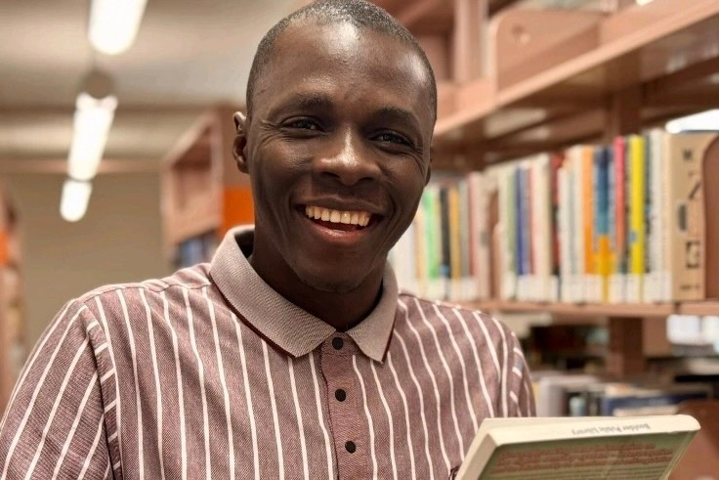
As of June, 2025, 94 African journalists and 11 press freedom organisations had joined RSF in calling on the Guinean authorities to shed light on his fate. While no reasons have been offered for his abduction, Camara is a very outspoken media critic of Guinea’s military government. He often questioned the military authorities and, in particular, raised the issue of the enforced disappearances of activists Foniké Menguè and Mamadou Billo Bah in his Facebook posts. Earlier in May 2024, a show on Djoma TV and Djoma FM that was associated with him, was banned from broadcasting. A few days before his abduction, the journalist’s lawyers said he had “received threats of imminent kidnapping from a group of unknown individuals.”
Figure 13 Guinean journalist, Habib Marouane Camara

Figure 569 Guinean journalist, Habib Marouane Camara

Figure 570 Guinean journalist, Habib Marouane Camara

Figure 571 Guinean journalist, Habib Marouane Camara

Figure 572 Guinean journalist, Habib Marouane Camara

Figure 573 Guinean journalist, Habib Marouane Camara

Figure 574 Guinean journalist, Habib Marouane Camara

Figure 575 Guinean journalist, Habib Marouane Camara

Figure 576 Guinean journalist, Habib Marouane Camara

Figure 577 Guinean journalist, Habib Marouane Camara

Figure 578 Guinean journalist, Habib Marouane Camara

Figure 579 Guinean journalist, Habib Marouane Camara

Figure 580 Guinean journalist, Habib Marouane Camara

Figure 581 Guinean journalist, Habib Marouane Camara

Figure 582 Guinean journalist, Habib Marouane Camara

Figure 583 Guinean journalist, Habib Marouane Camara

Figure 584 Guinean journalist, Habib Marouane Camara

Figure 585 Guinean journalist, Habib Marouane Camara

Figure 586 Guinean journalist, Habib Marouane Camara

Figure 587 Guinean journalist, Habib Marouane Camara

Figure 588 Guinean journalist, Habib Marouane Camara

Figure 589 Guinean journalist, Habib Marouane Camara

Figure 590 Guinean journalist, Habib Marouane Camara

Figure 591 Guinean journalist, Habib Marouane Camara

Figure 592 Guinean journalist, Habib Marouane Camara

Figure 593 Guinean journalist, Habib Marouane Camara

Figure 594 Guinean journalist, Habib Marouane Camara

Figure 595 Guinean journalist, Habib Marouane Camara

Figure 596 Guinean journalist, Habib Marouane Camara

Figure 597 Guinean journalist, Habib Marouane Camara

Figure 598 Guinean journalist, Habib Marouane Camara

Figure 599 Guinean journalist, Habib Marouane Camara

Figure 600 Guinean journalist, Habib Marouane Camara

Figure 601 Guinean journalist, Habib Marouane Camara

Figure 602 Guinean journalist, Habib Marouane Camara

Figure 603 Guinean journalist, Habib Marouane Camara

Figure 604 Guinean journalist, Habib Marouane Camara

Figure 605 Guinean journalist, Habib Marouane Camara

Figure 606 Guinean journalist, Habib Marouane Camara

Figure 607 Guinean journalist, Habib Marouane Camara

Figure 608 Guinean journalist, Habib Marouane Camara

Figure 609 Guinean journalist, Habib Marouane Camara

Figure 610 Guinean journalist, Habib Marouane Camara

Figure 611 Guinean journalist, Habib Marouane Camara

Figure 612 Guinean journalist, Habib Marouane Camara

Figure 613 Guinean journalist, Habib Marouane Camara

Figure 614 Guinean journalist, Habib Marouane Camara

Figure 615 Guinean journalist, Habib Marouane Camara

Figure 616 Guinean journalist, Habib Marouane Camara

Figure 617 Guinean journalist, Habib Marouane Camara

Figure 618 Guinean journalist, Habib Marouane Camara

Figure 619 Guinean journalist, Habib Marouane Camara

Figure 620 Guinean journalist, Habib Marouane Camara

Figure 621 Guinean journalist, Habib Marouane Camara

Figure 622 Guinean journalist, Habib Marouane Camara

Figure 623 Guinean journalist, Habib Marouane Camara

Figure 624 Guinean journalist, Habib Marouane Camara

Figure 625 Guinean journalist, Habib Marouane Camara

Figure 626 Guinean journalist, Habib Marouane Camara

Figure 627 Guinean journalist, Habib Marouane Camara

Figure 628 Guinean journalist, Habib Marouane Camara

Figure 629 Guinean journalist, Habib Marouane Camara

Figure 630 Guinean journalist, Habib Marouane Camara

Figure 631 Guinean journalist, Habib Marouane Camara

Figure 13 Guinean journalist, Habib Marouane Camara

Figure 569 Guinean journalist, Habib Marouane Camara

Figure 570 Guinean journalist, Habib Marouane Camara

Figure 571 Guinean journalist, Habib Marouane Camara

Figure 572 Guinean journalist, Habib Marouane Camara

Figure 573 Guinean journalist, Habib Marouane Camara

Figure 574 Guinean journalist, Habib Marouane Camara

Figure 575 Guinean journalist, Habib Marouane Camara

Figure 576 Guinean journalist, Habib Marouane Camara

Figure 577 Guinean journalist, Habib Marouane Camara

Figure 578 Guinean journalist, Habib Marouane Camara

Figure 579 Guinean journalist, Habib Marouane Camara

Figure 580 Guinean journalist, Habib Marouane Camara

Figure 581 Guinean journalist, Habib Marouane Camara

Figure 582 Guinean journalist, Habib Marouane Camara

Figure 583 Guinean journalist, Habib Marouane Camara

Figure 584 Guinean journalist, Habib Marouane Camara

Figure 585 Guinean journalist, Habib Marouane Camara

Figure 586 Guinean journalist, Habib Marouane Camara

Figure 587 Guinean journalist, Habib Marouane Camara

Figure 588 Guinean journalist, Habib Marouane Camara

Figure 589 Guinean journalist, Habib Marouane Camara

Figure 590 Guinean journalist, Habib Marouane Camara

Figure 591 Guinean journalist, Habib Marouane Camara

Figure 592 Guinean journalist, Habib Marouane Camara

Figure 593 Guinean journalist, Habib Marouane Camara

Figure 594 Guinean journalist, Habib Marouane Camara

Figure 595 Guinean journalist, Habib Marouane Camara

Figure 596 Guinean journalist, Habib Marouane Camara

Figure 597 Guinean journalist, Habib Marouane Camara

Figure 598 Guinean journalist, Habib Marouane Camara

Figure 599 Guinean journalist, Habib Marouane Camara

Figure 600 Guinean journalist, Habib Marouane Camara

Figure 601 Guinean journalist, Habib Marouane Camara

Figure 602 Guinean journalist, Habib Marouane Camara

Figure 603 Guinean journalist, Habib Marouane Camara

Figure 604 Guinean journalist, Habib Marouane Camara

Figure 605 Guinean journalist, Habib Marouane Camara

Figure 606 Guinean journalist, Habib Marouane Camara

Figure 607 Guinean journalist, Habib Marouane Camara

Figure 608 Guinean journalist, Habib Marouane Camara

Figure 609 Guinean journalist, Habib Marouane Camara

Figure 610 Guinean journalist, Habib Marouane Camara

Figure 611 Guinean journalist, Habib Marouane Camara

Figure 612 Guinean journalist, Habib Marouane Camara

Figure 613 Guinean journalist, Habib Marouane Camara

Figure 614 Guinean journalist, Habib Marouane Camara

Figure 615 Guinean journalist, Habib Marouane Camara

Figure 616 Guinean journalist, Habib Marouane Camara

Figure 617 Guinean journalist, Habib Marouane Camara

Figure 618 Guinean journalist, Habib Marouane Camara

Figure 619 Guinean journalist, Habib Marouane Camara

Figure 620 Guinean journalist, Habib Marouane Camara

Figure 621 Guinean journalist, Habib Marouane Camara

Figure 622 Guinean journalist, Habib Marouane Camara

Figure 623 Guinean journalist, Habib Marouane Camara

Figure 624 Guinean journalist, Habib Marouane Camara

Figure 625 Guinean journalist, Habib Marouane Camara

Figure 626 Guinean journalist, Habib Marouane Camara

Figure 627 Guinean journalist, Habib Marouane Camara

Figure 628 Guinean journalist, Habib Marouane Camara

Figure 629 Guinean journalist, Habib Marouane Camara

Figure 630 Guinean journalist, Habib Marouane Camara

Figure 631 Guinean journalist, Habib Marouane Camara
Abdoul Sacko: At 4 a.m., on February 19, 2025, gunmen broke into the home of prominent civil society leader, Abdoul Sacko, beat him in front of his family, seized his phone, and took him away in a pick-up truck without license plates. Known for his criticism of the military junta, Sacko is the coordinator of the Guinean Social Forces’ Forum (Forum des Forces Sociales de Guinée, or FFSG), a civil society network calling for a return to the country’s constitutional order in Guinea. Sacko’s abduction raised concerns about an enforced disappearance. On February 20, 2025, Sacko’s lawyers released a statement saying that their client had been found 100 kilometers from Conakry, dotted with severe injuries and signs of torture. He was taken to a local hospital. Given his high profile, Sacko’s abduction sent shockwaves across Guinea and abroad. On February 19, the United States embassy in Guinea released a statement urging the government to “swiftly investigate the incident,” and denouncing the “uptick in detentions targeting journalists and civil society leaders.”
Toumany Camara: On April 28, 2025, the HAC suspended the news website, www.presseinvestigation.com for three months and withdrew Camara’s press card over that period, barring him from practicing journalism until July 28, 2025. He was suspended after releasing a publication in which he reported that Ms. Beavogui—former General Manager of Guinea Alumina Corporation (GAC), a company reportedly shut down by Guinean authorities for noncompliance—had been appointed Country Manager of Predictive Discovery, a mining company which is seeking a gold mining permit in the UNESCO-protected Haut Niger National Park.
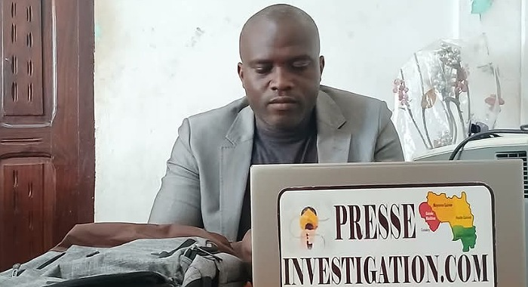
The article warned of potential compliance risks to the company and the extensive environmental risks if mining is permitted in the park. Camara’s investigation brought to the fore the grave threat to the park’s fragile ecosystem, home to endangered species and the source of the Niger River. As Guinea’s largest nature reserve and a conservation priority for the West African sub-region, the park plays a vital ecological role that could be jeopardised by extractive operations. The HAC concluded that Camara had failed to provide evidence supporting his claims against Ms. Beavogui and had not given her a chance to respond to the allegations. The regulator proceeded with separate sanctions on the journalist and his website on these grounds.
Figure 14 Guinean authorities banned Toumany Camara from operating his news website

Figure 632 Guinean authorities banned Toumany Camara from operating his news website

Figure 633 Guinean authorities banned Toumany Camara from operating his news website

Figure 634 Guinean authorities banned Toumany Camara from operating his news website

Figure 635 Guinean authorities banned Toumany Camara from operating his news website

Figure 636 Guinean authorities banned Toumany Camara from operating his news website

Figure 637 Guinean authorities banned Toumany Camara from operating his news website

Figure 638 Guinean authorities banned Toumany Camara from operating his news website

Figure 639 Guinean authorities banned Toumany Camara from operating his news website

Figure 640 Guinean authorities banned Toumany Camara from operating his news website

Figure 641 Guinean authorities banned Toumany Camara from operating his news website

Figure 642 Guinean authorities banned Toumany Camara from operating his news website

Figure 643 Guinean authorities banned Toumany Camara from operating his news website

Figure 644 Guinean authorities banned Toumany Camara from operating his news website

Figure 645 Guinean authorities banned Toumany Camara from operating his news website

Figure 646 Guinean authorities banned Toumany Camara from operating his news website

Figure 647 Guinean authorities banned Toumany Camara from operating his news website

Figure 648 Guinean authorities banned Toumany Camara from operating his news website

Figure 649 Guinean authorities banned Toumany Camara from operating his news website

Figure 650 Guinean authorities banned Toumany Camara from operating his news website

Figure 651 Guinean authorities banned Toumany Camara from operating his news website

Figure 652 Guinean authorities banned Toumany Camara from operating his news website

Figure 653 Guinean authorities banned Toumany Camara from operating his news website

Figure 654 Guinean authorities banned Toumany Camara from operating his news website

Figure 655 Guinean authorities banned Toumany Camara from operating his news website

Figure 656 Guinean authorities banned Toumany Camara from operating his news website

Figure 657 Guinean authorities banned Toumany Camara from operating his news website

Figure 658 Guinean authorities banned Toumany Camara from operating his news website

Figure 659 Guinean authorities banned Toumany Camara from operating his news website

Figure 660 Guinean authorities banned Toumany Camara from operating his news website

Figure 661 Guinean authorities banned Toumany Camara from operating his news website

Figure 662 Guinean authorities banned Toumany Camara from operating his news website

Figure 663 Guinean authorities banned Toumany Camara from operating his news website

Figure 664 Guinean authorities banned Toumany Camara from operating his news website

Figure 665 Guinean authorities banned Toumany Camara from operating his news website

Figure 666 Guinean authorities banned Toumany Camara from operating his news website

Figure 667 Guinean authorities banned Toumany Camara from operating his news website

Figure 668 Guinean authorities banned Toumany Camara from operating his news website

Figure 669 Guinean authorities banned Toumany Camara from operating his news website

Figure 670 Guinean authorities banned Toumany Camara from operating his news website

Figure 671 Guinean authorities banned Toumany Camara from operating his news website

Figure 672 Guinean authorities banned Toumany Camara from operating his news website

Figure 673 Guinean authorities banned Toumany Camara from operating his news website

Figure 674 Guinean authorities banned Toumany Camara from operating his news website

Figure 675 Guinean authorities banned Toumany Camara from operating his news website

Figure 676 Guinean authorities banned Toumany Camara from operating his news website

Figure 677 Guinean authorities banned Toumany Camara from operating his news website

Figure 678 Guinean authorities banned Toumany Camara from operating his news website

Figure 679 Guinean authorities banned Toumany Camara from operating his news website

Figure 680 Guinean authorities banned Toumany Camara from operating his news website

Figure 681 Guinean authorities banned Toumany Camara from operating his news website

Figure 682 Guinean authorities banned Toumany Camara from operating his news website

Figure 683 Guinean authorities banned Toumany Camara from operating his news website

Figure 684 Guinean authorities banned Toumany Camara from operating his news website

Figure 685 Guinean authorities banned Toumany Camara from operating his news website

Figure 686 Guinean authorities banned Toumany Camara from operating his news website

Figure 687 Guinean authorities banned Toumany Camara from operating his news website

Figure 688 Guinean authorities banned Toumany Camara from operating his news website
14
Figure 689 Guinean authorities banned Toumany Camara from operating his news website

Figure 690 Guinean authorities banned Toumany Camara from operating his news website

Figure 691 Guinean authorities banned Toumany Camara from operating his news website

Figure 692 Guinean authorities banned Toumany Camara from operating his news website

Figure 693 Guinean authorities banned Toumany Camara from operating his news website

Figure 694 Guinean authorities banned Toumany Camara from operating his news website

Figure 14 Guinean authorities banned Toumany Camara from operating his news website

Figure 632 Guinean authorities banned Toumany Camara from operating his news website

Figure 633 Guinean authorities banned Toumany Camara from operating his news website

Figure 634 Guinean authorities banned Toumany Camara from operating his news website

Figure 635 Guinean authorities banned Toumany Camara from operating his news website

Figure 636 Guinean authorities banned Toumany Camara from operating his news website

Figure 637 Guinean authorities banned Toumany Camara from operating his news website

Figure 638 Guinean authorities banned Toumany Camara from operating his news website

Figure 639 Guinean authorities banned Toumany Camara from operating his news website

Figure 640 Guinean authorities banned Toumany Camara from operating his news website

Figure 641 Guinean authorities banned Toumany Camara from operating his news website

Figure 642 Guinean authorities banned Toumany Camara from operating his news website

Figure 643 Guinean authorities banned Toumany Camara from operating his news website

Figure 644 Guinean authorities banned Toumany Camara from operating his news website

Figure 645 Guinean authorities banned Toumany Camara from operating his news website

Figure 646 Guinean authorities banned Toumany Camara from operating his news website

Figure 647 Guinean authorities banned Toumany Camara from operating his news website

Figure 648 Guinean authorities banned Toumany Camara from operating his news website

Figure 649 Guinean authorities banned Toumany Camara from operating his news website

Figure 650 Guinean authorities banned Toumany Camara from operating his news website

Figure 651 Guinean authorities banned Toumany Camara from operating his news website

Figure 652 Guinean authorities banned Toumany Camara from operating his news website

Figure 653 Guinean authorities banned Toumany Camara from operating his news website

Figure 654 Guinean authorities banned Toumany Camara from operating his news website

Figure 655 Guinean authorities banned Toumany Camara from operating his news website

Figure 656 Guinean authorities banned Toumany Camara from operating his news website

Figure 657 Guinean authorities banned Toumany Camara from operating his news website

Figure 658 Guinean authorities banned Toumany Camara from operating his news website

Figure 659 Guinean authorities banned Toumany Camara from operating his news website

Figure 660 Guinean authorities banned Toumany Camara from operating his news website

Figure 661 Guinean authorities banned Toumany Camara from operating his news website

Figure 662 Guinean authorities banned Toumany Camara from operating his news website

Figure 663 Guinean authorities banned Toumany Camara from operating his news website

Figure 664 Guinean authorities banned Toumany Camara from operating his news website

Figure 665 Guinean authorities banned Toumany Camara from operating his news website

Figure 666 Guinean authorities banned Toumany Camara from operating his news website

Figure 667 Guinean authorities banned Toumany Camara from operating his news website

Figure 668 Guinean authorities banned Toumany Camara from operating his news website

Figure 669 Guinean authorities banned Toumany Camara from operating his news website

Figure 670 Guinean authorities banned Toumany Camara from operating his news website

Figure 671 Guinean authorities banned Toumany Camara from operating his news website

Figure 672 Guinean authorities banned Toumany Camara from operating his news website

Figure 673 Guinean authorities banned Toumany Camara from operating his news website

Figure 674 Guinean authorities banned Toumany Camara from operating his news website

Figure 675 Guinean authorities banned Toumany Camara from operating his news website

Figure 676 Guinean authorities banned Toumany Camara from operating his news website

Figure 677 Guinean authorities banned Toumany Camara from operating his news website

Figure 678 Guinean authorities banned Toumany Camara from operating his news website

Figure 679 Guinean authorities banned Toumany Camara from operating his news website

Figure 680 Guinean authorities banned Toumany Camara from operating his news website

Figure 681 Guinean authorities banned Toumany Camara from operating his news website

Figure 682 Guinean authorities banned Toumany Camara from operating his news website

Figure 683 Guinean authorities banned Toumany Camara from operating his news website

Figure 684 Guinean authorities banned Toumany Camara from operating his news website

Figure 685 Guinean authorities banned Toumany Camara from operating his news website

Figure 686 Guinean authorities banned Toumany Camara from operating his news website

Figure 687 Guinean authorities banned Toumany Camara from operating his news website

Figure 688 Guinean authorities banned Toumany Camara from operating his news website
14
Figure 689 Guinean authorities banned Toumany Camara from operating his news website

Figure 690 Guinean authorities banned Toumany Camara from operating his news website

Figure 691 Guinean authorities banned Toumany Camara from operating his news website

Figure 692 Guinean authorities banned Toumany Camara from operating his news website

Figure 693 Guinean authorities banned Toumany Camara from operating his news website

Figure 694 Guinean authorities banned Toumany Camara from operating his news website
Dr Faya Millimono: On 20 February, Dr Faya Millimono, president of the opposition party Bloc Libéral (BL), told journalists at a press conference which he had in fact called for that day, that he had been forced to cancel the press conference after receiving a death threat that same day. He did not reveal the identity of the perpetrators of the threat, but the serious tone in which he spoke struck a chord with those present. Following the military coup in Guinea in September 2021, Millimono threw his support behind the military government. However, he became highly critical of the CNRD (Comité National du Rassemblement pour le Développement) regularly expressing his concerns about the progress of the democratic transition and other issues, through press conferences. The MFWA has called on the Guinean authorities to take all necessary measures to ensure the safety of Dr. Faya Millimono and his right to freedom of expression.

2.8 Sierra Leone
Following closely on the trail of the botched presidential elections of 2023 and the upheaval it caused in the country, the controversial National Counter-Terrorism Act of 2024, described by the government as a necessary and robust response to both domestic and global security threats, has drawn criticism for criminalizing journalistic work and dissent with penalties of up to 30 years in prison. In the wake of these concerns, Sierra Leone has experienced several civic space violations and attacks on human rights defenders, particularly those targeting journalists and online voices. Already, there are emerging reports of worsening press freedom conditions, with increasing use of cybercrime laws to silence dissent. Civil society and the media have documented a pattern of arbitrary arrests, legislative overreach, and physical intimidation creating a climate of fear for activists and civil society.
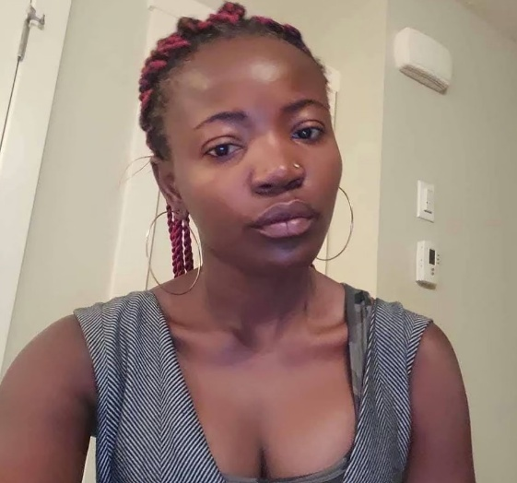
Hawa Hunt: Hawa Hunt, a Canadian and Sierra Leonean dual citizen, was arrested on 22 December, 2024, while starring in House of Stars, a reality TV show. Her arrest was for comments she made on social media about the president of Sierra Leone and the first lady in May 2023. In a 25-minute video, Hunt, a 42-year-old fitness and wellbeing influencer with more than 100,000 followers across Facebook, TikTok and Instagram, criticized Julius and Fatima Maada Bio. Slapping her with two counts of “transmitting insulting messages via a computer system” under the Cybersecurity and Crime Act 2021, prosecutors claimed the video incited public disorder and damaged the reputation of the president and his wife.
Figure 15 Hawa Hunt was accused of defaming the President and his wife
After multiple requests for bail had been denied, she appeared in a video on 28 December, apologising to the president and first lady. She said she was being treated well and that the police had handled everything professionally. However, her daughter as well as several human rights activists believed this was a forced confession and that she might have been facing physical abuse while being held in Pademba Road prison in Freetown. Following three months’ detention and prosecution, Ms. Hunt was released and her Canadian and Sierra Leonean passports which had been confiscated as part of legal proceedings, were returned to her.
Melvin Tejan Mansaray: On January 10, 2025, Melvin Tejan Mansaray, was slapped with an indefinite ban from parliament by the Speaker of Sierra Leone’s Parliament, Rt. Hon. Segepoh Solomon. The ban, which took immediate effect, was announced on the floor of Parliament by the Speaker himself without due process. Speaker Thomas accused Mansaray of an “insulting conduct,” alleging that the journalist called Members of Parliament (MPs) “useless” and accused the Speaker of rigging a parliamentary election without any evidence to substantiate his claims.
He justified the expulsion as a warning to other journalists covering legislative proceedings. He declared, “This is my Chamber. I have the authority to allow you to be here or not.” No evidence was provided to back his accusations. Neither were the names of the individuals who he claimed had reported Mansaray’s alleged comments to him provided. Following his accusations, the Speaker proceeded to expel Mansaray from the precincts of Parliament and ordered his immediate removal. The actions of the Speaker have been condemned by the Sierra Leone Association of Journalists and the Media Foundation for West Africa. The African Parliamentary Press Network (APPN) have all criticised the conduct of the speaker as heavy-handed, troubling and inimical to press freedom.

2.9 Benin
Despite calls for reform, the political and legal environment in Benin remains hostile to press freedom and public dissent. This has been evident in the concerning extradition and trial of two journalists who were seeking asylum in Togo and the suspension of independent media outlets under the Beninese digital code. On March 12, the news website Bénin Web TV was suspended and the managing director’s press card, withdrawn. The High Authority for Audiovisual and Communication (HAAC) accused the media outlet of publishing two articles containing inaccurate information: one concerning alleged errors in the budget request submitted by the HAAC to Parliament, the other, concerning the request for a company car by the institution’s president.
This incident is indicative of what has been noted as an increased suppression of the freedom of expression and protests in the wake of growing anti-French sentiments following recent terrorist attacks. The newspaper Le Patriote and its website were similarly sanctioned after the publication of an editorial pointing out ‘the government’s ineffective strategy’ during an attack on a military position in the border zone between Burkina Faso and Niger. But Le Patriote is only one of the six media outlets to have encountered this fate. On January 21, 2025, the HAAC suspended two newspapers and four news websites, accusing them of unauthorised publications and not being in good standing. All the suspensions were “until further notice.” The newspapers in question are L’Audace Infos, whose managing editor, Romuald Alingo, had his press card withdrawn and Le Patriote, whose website was also suspended. The online media outlets included “Reporter Médias Monde”, “Crystal News”, “Les Pharaons” and the Tik Tok account “Madame Actu”. The suspension of Bénin Web TV and Le Patriote have since been lifted.
During the 2025 International Workers’ Day celebrations in Benin, police stormed a peaceful workers’ assembly organized by the Confédération Syndicale des Travailleurs du Bénin (CSTB), arresting the union’s leadership in what has been widely condemned as a brutal and arbitrary crackdown on trade union rights. The arrests triggered immediate condemnation from union federations and civil society organizations across the country. A groundswell of national and international solidarity followed, with unions such as COSI-Benin, CGTB, and UNSTB visiting the detained comrades in custody and issuing statements of support. Though the arrested unionists were released later that same evening, the CSTB maintains that their arrest was an egregious violation of both national and international labor laws.
Hugues Comlan Sossoukpè: The unfortunate case of journalist and human rights defender Hugues Comlan Sossoukpè who was forcibly extradited from Côte d’Ivoire and detained in Benin, raises serious human rights concerns. As a political refugee in Togo since 2021, known for his investigations into the Beninese authorities, he had been invited to Abidjan by the Ivorian authorities on a professional mission. He was arrested in his hotel room, before being deported on a private plane to Cotonou, where he was immediately incarcerated. In the wake of these developments, his extradition has been condemned by many human rights and media organizations, including the Committee to Protect Journalists (CPJ) and Reporters Without Borders (RSF). In the wake of his incarceration, it has been suggested that his extradition may have been a gesture of goodwill by the Ivorian government to mend its fraught relationship with the Beninese government.
Steve Amoussou: The case of Hugues Comlan Sossoukpè bears unsettling similarities to that of Steve Amoussou, who was found guilty by the Court for the Repression of Economic Offences and Terrorism (CRIET) on June 2, 2025, and slapped with a two-year sentence and a 2-million-franc fine for cyberbullying, incitement to rebellion, and spreading false news and insults against a political group. This sentence comes after Steve Amoussou, a Beninese national who had gone into exile in Togo since 2019, was abducted in front of his Lomé residence by four individuals and sent back to Benin. Amoussou, is suspected of owning and running “Frère Hounvi,” a social media account that posted viral audio commentaries critical of the Talon administration to its 75,000 subscribers. He was charged with ‘harassment through electronic means’, ‘initiation and publication of false information through social networks’ and ‘direct provocation to rebellion’. His charges would later be reclassified to ‘cyberbullying,’ ‘incitement to rebellion’ and ‘spreading false news and insults against a political group.’ While Amoussou denies being behind “Frère Hounvi,” Media Foundation West Africa (MFWA) points out that it should neither be a criminal offence to create or manage a digital platform, nor punishable for citizens to express critical views about their government and public policies. His lawyers insist his conviction was a miscarriage of justice, absent of any real evidence of his guilt. However, following Amoussou’s abduction, two of the three kidnappers prosecuted by the CRIET in Benin for his abduction were sentenced to a year’s imprisonment each as well as a 5-million-franc fine, while arrest warrants were issued against four individuals in Togo, including a woman and a student, in connection with his abduction.

2.10 Liberia
While freedoms of speech, expression and association are duly regarded, the Liberian civic space has been marred by a lack of progress and episodes of repression. Journalists and defenders of press freedom have encountered harassment and intimidation in the form of unlawful detention and physical assault. Despite the renewal of the executive order establishing it, the Office of the War and Economic Crimes Court (OWEC) has not yet lived up to the civil war era of accountability it promised. Recent months have seen a palpable determination on the part of citizens to assert their rights and demand an end to unemployment, corruption, poor governance and lack of accountability on the part of the government.
This determination has recurrently materialized in a recent series of protests. However, youthful protesters hitting the streets to demand reforms in health rights, accountability, and governance risked arrests in the wake of heavy policing and other bureaucratic barriers to public assembly. While civil society remains vibrant, HRDs and the civic space exist in a political environment where state actions alternate between symbolic reconciliation gestures and measures that constrain civic freedoms.
Bai Best and David Yates: On January 6, 2025, Daily Observer Managing Director Bai S.G. Best and reporter David A. Yates were invited to the headquarters of the Liberian National Police (LNP) in relation to a report they published on the death of the Boulevard Palace Hotel's General Manager, Anwar Futloo. The police, who were not enthused with the release of the report, accused the duo of derailing their investigation into the death of the deceased. They threatened them with arrest and subjected them to hours of detention. Yates was required to fill out a form labeling him as a "person of interest" and to write a statement without legal counsel present. When the duo returned to the LNP headquarters three days later, after being forced to sign a copy of their report and a bond to the effect that they will return when summoned, they were also surprised to learn that Yates' designation on an official questionnaire he had been asked to fill had changed from "person of interest" to "suspect" – without any explanation. It was only after they had been subjected to a tedious hour of questioning that the duo and their legal representatives were allowed to leave. Despite the outrage the story sparked among media professionals, the Press Union of Liberia (PUL) and civil society advocates, an official complaint lodged with the Inspector General of the LNP is yet to trigger any action.

2.11 Senegal
On April 3, 2025, the Senegalese parliament approved revisions removing amnesty for specific crimes, including murder, torture and forced disappearance under the 2024 Amnesty Law. Signed into law amid the violent protests that trailed suspicions that then President Macky Sall was angling for a third term, the 2024 Amnesty Law granted amnesty for offences committed by both security forces and protesters during deadly opposition protests in the country.
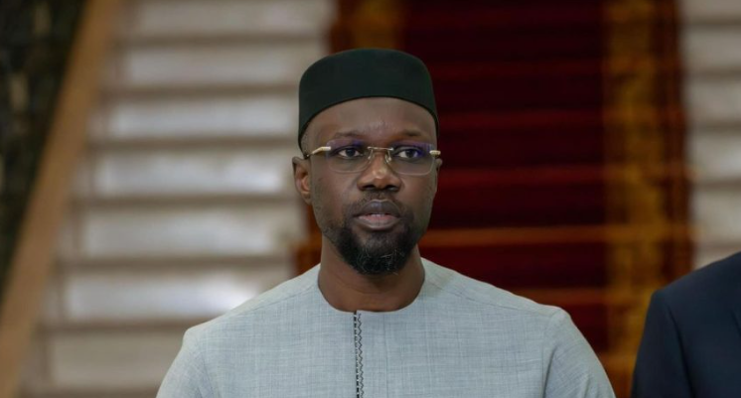
The Prime Minister Sonko reignited concerns about freedom of speech in the country with the declaration of a ‘zero tolerance’ criminal policy for the dissemination of fake news. Increasingly, critics point to the growing repression of press freedom under the Faye-Sonko government and how, increasingly, the government has clamped down on dissent by weaponizing the Press Code and the criminal charge of ‘disseminating false news’ against journalists.
Figure 16 Senegal Prime Minister, Osman Sonko

Figure 695 Senegal Prime Minister, Osman Sonko

Figure 696 Senegal Prime Minister, Osman Sonko

Figure 697 Senegal Prime Minister, Osman Sonko

Figure 698 Senegal Prime Minister, Osman Sonko

Figure 699 Senegal Prime Minister, Osman Sonko

Figure 700 Senegal Prime Minister, Osman Sonko

Figure 701 Senegal Prime Minister, Osman Sonko

Figure 702 Senegal Prime Minister, Osman Sonko

Figure 703 Senegal Prime Minister, Osman Sonko

Figure 704 Senegal Prime Minister, Osman Sonko

Figure 705 Senegal Prime Minister, Osman Sonko

Figure 706 Senegal Prime Minister, Osman Sonko

Figure 707 Senegal Prime Minister, Osman Sonko

Figure 708 Senegal Prime Minister, Osman Sonko

Figure 709 Senegal Prime Minister, Osman Sonko

Figure 710 Senegal Prime Minister, Osman Sonko

Figure 711 Senegal Prime Minister, Osman Sonko

Figure 712 Senegal Prime Minister, Osman Sonko

Figure 713 Senegal Prime Minister, Osman Sonko

Figure 714 Senegal Prime Minister, Osman Sonko

Figure 715 Senegal Prime Minister, Osman Sonko

Figure 716 Senegal Prime Minister, Osman Sonko

Figure 717 Senegal Prime Minister, Osman Sonko

Figure 718 Senegal Prime Minister, Osman Sonko

Figure 719 Senegal Prime Minister, Osman Sonko

Figure 720 Senegal Prime Minister, Osman Sonko

Figure 721 Senegal Prime Minister, Osman Sonko

Figure 722 Senegal Prime Minister, Osman Sonko

Figure 723 Senegal Prime Minister, Osman Sonko

Figure 724 Senegal Prime Minister, Osman Sonko

Figure 725 Senegal Prime Minister, Osman Sonko

Figure 726 Senegal Prime Minister, Osman Sonko

Figure 727 Senegal Prime Minister, Osman Sonko

Figure 728 Senegal Prime Minister, Osman Sonko

Figure 729 Senegal Prime Minister, Osman Sonko

Figure 730 Senegal Prime Minister, Osman Sonko

Figure 731 Senegal Prime Minister, Osman Sonko

Figure 732 Senegal Prime Minister, Osman Sonko

Figure 733 Senegal Prime Minister, Osman Sonko

Figure 734 Senegal Prime Minister, Osman Sonko

Figure 735 Senegal Prime Minister, Osman Sonko

Figure 736 Senegal Prime Minister, Osman Sonko

Figure 737 Senegal Prime Minister, Osman Sonko

Figure 738 Senegal Prime Minister, Osman Sonko

Figure 739 Senegal Prime Minister, Osman Sonko

Figure 740 Senegal Prime Minister, Osman Sonko

Figure 741 Senegal Prime Minister, Osman Sonko

Figure 742 Senegal Prime Minister, Osman Sonko

Figure 743 Senegal Prime Minister, Osman Sonko

Figure 744 Senegal Prime Minister, Osman Sonko

Figure 745 Senegal Prime Minister, Osman Sonko

Figure 746 Senegal Prime Minister, Osman Sonko

Figure 747 Senegal Prime Minister, Osman Sonko

Figure 748 Senegal Prime Minister, Osman Sonko

Figure 749 Senegal Prime Minister, Osman Sonko

Figure 750 Senegal Prime Minister, Osman Sonko

Figure 751 Senegal Prime Minister, Osman Sonko

Figure 752 Senegal Prime Minister, Osman Sonko

Figure 753 Senegal Prime Minister, Osman Sonko

Figure 754 Senegal Prime Minister, Osman Sonko

Figure 755 Senegal Prime Minister, Osman Sonko

Figure 756 Senegal Prime Minister, Osman Sonko

Figure 757 Senegal Prime Minister, Osman Sonko

Figure 16 Senegal Prime Minister, Osman Sonko

Figure 695 Senegal Prime Minister, Osman Sonko

Figure 696 Senegal Prime Minister, Osman Sonko

Figure 697 Senegal Prime Minister, Osman Sonko

Figure 698 Senegal Prime Minister, Osman Sonko

Figure 699 Senegal Prime Minister, Osman Sonko

Figure 700 Senegal Prime Minister, Osman Sonko

Figure 701 Senegal Prime Minister, Osman Sonko

Figure 702 Senegal Prime Minister, Osman Sonko

Figure 703 Senegal Prime Minister, Osman Sonko

Figure 704 Senegal Prime Minister, Osman Sonko

Figure 705 Senegal Prime Minister, Osman Sonko

Figure 706 Senegal Prime Minister, Osman Sonko

Figure 707 Senegal Prime Minister, Osman Sonko

Figure 708 Senegal Prime Minister, Osman Sonko

Figure 709 Senegal Prime Minister, Osman Sonko

Figure 710 Senegal Prime Minister, Osman Sonko

Figure 711 Senegal Prime Minister, Osman Sonko

Figure 712 Senegal Prime Minister, Osman Sonko

Figure 713 Senegal Prime Minister, Osman Sonko

Figure 714 Senegal Prime Minister, Osman Sonko

Figure 715 Senegal Prime Minister, Osman Sonko

Figure 716 Senegal Prime Minister, Osman Sonko

Figure 717 Senegal Prime Minister, Osman Sonko

Figure 718 Senegal Prime Minister, Osman Sonko

Figure 719 Senegal Prime Minister, Osman Sonko

Figure 720 Senegal Prime Minister, Osman Sonko

Figure 721 Senegal Prime Minister, Osman Sonko

Figure 722 Senegal Prime Minister, Osman Sonko

Figure 723 Senegal Prime Minister, Osman Sonko

Figure 724 Senegal Prime Minister, Osman Sonko

Figure 725 Senegal Prime Minister, Osman Sonko

Figure 726 Senegal Prime Minister, Osman Sonko

Figure 727 Senegal Prime Minister, Osman Sonko

Figure 728 Senegal Prime Minister, Osman Sonko

Figure 729 Senegal Prime Minister, Osman Sonko

Figure 730 Senegal Prime Minister, Osman Sonko

Figure 731 Senegal Prime Minister, Osman Sonko

Figure 732 Senegal Prime Minister, Osman Sonko

Figure 733 Senegal Prime Minister, Osman Sonko

Figure 734 Senegal Prime Minister, Osman Sonko

Figure 735 Senegal Prime Minister, Osman Sonko

Figure 736 Senegal Prime Minister, Osman Sonko

Figure 737 Senegal Prime Minister, Osman Sonko

Figure 738 Senegal Prime Minister, Osman Sonko

Figure 739 Senegal Prime Minister, Osman Sonko

Figure 740 Senegal Prime Minister, Osman Sonko

Figure 741 Senegal Prime Minister, Osman Sonko

Figure 742 Senegal Prime Minister, Osman Sonko

Figure 743 Senegal Prime Minister, Osman Sonko

Figure 744 Senegal Prime Minister, Osman Sonko

Figure 745 Senegal Prime Minister, Osman Sonko

Figure 746 Senegal Prime Minister, Osman Sonko

Figure 747 Senegal Prime Minister, Osman Sonko

Figure 748 Senegal Prime Minister, Osman Sonko

Figure 749 Senegal Prime Minister, Osman Sonko

Figure 750 Senegal Prime Minister, Osman Sonko

Figure 751 Senegal Prime Minister, Osman Sonko

Figure 752 Senegal Prime Minister, Osman Sonko

Figure 753 Senegal Prime Minister, Osman Sonko

Figure 754 Senegal Prime Minister, Osman Sonko

Figure 755 Senegal Prime Minister, Osman Sonko

Figure 756 Senegal Prime Minister, Osman Sonko

Figure 757 Senegal Prime Minister, Osman Sonko
Civil society observes that this is in contrast to the manifesto pledge by Faye that the Senegalese government under him would abolish prison sentences for press offences. There is a sentiment that the government’s conduct toward the press is reminiscent of the dark years of the Macky Sall regime, which weaponized Article 254 of the Criminal Code, criminalizing the offence of insulting the Head of State.
On June 10, 2025, former Member of Parliament Moustapha Diakhaté was detained at the Criminal Investigation Division (DIC) after being summoned and questioned for comments made in the press, denouncing what he calls a "monopoly of political space", which he attributes to Ousmane Sonko and the "Sonkolâtres". After being prosecuted for “offending the Head of State and a person exercising all or part of the powers of the Head of State,” he was released, after a court sentenced him to two months and fifteen days’ imprisonment on July 30, 2025, for insulting the Head of State. He was acquitted on the charge of insulting a person exercising one or all of the prerogatives of the President of the Republic.
On July 11, the Minister of African Integration and Foreign Affairs, Yacine Fall, issued a stern warning against a scheduled screening of a film on LGBTQI+ rights, stating that "Senegal accepts no form of propaganda and promotion of the LGBTQI phenomenon,” and warning the public that the Senegalese government “reserves the right to take any appropriate action against any organizers of such activities and even against participants, regardless of their origins, status or rank, in accordance with the legal and regulatory provisions in force." In response, the Dutch Embassy and the Regional Office of the United Nations High Commissioner for Human Rights (OHCHR) were forced to cancel the screening of the LGBTQIA-themed film. This comes amid growing agitations by special interest groups advocating for tougher legislation against homosexuality, has parliament again debating whether to stiffen penalties for homosexual activity.
Simon Faye: On April 10, 2025, Simon Pierre Faye, the editor-in-chief of Zik FM associated with SenTV, was arrested by Senegalese authorities, following a post on Zik FM’s official Facebook page, in which he shared an article from the Afrique Confidentielle website entitled "Political crisis in Senegal: Ouattara summons Ousmane Sonko to Abidjan.” His arrest and detention were part of an investigation into the publication that was sanctioned by the public prosecutor a day after SenTV relayed the publication. Following an appearance before the court on charges of spreading false news, he was placed under judicial supervision and released on bail on April 14, 2025, yet a judicial investigation has now been opened against him. Faye’s story sparked outrage across Senegalese civil society and human rights organizations who condemned his arrest as evidence of growing repression of civil freedoms and called for constitutional and legal reforms to better protect freedom of the press and freedom of expression. On the day of his release, Prime Minister Ousmane Sonko, in a question and answer session at the National Assembly, declared a ‘zero tolerance’ criminal policy regarding excesses on social media.
In the wake of this development, Media Foundation West Africa (MFWA) has called on Senegalese authorities to defer issues about media conduct and content to the statutory media regulator, The Conseil National de Régulation de l’Audiovisuel and to also apply the principle of fairness to all in every situation to avoid raising doubts about the motive and intention that informs their actions.
Abdou Nguer and Pape Amadou Ndiaye Diaw: On April 14, 2025, journalist and SEN TV columnist, Abdou Nguer and two of his colleagues, Oumar Ndiaye and Fatima Coulibaly, were called for questioning by the Colobane Police Division. While Oumar and Fatima were released after hours of interrogation, Abdou Nguer was taken into custody. Nguer’s detention was in connection with a post on the Tik Tok account “Abdou Nguer Seul.” The post the President of Senegal’s Constitutional Council, Mamadou Badio Camara, who succumbed to illness on April 10, 2025 and read, “the people demand an autopsy on the deceased Badio Camara.”
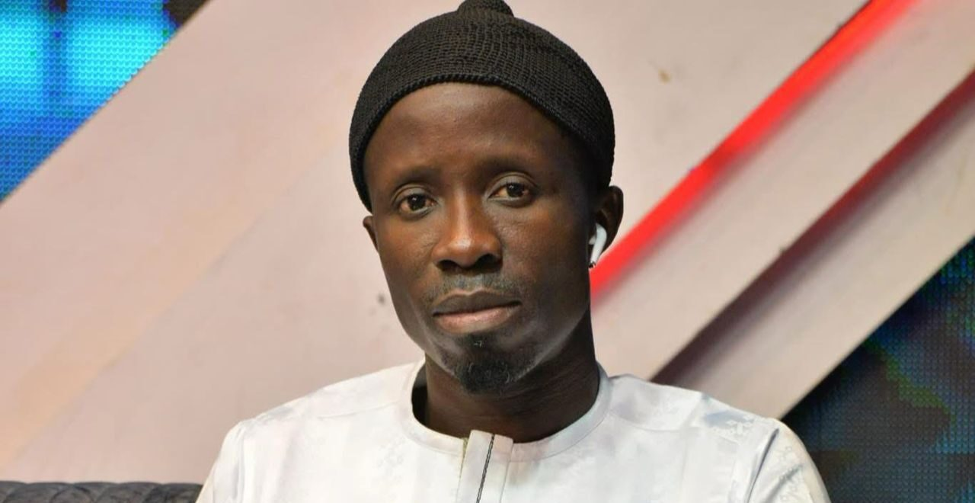
Following claims by Abdou that he was neither the author of the said post nor the owner of the account, Pape Amadou Ndiaye Diaw, a self-professed admirer of the journalist, was identified by the police and admitted to being the actual owner of the incriminated TikTok account. On April 17, 2025, after being presented to the investigating judge of the third chamber of the Dakar court, a legal investigation was opened against the two men. Several court appearances later, despite several appeals for a provisional release, Abdou Nguer and Pape Amadou Ndiaye Diaw remain in police custody.
Figure 17 Abdou Nguer still remains in police custody

Figure 758 Abdou Nguer still remains in police custody

Figure 759 Abdou Nguer still remains in police custody

Figure 760 Abdou Nguer still remains in police custody

Figure 761 Abdou Nguer still remains in police custody

Figure 762 Abdou Nguer still remains in police custody

Figure 763 Abdou Nguer still remains in police custody

Figure 764 Abdou Nguer still remains in police custody

Figure 765 Abdou Nguer still remains in police custody

Figure 766 Abdou Nguer still remains in police custody

Figure 767 Abdou Nguer still remains in police custody

Figure 768 Abdou Nguer still remains in police custody

Figure 769 Abdou Nguer still remains in police custody

Figure 770 Abdou Nguer still remains in police custody

Figure 771 Abdou Nguer still remains in police custody

Figure 772 Abdou Nguer still remains in police custody

Figure 773 Abdou Nguer still remains in police custody

Figure 774 Abdou Nguer still remains in police custody

Figure 775 Abdou Nguer still remains in police custody

Figure 776 Abdou Nguer still remains in police custody

Figure 777 Abdou Nguer still remains in police custody

Figure 778 Abdou Nguer still remains in police custody

Figure 779 Abdou Nguer still remains in police custody

Figure 780 Abdou Nguer still remains in police custody

Figure 781 Abdou Nguer still remains in police custody

Figure 782 Abdou Nguer still remains in police custody

Figure 783 Abdou Nguer still remains in police custody

Figure 784 Abdou Nguer still remains in police custody

Figure 785 Abdou Nguer still remains in police custody

Figure 786 Abdou Nguer still remains in police custody

Figure 787 Abdou Nguer still remains in police custody

Figure 788 Abdou Nguer still remains in police custody

Figure 789 Abdou Nguer still remains in police custody

Figure 790 Abdou Nguer still remains in police custody

Figure 791 Abdou Nguer still remains in police custody

Figure 792 Abdou Nguer still remains in police custody

Figure 793 Abdou Nguer still remains in police custody

Figure 794 Abdou Nguer still remains in police custody

Figure 795 Abdou Nguer still remains in police custody

Figure 796 Abdou Nguer still remains in police custody

Figure 797 Abdou Nguer still remains in police custody

Figure 798 Abdou Nguer still remains in police custody

Figure 799 Abdou Nguer still remains in police custody

Figure 800 Abdou Nguer still remains in police custody

Figure 801 Abdou Nguer still remains in police custody

Figure 802 Abdou Nguer still remains in police custody

Figure 803 Abdou Nguer still remains in police custody

Figure 804 Abdou Nguer still remains in police custody

Figure 805 Abdou Nguer still remains in police custody

Figure 806 Abdou Nguer still remains in police custody

Figure 807 Abdou Nguer still remains in police custody

Figure 808 Abdou Nguer still remains in police custody

Figure 809 Abdou Nguer still remains in police custody

Figure 810 Abdou Nguer still remains in police custody

Figure 811 Abdou Nguer still remains in police custody

Figure 812 Abdou Nguer still remains in police custody

Figure 813 Abdou Nguer still remains in police custody

Figure 814 Abdou Nguer still remains in police custody

Figure 815 Abdou Nguer still remains in police custody

Figure 816 Abdou Nguer still remains in police custody

Figure 817 Abdou Nguer still remains in police custody

Figure 818 Abdou Nguer still remains in police custody

Figure 819 Abdou Nguer still remains in police custody

Figure 820 Abdou Nguer still remains in police custody

Figure 17 Abdou Nguer still remains in police custody

Figure 758 Abdou Nguer still remains in police custody

Figure 759 Abdou Nguer still remains in police custody

Figure 760 Abdou Nguer still remains in police custody

Figure 761 Abdou Nguer still remains in police custody

Figure 762 Abdou Nguer still remains in police custody

Figure 763 Abdou Nguer still remains in police custody

Figure 764 Abdou Nguer still remains in police custody

Figure 765 Abdou Nguer still remains in police custody

Figure 766 Abdou Nguer still remains in police custody

Figure 767 Abdou Nguer still remains in police custody

Figure 768 Abdou Nguer still remains in police custody

Figure 769 Abdou Nguer still remains in police custody

Figure 770 Abdou Nguer still remains in police custody

Figure 771 Abdou Nguer still remains in police custody

Figure 772 Abdou Nguer still remains in police custody

Figure 773 Abdou Nguer still remains in police custody

Figure 774 Abdou Nguer still remains in police custody

Figure 775 Abdou Nguer still remains in police custody

Figure 776 Abdou Nguer still remains in police custody

Figure 777 Abdou Nguer still remains in police custody

Figure 778 Abdou Nguer still remains in police custody

Figure 779 Abdou Nguer still remains in police custody

Figure 780 Abdou Nguer still remains in police custody

Figure 781 Abdou Nguer still remains in police custody

Figure 782 Abdou Nguer still remains in police custody

Figure 783 Abdou Nguer still remains in police custody

Figure 784 Abdou Nguer still remains in police custody

Figure 785 Abdou Nguer still remains in police custody

Figure 786 Abdou Nguer still remains in police custody

Figure 787 Abdou Nguer still remains in police custody

Figure 788 Abdou Nguer still remains in police custody

Figure 789 Abdou Nguer still remains in police custody

Figure 790 Abdou Nguer still remains in police custody

Figure 791 Abdou Nguer still remains in police custody

Figure 792 Abdou Nguer still remains in police custody

Figure 793 Abdou Nguer still remains in police custody

Figure 794 Abdou Nguer still remains in police custody

Figure 795 Abdou Nguer still remains in police custody

Figure 796 Abdou Nguer still remains in police custody

Figure 797 Abdou Nguer still remains in police custody

Figure 798 Abdou Nguer still remains in police custody

Figure 799 Abdou Nguer still remains in police custody

Figure 800 Abdou Nguer still remains in police custody

Figure 801 Abdou Nguer still remains in police custody

Figure 802 Abdou Nguer still remains in police custody

Figure 803 Abdou Nguer still remains in police custody

Figure 804 Abdou Nguer still remains in police custody

Figure 805 Abdou Nguer still remains in police custody

Figure 806 Abdou Nguer still remains in police custody

Figure 807 Abdou Nguer still remains in police custody

Figure 808 Abdou Nguer still remains in police custody

Figure 809 Abdou Nguer still remains in police custody

Figure 810 Abdou Nguer still remains in police custody

Figure 811 Abdou Nguer still remains in police custody

Figure 812 Abdou Nguer still remains in police custody

Figure 813 Abdou Nguer still remains in police custody

Figure 814 Abdou Nguer still remains in police custody

Figure 815 Abdou Nguer still remains in police custody

Figure 816 Abdou Nguer still remains in police custody

Figure 817 Abdou Nguer still remains in police custody

Figure 818 Abdou Nguer still remains in police custody

Figure 819 Abdou Nguer still remains in police custody

Figure 820 Abdou Nguer still remains in police custody
Bachir Fofana: On June 25, 2025, Senegalese journalist and columnist, Bachir Fofana was arrested and taken into custody by the Special Division for Cybersecurity. His detention followed an investigation by the public prosecutor into a complaint lodged by the president of the National Assembly, El Malick Ndiaye. Ndiaye accused Fofana of sharing false information regarding a public procurement process for official vehicles intended for members of parliament, a process overseen by the National Assembly. While the National Assembly has not contested the substance of Fofana’s claims or denied them, he remains in detention over a naming error. He mistakenly identified the contractor involved in the procurement as Cheikh Guèye, who has an alleged history of embezzlement, instead of Cheikh Dieng, the actual contract awardee. Following protests against his arrest and calls for his release, Fofana was released after a court sentenced him on July 30, 2025, to a two-month suspended prison sentence and a fine of 200,000 CFA francs.

2.12 The Gambia
A long-awaited review of the country’s 1997 Constitution is still pending, after the 2024 Draft Constitution, the revision of the 2020 draft constitution, was rejected in parliament, following concerns that it weakened checks and balances, removed anti‑corruption provisions, and centralized power in the executive. Any further attempt to revise the 1997 Constitution, will now require a new draft constitution to be compiled. In the wake of the growing economic hardship sweeping across the continent, civic activism against corruption has seen an uptick.
Gambians Against Looted Assets: Gambians Against Looted Assets (GALA) is a youth movement that prominently brings together a new wave of civic formations countering corruption and advocating for transparency in the management of state resources. On May 8, 2025, the group embarked on a protest to demand transparency in the sale of state assets recovered from former leader Yahya Jammeh. This protest came in the wake of massive public outrage over a report in the local news, which alleged that assets forfeited from Yahya Jammeh were being disposed of in secret deals. Police denied the protest permit under the Public Order Act 1961, and forcibly arrested 29 protesters and two journalists, including Alieu Ceesay and Sheriff Conteh, who were released on the same day. Following the upheaval, the remaining protesters were released on May 10, 2025 and the Gambian government disclosed the facts of the sale of the assets, which have mostly confirmed the concerns that citizens had concerning the transparency of the sale.
Protests against astronomical hikes in internet tarrifs: On August 22, 2025, dozens of young Gambians have gathered outside the Public Utilities Regulatory Authority (PURA) to protest its decision to impose a D50 per 1GB price floor on mobile data. Spearheaded by a coalition of civil society organisations and social movements, including the Edward Francis Small Centre for Rights and Justice (EFSCRJ), Gambians Against Looted Assets (GALA), and Team Gom Sa Bopa, the protesters said the price floor has ended competitive pricing and raised data costs by at least 243%. GSM operators had previously offered promotional bundles as low as D13.33 per 1GB.
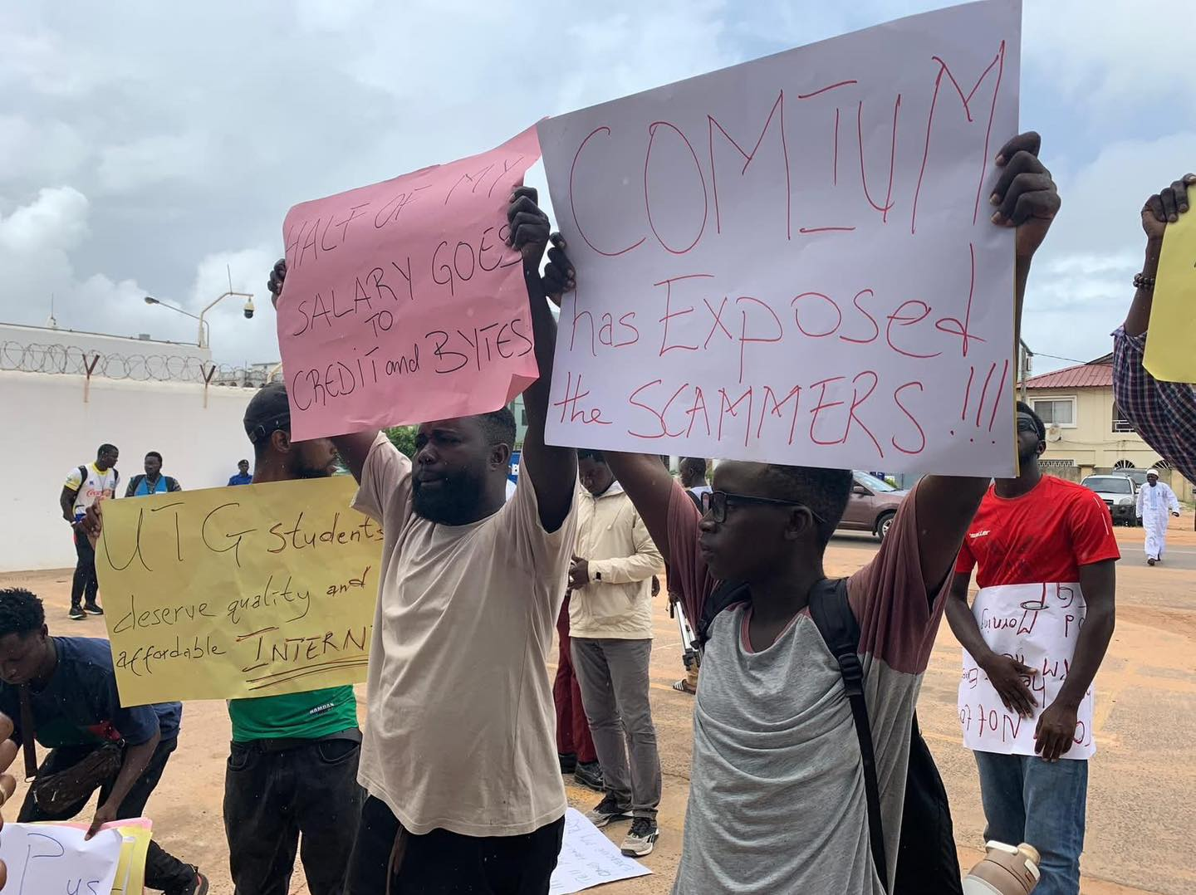
Twenty-three protesters were arrested, detained and eventually charged under the Public Order Act, with conducting themselves without lawful authority in a manner likely to breach the peace by holding a procession in a public place without a license from the Inspector General of Police (IGP). The international community and Gambian civil society condemned the arrest and detention, calling for the immediate and unconditional release of the detainees. The detained protesters contested the charge, arguing that their right to protest is guaranteed by the 1997 Constitution. When offered bail in detention, majority of the protesters declined it, insisting otherwise, on their unconditional release, seeing as they, as they argued, they were in breach of no law.
Figure 18 Demonstrators demanding a reduction in data cost

Figure 18 Demonstrators demanding a reduction in data cost
In a context not unlike what prevails in much of Africa, where state security is weaponised to suppress freedoms of association and assembly, protesting without a permit is a regular exercise for civil society and social movements in the Gambia, as applications for a license to protest are nearly always rejected. When a magistrate ordered the protesters to be remanded, violence and unrest ensued between the police and a group of angry youth gathered outside the court premises. The police deployed tear gas to disperse a crowd that was reportedly throwing stones into the court complex, blocking the road, and setting tyres ablaze. On August 25, 2025, 21 members of another group of protesters who obstructed police tasked with transporting the protesters on remand to the Mile 2 Prison, were also arrested but later on released. calling for the release of the protesters on remand, during a march to the capital Banjul were arrested by the police. On August 27, all 23 protesters were released on bail, which was set at D50,000 for each protester, with the option of securing it through a Gambian surety, a biometric ID card, or a passport.

2.13 Ghana
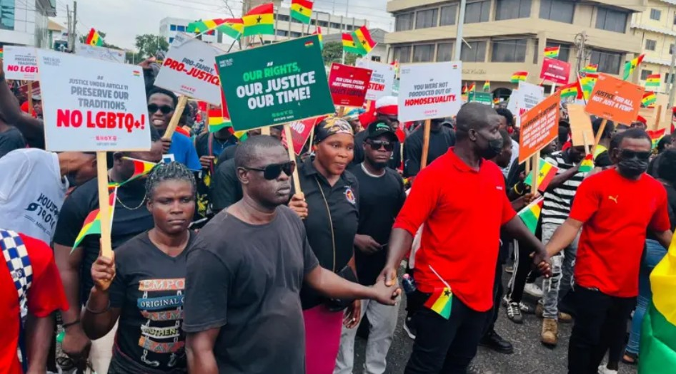
Amid growing economic hardship, public disaffection over perceived nepotism and state-sponsored corruption, pertinent governance challenges in Ghana have coincided with serious concerns over human rights and press freedoms over the first half of the year. Recurrent controversies involving the environment and the country's resource wealth have once again been thrust into the limelight, raising questions about the openness of the civic space. With the reintroduction of the infamous Human Sexual Rights and Family Values Bill (Anti-LGBTQ Bill) in Parliament, there have been violent and verbal attacks on HRDs advocating for LGBTQI+ rights. Escalating economic hardship has triggered protests that were forcefully and fully quelled by state security forces.
Figure 19 Anti-LGBTQ demonstration in Ghana
Akwasi Agyei Annim, Henry Emil Fynn and Jacob Adu-Baah: Three journalists who were filming an illegal mining operation in the Breman‑Adomanya Forest were threatened and violently attacked, in a bid to seize their equipment and prevent them from filming. The illegal miners destroyed their equipment, confiscated devices, deleted recordings, and detained them for several hours, despite the four-person police escort that accompanied the journalists. Even with the arrival of police reinforcements, the journalists were only allowed to leave the area on condition that they promise to delete the videos at the Asankrangwa District Police Station. The incident has been vehemently condemned by several national and international rights groups, including the Ghana Journalists Association (GJA) and Reporters without Borders (RSF). Upon arrival at the police station, the illegal miners were arrested. Reports on the incident claim that illegal mining has destroyed over 200 acres of land in the Breman-Adomanya area.
This incident mirrors the growing attacks on journalists across the country. Five journalists, Gideon Nana Peprah, Akwasi Oppong, Kofi Adade, Atta Henry and Charles Awuah Mensah, were violently assaulted on February 11, 2025, while covering the Council of State elections in the Ashanti region. The five were accosted by thugs who claimed to have seen them filming proceedings and demanded they delete the footage from their phones. The five were brutally assaulted when they refused to hand over the footage and their phones were confiscated. While the confiscated phones have been returned, perpetrators are yet to be charged with any crimes.
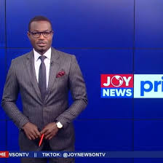
Carlos Carlony: On Wednesday, July 30, 2025, at Spintex in Accra, reporter Carlos Carlony was covering the demolition of a warehouse belonging to Daniel McKorley, a popular businessman affiliated with the main opposition National Patriotic Party (NPP) when he was physically assaulted by military men who arrived on the scene. The demolition was believed to be linked to a legal dispute over the ownership of the land between the McDan Group, a conglomerate owned by Mr. McKorley, and the Ghana Airport Company. Along with a key eyewitness, Calony was manhandled and punched before being forced into a vehicle and sent to the National Security Headquarters. He was detained and questioned for about an hour while his phone was temporarily confiscated and inspected. In a statement by the Minister for Government Communications and spokesperson to the President of Ghana, the government condemned the assault of the reporter, describing the actions of the military personnel as ‘utterly unacceptable,’ and having no place in a democratic society. The President of the country has since ordered an investigation into the matter.
Figure 20 JoyNews Reporter, Carlos Caloney was assault during a live report

Figure 823 JoyNews Reporter, Carlos Caloney was assault during a live report

Figure 824 JoyNews Reporter, Carlos Caloney was assault during a live report

Figure 825 JoyNews Reporter, Carlos Caloney was assault during a live report

Figure 826 JoyNews Reporter, Carlos Caloney was assault during a live report

Figure 827 JoyNews Reporter, Carlos Caloney was assault during a live report

Figure 828 JoyNews Reporter, Carlos Caloney was assault during a live report

Figure 829 JoyNews Reporter, Carlos Caloney was assault during a live report

Figure 830 JoyNews Reporter, Carlos Caloney was assault during a live report

Figure 831 JoyNews Reporter, Carlos Caloney was assault during a live report

Figure 832 JoyNews Reporter, Carlos Caloney was assault during a live report

Figure 833 JoyNews Reporter, Carlos Caloney was assault during a live report

Figure 834 JoyNews Reporter, Carlos Caloney was assault during a live report

Figure 835 JoyNews Reporter, Carlos Caloney was assault during a live report

Figure 836 JoyNews Reporter, Carlos Caloney was assault during a live report

Figure 837 JoyNews Reporter, Carlos Caloney was assault during a live report

Figure 838 JoyNews Reporter, Carlos Caloney was assault during a live report

Figure 839 JoyNews Reporter, Carlos Caloney was assault during a live report

Figure 840 JoyNews Reporter, Carlos Caloney was assault during a live report

Figure 841 JoyNews Reporter, Carlos Caloney was assault during a live report

Figure 842 JoyNews Reporter, Carlos Caloney was assault during a live report

Figure 843 JoyNews Reporter, Carlos Caloney was assault during a live report

Figure 844 JoyNews Reporter, Carlos Caloney was assault during a live report

Figure 845 JoyNews Reporter, Carlos Caloney was assault during a live report

Figure 846 JoyNews Reporter, Carlos Caloney was assault during a live report

Figure 847 JoyNews Reporter, Carlos Caloney was assault during a live report

Figure 848 JoyNews Reporter, Carlos Caloney was assault during a live report

Figure 849 JoyNews Reporter, Carlos Caloney was assault during a live report

Figure 850 JoyNews Reporter, Carlos Caloney was assault during a live report

Figure 851 JoyNews Reporter, Carlos Caloney was assault during a live report

Figure 852 JoyNews Reporter, Carlos Caloney was assault during a live report

Figure 853 JoyNews Reporter, Carlos Caloney was assault during a live report

Figure 854 JoyNews Reporter, Carlos Caloney was assault during a live report

Figure 855 JoyNews Reporter, Carlos Caloney was assault during a live report

Figure 856 JoyNews Reporter, Carlos Caloney was assault during a live report

Figure 857 JoyNews Reporter, Carlos Caloney was assault during a live report

Figure 858 JoyNews Reporter, Carlos Caloney was assault during a live report

Figure 859 JoyNews Reporter, Carlos Caloney was assault during a live report

Figure 860 JoyNews Reporter, Carlos Caloney was assault during a live report

Figure 861 JoyNews Reporter, Carlos Caloney was assault during a live report

Figure 862 JoyNews Reporter, Carlos Caloney was assault during a live report

Figure 863 JoyNews Reporter, Carlos Caloney was assault during a live report

Figure 864 JoyNews Reporter, Carlos Caloney was assault during a live report

Figure 865 JoyNews Reporter, Carlos Caloney was assault during a live report

Figure 866 JoyNews Reporter, Carlos Caloney was assault during a live report

Figure 867 JoyNews Reporter, Carlos Caloney was assault during a live report

Figure 868 JoyNews Reporter, Carlos Caloney was assault during a live report

Figure 869 JoyNews Reporter, Carlos Caloney was assault during a live report

Figure 870 JoyNews Reporter, Carlos Caloney was assault during a live report

Figure 871 JoyNews Reporter, Carlos Caloney was assault during a live report

Figure 872 JoyNews Reporter, Carlos Caloney was assault during a live report

Figure 873 JoyNews Reporter, Carlos Caloney was assault during a live report

Figure 874 JoyNews Reporter, Carlos Caloney was assault during a live report

Figure 875 JoyNews Reporter, Carlos Caloney was assault during a live report

Figure 876 JoyNews Reporter, Carlos Caloney was assault during a live report

Figure 877 JoyNews Reporter, Carlos Caloney was assault during a live report

Figure 878 JoyNews Reporter, Carlos Caloney was assault during a live report

Figure 879 JoyNews Reporter, Carlos Caloney was assault during a live report

Figure 880 JoyNews Reporter, Carlos Caloney was assault during a live report

Figure 881 JoyNews Reporter, Carlos Caloney was assault during a live report

Figure 882 JoyNews Reporter, Carlos Caloney was assault during a live report

Figure 883 JoyNews Reporter, Carlos Caloney was assault during a live report

Figure 884 JoyNews Reporter, Carlos Caloney was assault during a live report

Figure 885 JoyNews Reporter, Carlos Caloney was assault during a live report

Figure 20 JoyNews Reporter, Carlos Caloney was assault during a live report

Figure 823 JoyNews Reporter, Carlos Caloney was assault during a live report

Figure 824 JoyNews Reporter, Carlos Caloney was assault during a live report

Figure 825 JoyNews Reporter, Carlos Caloney was assault during a live report

Figure 826 JoyNews Reporter, Carlos Caloney was assault during a live report

Figure 827 JoyNews Reporter, Carlos Caloney was assault during a live report

Figure 828 JoyNews Reporter, Carlos Caloney was assault during a live report

Figure 829 JoyNews Reporter, Carlos Caloney was assault during a live report

Figure 830 JoyNews Reporter, Carlos Caloney was assault during a live report

Figure 831 JoyNews Reporter, Carlos Caloney was assault during a live report

Figure 832 JoyNews Reporter, Carlos Caloney was assault during a live report

Figure 833 JoyNews Reporter, Carlos Caloney was assault during a live report

Figure 834 JoyNews Reporter, Carlos Caloney was assault during a live report

Figure 835 JoyNews Reporter, Carlos Caloney was assault during a live report

Figure 836 JoyNews Reporter, Carlos Caloney was assault during a live report

Figure 837 JoyNews Reporter, Carlos Caloney was assault during a live report

Figure 838 JoyNews Reporter, Carlos Caloney was assault during a live report

Figure 839 JoyNews Reporter, Carlos Caloney was assault during a live report

Figure 840 JoyNews Reporter, Carlos Caloney was assault during a live report

Figure 841 JoyNews Reporter, Carlos Caloney was assault during a live report

Figure 842 JoyNews Reporter, Carlos Caloney was assault during a live report

Figure 843 JoyNews Reporter, Carlos Caloney was assault during a live report

Figure 844 JoyNews Reporter, Carlos Caloney was assault during a live report

Figure 845 JoyNews Reporter, Carlos Caloney was assault during a live report

Figure 846 JoyNews Reporter, Carlos Caloney was assault during a live report

Figure 847 JoyNews Reporter, Carlos Caloney was assault during a live report

Figure 848 JoyNews Reporter, Carlos Caloney was assault during a live report

Figure 849 JoyNews Reporter, Carlos Caloney was assault during a live report

Figure 850 JoyNews Reporter, Carlos Caloney was assault during a live report

Figure 851 JoyNews Reporter, Carlos Caloney was assault during a live report

Figure 852 JoyNews Reporter, Carlos Caloney was assault during a live report

Figure 853 JoyNews Reporter, Carlos Caloney was assault during a live report

Figure 854 JoyNews Reporter, Carlos Caloney was assault during a live report

Figure 855 JoyNews Reporter, Carlos Caloney was assault during a live report

Figure 856 JoyNews Reporter, Carlos Caloney was assault during a live report

Figure 857 JoyNews Reporter, Carlos Caloney was assault during a live report

Figure 858 JoyNews Reporter, Carlos Caloney was assault during a live report

Figure 859 JoyNews Reporter, Carlos Caloney was assault during a live report

Figure 860 JoyNews Reporter, Carlos Caloney was assault during a live report

Figure 861 JoyNews Reporter, Carlos Caloney was assault during a live report

Figure 862 JoyNews Reporter, Carlos Caloney was assault during a live report

Figure 863 JoyNews Reporter, Carlos Caloney was assault during a live report

Figure 864 JoyNews Reporter, Carlos Caloney was assault during a live report

Figure 865 JoyNews Reporter, Carlos Caloney was assault during a live report

Figure 866 JoyNews Reporter, Carlos Caloney was assault during a live report

Figure 867 JoyNews Reporter, Carlos Caloney was assault during a live report

Figure 868 JoyNews Reporter, Carlos Caloney was assault during a live report

Figure 869 JoyNews Reporter, Carlos Caloney was assault during a live report

Figure 870 JoyNews Reporter, Carlos Caloney was assault during a live report

Figure 871 JoyNews Reporter, Carlos Caloney was assault during a live report

Figure 872 JoyNews Reporter, Carlos Caloney was assault during a live report

Figure 873 JoyNews Reporter, Carlos Caloney was assault during a live report

Figure 874 JoyNews Reporter, Carlos Caloney was assault during a live report

Figure 875 JoyNews Reporter, Carlos Caloney was assault during a live report

Figure 876 JoyNews Reporter, Carlos Caloney was assault during a live report

Figure 877 JoyNews Reporter, Carlos Caloney was assault during a live report

Figure 878 JoyNews Reporter, Carlos Caloney was assault during a live report

Figure 879 JoyNews Reporter, Carlos Caloney was assault during a live report

Figure 880 JoyNews Reporter, Carlos Caloney was assault during a live report

Figure 881 JoyNews Reporter, Carlos Caloney was assault during a live report

Figure 882 JoyNews Reporter, Carlos Caloney was assault during a live report

Figure 883 JoyNews Reporter, Carlos Caloney was assault during a live report

Figure 884 JoyNews Reporter, Carlos Caloney was assault during a live report

Figure 885 JoyNews Reporter, Carlos Caloney was assault during a live report
Reintroduction of the Anti-LGBTQ+ Bill in Parliament and Attacks on LGBTQ+ Rights Defenders: In February 2024, Parliament passed the Human Sexual Rights and Family Values Bill, which the immediate former President Nana Addo-Dankwa Akufo-Addo did not sign into law. The Bill has been reintroduced in parliament after the Supreme Court of Ghana rejected two legal bids to get the Bill declared unconstitutional. The promulgation of this bill into law will mean that LGBTQ+ Ghanaians, already facing discrimination and marginalisation, could also be denied access to jobs, healthcare, and housing.
Unsurprisingly, as calls for the bill to pass have been revamped, LGBTQI+ human rights defenders are increasingly being targeted with physical assault, threats and forced evictions. In Tamale and Wa, two cities where LGBTQI+ people and HRDs increasingly face hostilities, a journalist led a public campaign naming and shaming queer individuals, resulting in LGBTQI+ individuals being threatened and losing their businesses. Two pro-LGBTQI+ HRDs are currently homeless after one was beaten, fined, and banished, and the other received a death threat. Traditional authorities lead the anti-LBGTQI+ campaigns that have left LGBTQI+ individuals endangered. While acknowledging the severity of the plight of LGBTQI+ persons across the country, civil society groups have called for accountability from traditional and religious authorities, media houses and the state.

The fate of the ECOWAS and the AES remain inextricably tied to their combined ability to rein in elite excesses, recognize dissent, promote and protect the freedoms of expression and association, and entrench fairness and equality in the institutional, political and social fabric of the countries across the West African subregion. While the quality of democracy and the fate of human rights defenders across the subregion do not suggest immediate outcomes for democratic renaissance and stability, the chances could be greatly enhanced if the relevant institutions would adhere to these recommendations.

3.0 RECOMMENDATIONS

4.0 CONCLUSION

3.0 RECOMMENDATIONS

3.1 Civil Society Organizations (CSOs)
It is recommended that CSOs must pursue:
- Cross-border solidarity & regional coalitions
- Establish networks within country and across borders to share resources, lessons, and knowledge across ECOWAS/AES boundaries to support defenders within their borders, in exile or displaced.

- Document incidences of attacks, abductions, illegal arrests and forced disappearances.

- Amplify cases of human rights violations and abuses as well as positive outcomes in human rights advocacy.

- Legal advocacy and strategic litigation
- Sustain an unrelenting advocacy for the independence and the integrity of the judiciary.

- Confront and challenge illegal restrictions and unjust prosecutions targeting civil society and human rights defenders.

- Advocate and protest against repressive legislation (assembly, association, counter-terrorism) using local and regional courts to set precedents.

- Emergency protection and relocation networks
- Establish local and international networks for solidarity and information-sharing in order to stay ahead of emerging risks to human rights defenders across the West African subregion.

- Collaborate with build synergies with local and regional rapid-response systems for human rights defenders across the West African subregion.

- Online safety, secure communications and countersurveillance measures
- Train defenders on encrypted messaging, safe online practices, and anonymous reporting tools.

- Media collaboration and awareness campaigns
- Leverage independent media both locally and internationally to spread information on human rights violations and injustices, and pressure authorities to do the right thing.

3.2 ECOWAS
As a regional body, ECOWAS must:
- Operationalize a regional rapid-response mechanism for HRD protection
- Institute an ECOWAS Emergency Civic Protection Fund for legal aid, temporary relocation, and emergency medical/psychosocial support.

- Map national focal points and safe houses in stable countries for HRDs fleeing persecution (especially from AES states).

- Create an ECOWAS Civic Space and Repression Monitoring System (CSRMS)
- Establish a data-driven civic space observatory within the ECOWAS Commission’s Political Affairs Directorate to monitor indicators like protest bans, arbitrary arrests, NGO closures, and internet shutdowns.

- Publish quarterly Civic Space Status Reports for all member states and AES countries.

- Enhance cross-border capacity support and agency of human rights institutions in the sub-region.
- Use political leverage and mediation to protect HRDs in transitional regimes
- Advocate for the inculcation of HRD protection clauses and civic space benchmarks into political transition roadmaps in Mali, Burkina Faso, and Niger.

- Enhance diplomatic and mediation interventions in countries experiencing worst forms of violations and repression.

- Fast-track the adoption of a binding ECOWAS Human Rights Defenders Protection Protocol
- Collaborate with the ACHPR, civil society and human rights experts to draft and adopt a legally binding regional instrument that defines, recognizes, and protects HRDs.

- Ensure it provides legal safeguards, emergency support provisions, and clearly mandates member state compliance.

- Revise and expand the 2001 Protocol on Democracy and Good Governance
- Enhance and expand protections for civic actors, freedom of expression, assembly, press, and digital rights.

- Include mechanisms to track, report, and respond to violations by member states and transitional regimes.

- Tie electoral integrity assessments and ECOWAS mechanisms to respect for civic space and HRD protection.

- Strengthen access to justice through the ECOWAS Court of Justice
- Reinforce the independence and jurisdiction of the ECOWAS Court to hear HRD and civic space violations.

- Consider appointing a Special Rapporteur on Civic Space and HRDs within ECOWAS' legal architecture.
- Convene an annual ECOWAS Civic Space and Democracy Dialogue
- Institutionalize a yearly high-level forum involving governments, CSOs, journalists, regional courts, and donors.

- Use the platform to assess progress, review challenges, and promote coordination on protecting civic freedoms across the region.

3.3 ECOWAS Member States:
The member states of ECOWAS must:
- Legal and institutional reform
- Adopt national frameworks recognizing HRD status, per ACHPR Resolution 376 (LX)

- Repeal or amend restrictive NGO laws, anti-terrorism measures, and assembly regulations
- In the case of Sierra Leone, the National Counterterrorism Act of 2024 must be thoroughly reviewed to address abuse by state authority.

- Strengthen national accountability and justice
- Investigate and prosecute abuses, including crackdowns on protests and enforced disappearances.

- Ensure the safety of journalists and civil society activists.

- Participate actively in ECOWAS-level mechanisms
- Develop an ECOWAS Protection Protocol for HRDs and civic space monitors.
- Promote regional press and digital rights standards.

The African Commission on Human and Peoples’ Rights (ACHPR)
To address the challenges in the sub-region and across the continent, ACHPR must:
- Mandate more targeted country visits and reporting
- Prioritize high-risk countries (Niger, Mali, Guinea, Burkina Faso, Benin, Nigeria).

- Document incidents and issue findings with actionable recommendations.

- Advocate adoption of HRD-specific legislation
- Encourage member states to implement the ACHPR’s Resolution 376 to legally recognize and protect defenders.

- Condemn reprisals and restrictive laws

- Use the Special Rapporteur’s platform to oppose arbitrary arrests and bans on civil society.

- Support digital safety and coordination tools for HRDs
- Promote civic-tech innovations and secure reporting mechanisms developed in coordination with CSOs
- Collaborate with ECOWAS on protocols and enforcement
- Support regional adoption of civic space standards and HRD protection measures

United Nations & International Bodies
The state of human rights defenders and activists has international implications. The UN and other supranational bodies must:
- Diplomatic advocacy and conditional engagement
- Insist on governments honoring human rights treaties and protecting HRDs, as part of bilateral and multilateral commitments on HRDs
- Financial & capacity-building support
- Support the training of CSOs in legal action, digital security, crisis response, and organizational resilience
- Monitoring and rapid reporting platforms
- Ensure UN OHCHR and Special Rapporteurs regularly monitor the ECOWAS and the AES.

- Issue alerts when reprisals occur—e.g., abducted journalists, mass arrests, etc.
- Integrate digital rights into human rights strategies
- Combat online repression, disinformation, and surveillance threats facing defenders and civil society
- Support ECOWAS enforcement mechanisms
- Back the reform of the ECOWAS Court and the Protocol on Democracy and Good Governance to ensure HRD protections are enforceable.

- Provide technical support for protocol drafting and implementation.
The evidence reveals deteriorating conditions regarding the exercise of political freedoms and civil liberties in the region. Countries which served as the benchmark in the region on human rights are gradually retreating from the gains and showing growing signs of violations and weaponization of the civic space. Indeed, the first half of 2025 was rife with threats to human rights defenders across ECOWAS and AES member states in the form of arbitrary arrests, surveillance, enforced disappearances, and violent reprisals, particularly in authoritarian and transitional contexts. These hazards transpired in a hostile climate of media restrictions, digital repression, and the weaponization of legal frameworks to silence dissent. Somehow, unfazed by all these, human rights defenders, journalists, and civil society actors remain unwavering in their demand for transparency and accountability from power.

4.0 CONCLUSION

REFERENCES4.0 CONCLUSION

The recommendations presented in this report are intended to offer a clear, actionable roadmap for civil society, national governments, regional economic communities, networks and other international bodies to undo the repression of criticism and dissent and engender an atmosphere cordial to the promotion of human rights. Human rights defenders can only be safe and secure when the institutions mandated to protect the rights and freedoms that affirm humanity to be dignified and sacred, embrace a culture of stability, inclusion, and equality.

REFERENCES

REFERENCES

    - Abakah, G. (2025) 'GJA condemns attack on Journalists by illegal miners at Breman Adomanya forest,' Ghana News Agency, 26 February. https://gna.org.gh/2025/02/gja-condemns-attack-on-journalists-by-illegal-miners-at-breman-adomanya-forest.
    - Actu Niger (2025) ‘Niger : quatre syndicats de la justice dissous pour "entrave à l’autorité de l’État,’ https://www.actuniger.com/societe/21217-niger-quatre-syndicats-de-la-justice-dissous-pour-entrave-a-lautorite-de-letat.html
    - Agence France Presse (2025a) 'Noted Burkina lawyer-politician feared conscripted,' Barrons, 27 July. https://www.barrons.com/news/noted-burkina-lawyer-politician-feared-conscripted-8f3e04a6?refsec=topics_AFP-news.
    - Agence France Presse (2025b) 'Niger junta dissolves three paramilitary unions,' Barrons, 9 April. https://www.barrons.com/news/niger-junta-dissolves-three-paramilitary-unions-1fde4b0e.
    - Agence France Presse (2025c) 'Au Mali, la coalition d’opposition hausse le ton pour ne pas disparaître,' Le Monde.fr,’ 2 May. https://www.lemonde.fr/afrique/article/2025/05/02/au-mali-la-coalition-d-opposition-hausse-le-ton-pour-ne-pas-disparaitre_6602258_3212.html.
    - Agence France Presse (2025d) 'Au Mali, un journaliste écroué pour avoir critiqué la justice,' Le Monde.fr, 10 April. https://www.lemonde.fr/afrique/article/2025/04/10/au-mali-un-journaliste-ecroue-pour-avoir-critique-la-justice_6593567_3212.html.
    - Agence France Presse (2025) 'Niger declares 3 days of mourning after 44 people were killed in attack,' Le Monde.fr, 22 March. https://www.lemonde.fr/en/le-monde-africa/article/2025/03/22/niger-declares-3-days-of-mourning-after-44-people-were-killed-inattack_6739404_124.html.
    - Agence France Presse (2025e) 'Togo. Arrêté il y a une semaine, le rappeur Aamron s’excuse en vidéo auprès de Faure Gnassingbé,' africaradio.com, 5 June. https://www.africaradio.com/actualite-109919-togo-arrete-il-y-a-une-semaine-le-rappeur-aamron-s-excuse-en-video-aupres-de-faure-gnassingbe.
    - Africa News (2025, May 20) ‘Mali : des militants pro-démocratie arrêtés et accusés de déstabilisation.’ 20 May. https://fr.africanews.com/2025/05/20/mali-des-militants-pro-democratie-arretes-et-accuses-de-destabilisation
    - Africa Center for Strategic Studies (2024) 'Togo revises Constitution to eliminate term limits: An explainer,' 23 April. https://africacenter.org/spotlight/togo-revises-constitution-to-eliminate-term-limits-an-explainer/.
    - Africa Intelligence (2025) 'Benin/Ivory Coast : Forced transfer of journalist cools relations between Abidjan and Cotonou,' Africa Intelligence, 29 July. https://www.africaintelligence.com/west-africa/2025/07/29/forced-transfer-of-journalist-cools-relations-between-abidjan-and-cotonou,110496315-art.
    - African Human Rights Coaltion (2025) 'Escalating threats against LGBTQI+ human rights defenders in Ghana:,' african-hrc, 28 May. https://www.africanhrc.org/single-post/escalating-threats-against-lgbtqi-human-rights-defenders-in-ghana.
- African Perceptions (2025) ‘Niger government dissolves three judicial unions and warns against “Obstruction of public service” https://africanperceptions.org/en/2025/08/niger-government-dissolves-three-judicial-unions-and-warns-against-obstruction-of-public-service/
- AfrikPage (2025) 'Tog : Citizens demand end to 50+ year Gnassingbé family reign,' AfrikPage, 27 June. https://afrikpage.com/2025/06/27/togo-citizens-demand-end-to-50-year-gnassingbe-family-reign/.
- Afriquinos (2025) ‘Arrestation de praticiens hospitaliers au Togo,’ https://afriquinfos.com/togo-arrestation-de-praticiens-hospitaliers-les-05-et-06-juin-confessions-de-leur-syndicat-sur-leur-traitement-a-la-gendarmerie/.
- Afrique Confidentielle (2025) ‘Crise politique au Sénégal : Ouattara convoque Ousmane Sonko à Abidjan,’ 9 April. https://afriqueconfidentielle.com/fr/afrique/crise-politique-au-senegal-ouattara-convoque-ousmane-sonko-a-abidjan/
- Agbenou, M. (2025) Court sent Togolese activist 'Affectio' back to jail pending final ruling -. https://icilome.com/2025/02/court-sent-togolese-activist-affectio-back-to-jail-pending-final-ruling/?utm_source=chatgpt.com#google_vignette.
- Agboglati, K. (2025) ‘Aamron, le Fils du Peuple!’ Le Temps https://letempstg.com/2025/05/30/aamron-le-fils-du-peuple/.
- Ahougnon, S. (2025) ‘Sénégal: ‘Ousmane Sonko adopte une politique de « zéro tolérance » contre la diffusion de fausses Nouvelles,’ Agence Ecofin, 16 April. https://www.agenceecofin.com/actualites/1604-127596-senegal-ousmane-sonko-adopte-une-politique-de-zero-tolerance-contre-la-diffusion-de-fausses-nouvelles
- Alkamba Times (2025) Two journalists arrested at Anti-Corruption protest released. https://alkambatimes.com/two-journalists-arrested-at-anti-corruption-protest-released/
- Akintayo, O. (2025) ‘NPF writes Amnesty, demands retraction, apology over publication on #EndBadGovernance protest,’ Channels News TV, 14 January. https://www.channelstv.com/2025/01/14/npf-writes-amnesty-demands-retraction-apology-over-publication-on-endbadgovernance-protest/
- Akpa, G. (2025) ‘Togo- Sokpor Sitsopé : La vraie raison de son arrestation,’ https://icilome.com/2025/01/togo-sokpor-sitsope-la-vraie-raison-de-son-arrestation/#google_vignette.
- Amnesty International (2024) ‘Nigeria: Bloody August: Nigerian government’s violent crackdown on #EndBadGovernance protests.’ 28 November. https://www.amnesty.org/en/documents/afr44/8780/2024/en/
- Amnesty International (2025a) ‘Sierra Leone: Authorities must release and guarantee fair trial for TV personality detained under accusations of insulting the President and First Lady,’ https://www.amnesty.org/en/latest/news/2025/01/sierra-leone-fair-trial-hawa-hunt/.
- Amnesty International (2025b) ‘Togo: Authorities must investigate allegations protesters were tortured and end crackdown on dissent,’ 2 May. https://allafrica.com/stories/202505020223.html https://www.amnesty.org/en/latest/news/2025/06/togo-protesters-tortured/.
- Amnesty International (2025c) ‘Togo: Testimonies provide glimpse into violent repression of protests,’ https://www.amnesty.org/en/latest/news/2025/07/togo-repression-protests/.
- AP News (2022). ‘Burkina Faso expels top UN official in West African country,’ https://apnews.com/article/violence-united-nations-burkina-faso-f4dc3bd50b16bd49c74d95472d5ec5f6
- AP News (2024) ’Mali’s junta suspends all political activities until further notice,’ https://apnews.com/article/mali-politics-election-coup-junta-14d19027392bb1bf7eb110bf755ab631.
- AP News (2025a). ‘2 activists who criticized Mali military rulers were seized and taken away, relatives say,’ https://apnews.com/article/mali-military-activists-arrested-0f24b80fe708b63b6f051f1f2c4ea0da
- AP News (2025b) ‘At least 3 people dead in Togo protests calling for leader’s resignation, Amnesty says,’ https://apnews.com/article/togo-protests-amnesty-international-gnassingbe-lome-482a3bcd7c267a440ecd191c22e3a1b5.
- AP News (2025c) ‘Burkina Faso ruling junta dissolves independent electoral commission,’ https://apnews.com/article/burkina-faso-electoral-comission-910d22d0493e5302509782c7c18953c0.
- AP News (2025d) ‘Guinea’s junta faces protests after missing a deadline for a return to democracy,’ https://apnews.com/article/guinea-junta-doumbouya-conakry-democracy-49a54a2cea3cf412770878616c1e7121.
- AP News (2025e) ‘Guinea’s main opposition parties call for withdrawal from junta-led legislative body,’ https://apnews.com/article/guinea-opposition-forces-vives-de-guinee-junta-doumbouya-419c3f56cb085e1a4ec178667cb81d10.
- AP News (2025f) ‘Hundreds of activists stage Mali’s first pro-democracy rally in years,’ (https://apnews.com/article/mali-politics-democracy-demonstration-military-government-270461e6dd91784cb31bfb9f1172c0a4.
- AP News (2025g) ‘Mali’s leader dissolves political parties and bans meetings of their members,’ https://apnews.com/article/mali-political-parties-dissolve-military-b9a97cc673cc11a804e023250fbecaea.
- AP News (2025i) ‘Senegal revises amnesty law that covered deadly protests.’ 3 April. https://apnews.com/article/senegal-amnesty-law-sonko-macky-sall-d8f45d757e7057678e26f5df6f23824f
- AP News (2025j) ‘Mali political activist freed after monthlong abduction,’ https://apnews.com/article/mali-pro-democracy-leader-freed-alassane-abba-4895d5049125ed74a34370f2b262bea7
- AP News (2025k) ‘Nigeria’s president pardons activists executed during military junta,’ 13 June. https://apnews.com/article/nigeria-environmental-activists-pardon-822d06021bcf0ef7d69d457d4082b1b6
- APA News (2025a) 'Malian political parties reject new national consultations on charter,' 16 April. https://apanews.net/malian-political-parties-reject-new-national-consultations-on-charter/.
- APA News (2025b) 'Mali’s detained university professor freed,' 27 March. https://apanews.net/malis-detained-university-professor-freed/.
- APA News (2025c) 'Mali’s junta leader signs extended transition mandate,' 11 July. https://apanews.net/malis-junta-leader-signs-extended-transition-mandate/
- APA News (2025d) ‘Niger : lancement officiel des résolutions des Assises nationales’ 26 March. https://fr.apanews.net/news/226123/
- APA News (2025e) ‘Niger launches National Conference Reforms, initiating five-year transition’ 26 March. https://apanews.net/niger-launches-national-conference-reforms-initiating-five-year-transition/
- APA News (2025f) ‘Mali: Alassane Abba et Ab. K. Traoré ‘Exo’ de retour (proches)’ 7 June. https://fr.apanews.net/politique/mali-alassane-abba-et-abdoul-karim-traore-exo-de-retour-chez-eux-proches/
- APS (2025) ‘Ousmane Sonko décrète la ”tolérance zéro” contre les dérives sur les réseaux sociaux,’ 14 April. https://aps.sn/ousmane-sonko-decrete-la-tolerance-zero-contre-les-derives-sur-les-reseaux-sociaux/
- Arthur, A. (2025) 'Galamsey operators invade Breman-Adomanya Forest, attack Citi News,’ Citinewsroom 25 February. https://citinewsroom.com/2025/02/galamsey-operators-invade-breman-adomanya-forest-attack-citi-news-akwasi-agyei/.
- Article 19 (2025) ‘The Gambia: Authorities must release protesters and protect their rights,’ https://www.article19.org/resources/the-gambia-authorities-must-release-protesters-and-protect-their-rights/
- Askanwi Gambia (2025a) ‘19 detained and charged for “Unlawful assembly,” But what does the Public Order Act say?’ 23 August. https://www.askanwi.com/news/19-detained-and-charged-for-unlawful-assembly-but-what-does-the-public-order-act-say.
- Askanwi Gambia (2025b) ‘Crackdown on Dissent: Gambia’s Public Order Act Blocks Peaceful Protest’ Askanwi Gambia, 12 May. https://www.askanwi.com/news/crackdown-on-dissent-gambias-public-order-act-blocks-peaceful-protest/
- Askanwi Gambia (2025c) Gambian and international CSOs condemn arrest of protester, demand “Immediate and unconditional release,” 24 August https://www.askanwi.com/news/gambian-and-international-csos-condemn-arrest-of-protester-demand-immediate-and-unconditional-release
- Atafa, A. (2025) ‘Niger: Trois journalistes interpellés à deux reprises à Agadez.’ https://airinfoagadez.com/2025/05/10/niger-trois-journalistes-interpelles-a-deux-reprises-a-agadez/.
- Aziato, K. (2025) 'Togo : Les excuses du rappeur Aamron à Faure Gnassingbé,' togopost.tg, 5 June. https://togopost.tg/togo-les-excuses-du-rappeur-aamron-a-faure-gnassingbe/.
- Ba, F. (2025) ‘Simon Faye de SenTV interpellé par la police sénégalaise après une publication controversée.’ Senego, 10 April. https://senego.com/simon-faye-de-sentv-interpelle-par-la-police-senegalaise-apres-une-publication-controversee_1824949.html
- Bah, S. (2025) 'Court Grants Bail to 23 PURA Protesters,’ Foroyaa Newspaper, 28 August. https://foroyaa.net/court-grants-bail-to-23-pura-protesters/
- Baldé, D. (2025a) 'Bissau: LGDH denuncia mais de cem pessoas torturadas em 2024,' dw.com, 26 June. https://www.dw.com/pt-002/guin%C3%A9-bissau-lgdh-denuncia-mais-de-cem-pessoas-torturadas-em-2024/a-73055202.
- Baldé, D. (2025b) 'Processo eleitoral ‘vicioso’ no Supremo da Guiné-Bissau,' dw.com, 9 May. https://www.dw.com/pt-002/processo-eleitoral-vicioso-no-supremo-da-guin%C3%A9-bissau/a-72484261.
- Bellamin, G. (2025) 'Malian authorities detain Daouda Magassa amid Imam Dicko’s expected return,' WeAfrica24, 11 February. https://weafrica24.com/2025/02/11/malian-authorities-detain-daouda-maga/.
- Berry, A. (2025) 'IMF praises Nigeria’s reforms, warns poverty still high,' dw.com, 18 April. https://www.dw.com/en/imf-praises-nigerias-reforms-warns-poverty-still-high/a-72285052.
- Biedermann, K. (2025) ‘Benin: Hugues Comlan Sossoukpè arrested in Abidjan and extradited to Cotonou,’ Sahel Intelligence, 14 July. https://sahel-intelligence.com/39167-benin-hugues-comlan-sossoukpe-arrested-in-abidjan-and-extradited-to-cotonou.html.
- Braimah, T. (2025) 'Mali: Author and activist released after a year in detention,' Amnesty International Canada, 25 April. https://www.amnesty.ca/urgent-actions/mali-author-and-activist-released-after-a-year-in-detention/.
- Cam, M.L. (2024) 'Au Burkina Faso, la junte enrôle de force des magistrats récalcitrants sur le front antidjihadiste,' Le Monde.fr, 16 August. https://www.lemonde.fr/afrique/article/2024/08/16/au-burkina-faso-la-junte-enrole-de-force-des-magistrats-recalcitrants-sur-le-front-antidjihadiste_6283669_3212.html.
- Ceesay, J. (2025a) '16 protesters decline bails, urge unconditional release,' The Point, The Gambia, 25 August. https://thepoint.gm/africa/gambia/headlines/16-protesters-decline-bails-urge-unconditional-release.
- Ceesay, J. (2025b) 'Protesters arrested over cloudy sale of alleged Jammeh-looted assets,' , The Point, The Gambia, 9 May. https://thepoint.gm/africa/gambia/headlines/protesters-arrested-over-cloudy-sale-of-alleged-jammeh-looted-assets
- CIVICUS Monitor (2025). ‘Benin: Activist living in exile abducted from Lomé, brought before court in Cotonou.’ 14 July. https://monitor.civicus.org/explore/benin-activist-living-in-exile-abducted-from-lom%C3%A9-brought-before-court-in-cotonou/
- Cm and Lusa (2025) 'Bissau: Detenções e aparato policial em dia de protesto,' dw.com, 25 May. https://www.dw.com/pt-002/bissau-deten%C3%A7%C3%B5es-e-aparato-policial-em-dia-de-protesto/a-72664979.
- Chisom, M. (2025) 'Togo erupts in protest as citizens demand President Faure Gnassingbé’s resignation amid constitutional crisis and economic hardship,' Africa Scorecard, 27 June. https://www.theafricascorecard.com/2025/06/28/togo-erupts-in-protest-as-citizens-demand-president-faure-gnassingbes-resignation-amid-constitutional-crisis-and-economic-hardship/
- Christian Daily International (2025) ‘Fulani herdsmen kill more than 60 Christians in ‘genocide’ in Nigeria’ Christian Daily International 8 April. https://www.christiandaily.com/news/fulani-herdsmen-kill-more-than-60-christians-in-genocide-in-nigeria.
- Committee to Protect Journalists (2024a) Burkina Faso confirms conscription of 3 journalists, 1 still missing. 25 October. https://cpj.org/2024/10/burkina-faso-confirms-conscription-of-3-journalists-1-still-missing/.
- Committee to Protect Journalists (2024b) ‘Niger reinstates prison sentences for journalists for defamation, insult,’. https://cpj.org/2024/06/niger-reinstates-prison-sentences-for-journalists-for-defamation-insult/.
- Committee to Protect Journalists (2025a) ‘3 detained Burkina Faso journalists appear in videos wearing military uniforms,’ 4 April. https://cpj.org/2025/04/3-detained-burkina-faso-journalists-appear-in-videos-wearing-military-uniforms/.
- Committee to Protect Journalists (2025b) ‘3 Nigerien journalists detained after broadcast on Russia military cooperation,’ 15 May. https://cpj.org/2025/05/3-nigerien-journalists-detained-after-broadcast-on-russia-military-cooperation/.
- Committee to Protect Journalists (2025c)’ In Burkina Faso, 3 journalists missing after media association condemns kidnaps,’ 27 March. https://cpj.org/2025/03/in-burkina-faso-3-journalists-missing-after-media-association-condemns-kidnaps/.
- Committee to Protect Journalists (2025) ‘Journalist Comlan Hugues Sossoukpè forcibly extradited to Benin,’ 17 July. https://cpj.org/2025/07/journalist-comlan-hugues-sossoukpe-forcibly-extradited-to-benin/
- Constitution Net (2025) 'Constitution Bill rejected at second reading: Halting the reform process in the Gambia?,' 8 July. https://constitutionnet.org/news/voices/constitution-bill-rejected-second-reading-halting-reform-process-gambia/.
- Crellin, Z. (2025) 'Nigeria bans song critical of President Bola Tinubu,' dw.com, 11 April. https://www.dw.com/en/nigeria-bans-song-critical-of-president-bola-tinubu/a-72225039.
- Dakar Actu (2025) ‘Convoqué à la DIC à 10h : Moustapha Diakhaté dénonce le "monopole de l'espace politique" par Sonko. 10 June. https://www.dakaractu.com/Convoque-a-la-DIC-a-10h-Moustapha-Diakhate-denonce-le-monopole-de-l-espace-politique-par-Sonko_a262223.html
- Dansó, I. (2025a) 'Estado de Direito desmorona na Guiné-Bissau, dizem ONG,' dw.com, 28 July. https://www.dw.com/pt-002/suposta-execu%C3%A7%C3%A3o-exp%C3%B5e-crise-no-estado-de-direito-da-guin%C3%A9/a-73443084.
- Dansó, I. (2025b) 'Não havia ‘motivo sério’ para proibir manifestações,' dw.com, 15 January. https://www.dw.com/pt-002/guin%C3%A9-bissau-n%C3%A3o-havia-motivo-s%C3%A9rio-e-cred%C3%ADvel-para-proibir-manifesta%C3%A7%C3%B5es/a-71302924.
- Dansó, I. (2025c) 'Sissoco acusado de caçar voto com recurso aos bens do Estado,' dw.com, 23 May. https://www.dw.com/pt-002/sissoco-acusado-de-ca%C3%A7ar-votos-fora-da-%C3%A9poca-usando-bens-do-estado/a-72650766.
- Darame, B. (2025a) 'Bissau: Liga diz que ativista detido está hospitalizado,' dw.com, 26 May. https://www.dw.com/pt-002/bissau-liga-diz-que-ativista-detido-est%C3%A1-hospitalizado/a-72676576.
- Darame, B. (2025b) 'Proibição de aglomerados: Há ‘dois pesos e duas medidas’?,' dw.com, 21 May. https://www.dw.com/pt-002/proibi%C3%A7%C3%A3o-de-aglomerados-permitida-presid%C3%AAncia-aberta-mas-protestos-s%C3%A3o-negados/a-72627158.
- Darboe, M. K. (2019) ‘Gambia to take all assets belonging to former ruler,’ Anadolu Ajensi, 12 June. https://www.aa.com.tr/en/africa/gambia-to-take-all-assets-belonging-to-former-ruler/1502607.
- Darboe, M.K. (2025) 'The assets of Gambia’s former dictator go for a song,' The Republic Gambia, 7 May. https://therepublic.gm/the-assets-of-gambias-former-dictator-go-for-a-song/3042.
- Deguenon, P.A. (2025) 'Au Togo, l’arrestation du rappeur Amron passe mal,' BENIN WEB TV, 29 May. https://beninwebtv.bj/au-togo-larrestation-de-lartiste-amron-passe-mal/.
- Deutsche Welle (2024a) 'Ghana Supreme Court upholds anti-LGBTQ+ bill,' dw.com, 18 December. https://www.dw.com/en/ghana-supreme-court-upholds-anti-lgbtq-bill/a-71093303.
- Deutsche Welle (2024b) 'Nigeria: Hardship protests met with tear gas,' dw.com, 1 October. https://www.dw.com/en/nigeria-hardship-protests-met-with-tear-gas/a-70378054
- Diallo, D. (2025) ‘Arrestation du journaliste Simon Faye : Des voix s’élèvent pour exiger sa libération et la dépénalisation des délits de presse,’ Senego, 14 April. https://senego.com/arrestation-du-journaliste-simon-faye-des-voix-selevent-pour-exiger-sa-liberation-et-la-depenalisation-des-delits-de-presse_1826318.html
- Diouf, M. (2025) ‘Poursuivi pour fausse nouvelle, Simon Faye déféré ce lundi: le SYNPICS monte au créneau,’ 12 April. https://senego.com/poursuivi-pour-fausse-nouvelle-simon-faye-defere-ce-lundi-le-synpics-monte-au-creneau_1825622.html
- Djade, C. (2024) ‘Deux des ravisseurs de Steve Amoussou écopent d’un an de prison ferme au Bénin, Jeune Afrique, 4 September. https://www.jeuneafrique.com/1604974/politique/deux-des-ravisseurs-de-steve-amoussou-ecopent-dun-an-de-prison-ferme-au-benin/.
- Domena, A.T. (2025) 'Ghana pushes anti-LGBTQ+ bill as defense of ‘family values,’ dw.com, 26 May. https://www.dw.com/en/ghana-pushes-anti-lgbtq-bill-as-defense-of-family-values/a-72540728.
- Egbejule, E. (2025a) ‘Activists call for state of emergency in Nigeria over gender-based violence.’ The Guardian, 25 February. https://www.theguardian.com/world/2025/feb/25/activists-call-state-emergency-gender-based-violence-nigeria
- Egbejule, E. (2025b) 'One too many’: rapper’s arrest sparks protests against Togo’s ruling dynasty,' The Guardian, 10 July. https://www.theguardian.com/world/2025/jul/10/rapper-aamron-arrest-protests-togo-ruling-dynasty?CMP=Share_iOSApp_Other.
- Emre (2025) ‘At least 44 killed in Mosque attack in Niger’s southwest,' The Sudan Times, 22 March. https://thesudantimes.com/africa/at-least-44-killed-in-mosque-attack-in-nigers-southwest/.
- Federation Internationale pour les Droit Humains (2025) ‘Burkina Faso : Disparition forcée des défenseurs de droits humains Miphal Ousmane Lankoandé et Amadou Sawadogo’ https://www.fidh.org/fr/themes/defenseurs-des-droits-humains/burkina-faso-disparition-forcee-des-defenseurs-de-droits-humains.
- Foundation for Investigative Journalism, Nigeria (2024) 'Police deny rights advocate Olamide Abiodun Thomas bail, say IGP wants her detained,' 14 December. https://fij.ng/article/police-deny-rights-advocate-olamide-abiodun-thomas-bail-say-igp-wants-her-detained/.
- France24 (2023) ‘Senegalese opponent charged over verbal attack on President Macky Sall,' 12 July. https://www.france24.com/en/africa/20230712-senegalese-opponent-charged-over-verbal-attack-on-president-macky-sall
- France24 (2025) 'Gunmen kill at least 56 people in central Nigeria,' 20 April. https://www.france24.com/en/africa/20250420-gunmen-kill-at-least-56-people-in-central-nigeria.
- Freedom House (2025) Burkina Faso, Freedom House. https://freedomhouse.org/country/burkina-faso.
- Freedom House (2025) Guinea, Freedom House. https://freedomhouse.org/country/guinea
- Freedom House (2025) Mali, Freedom House. https://freedomhouse.org/country/mali
- Freedom House (2025) Niger, Freedom House. https://freedomhouse.org/country/niger
- Guézodjè, R. (2024) ‘Polémique autour de l’arrestation de "Frère Hounvi" au Bénin,’ DW, 23 August. https://www.dw.com/fr/b%C3%A9nin-criet-arrestation-fr%C3%A8re-hounvi-szeeve-amoussou/a-70025759.
- Herrera Y. (2025) ‘Le gouvernement du Sénégal met en garde les organisateurs d'un événement LGBTQIA+.’ TV5 Monde, 12 July. https://information.tv5monde.com/societe/le-gouvernement-du-senegal-met-en-garde-les-organisateurs-dun-evenement-lgbtqia-2782152
- Human Rights Watch (2024a) 'Burkina Faso: Abductions used to crack down on dissent,' 28 February. https://www.hrw.org/news/2024/02/27/burkina-faso-abductions-used-crack-down-dissent.
- Human Rights Watch (2024b) 'Burkina Faso: conscription used to punish prosecutors, judges,' 21 August. https://www.hrw.org/news/2024/08/21/burkina-faso-conscription-used-punish-prosecutors-judges
- Human Rights Watch (2025a) 'Burkina Faso: Army directs ethnic massacres,' 13 May. https://www.hrw.org/news/2025/05/12/burkina-faso-army-directs-ethnic-massacres.
- Human Rights Watch (2025b) ‘Burkina Faso criminalizes Same-Sex conduct,’ 3 September. https://www.hrw.org/news/2025/09/03/burkina-faso-criminalizes-same-sex-conduct
- Human Rights Watch (2025c) ‘Burkina Faso expels senior UN official following critical report,’ 20 August. https://www.hrw.org/news/2025/08/20/burkina-faso-expels-senior-un-official-following-critical-report
- Human Rights Watch (2025d) 'Burkina Faso releases conscripted journalists, activist,' 31 July. https://www.hrw.org/news/2025/07/31/burkina-fashttps://www.hrw.org/news/2025/07/31/burkina-faso-releases-conscripted-journalists-activist.
- Human Rights Watch (2025e) 'Burkina Faso’s relentless crackdown on dissent, media,' 2 April. https://www.hrw.org/news/2025/04/02/burkina-fasos-relentless-crackdown-dissent-media/.
- Human Rights Watch (2025f) 'Guinean ‘Disappeared’ Activist Resurfaces with Marks of Torture,' 20 February. https://www.hrw.org/news/2025/02/20/guinean-disappeared-activist-resurfaces-marks-torture.
- Human Rights Watch (2025g) 'Mali: 22 men found dead after arrest by soldiers,' 9 June. https://www.hrw.org/news/2025/05/20/mali-22-men-found-dead-after-arrest-soldiers.
- Human Rights Watch (2025h) 'Mali opposition politicians feared forcibly disappeared,' 9 May. https://www.hrw.org/news/2025/05/09/mali-opposition-politicians-feared-forcibly-disappeared.
- Human Rights Watch (2025i) 'Mali’s return to democracy suffers new blow,' 5 May. https://www.hrw.org/news/2025/05/05/malis-return-democracy-suffers-new-blow.
- Human Rights Watch (2024j) 'Niger Counterterrorism decree targets political opponents,' 15 October. https://www.hrw.org/news/2024/10/15/niger-counterterrorism-decree-targets-political-opponents.
- Human Rights Watch (2024k) 'Niger: Prominent civil society activist arbitrarily arrested,' 9 December. https://www.hrw.org/news/2024/12/09/niger-prominent-civil-society-activist-arbitrarily-arrested.
- Human Rights Watch (2025l) 'Niger junta dissolves Justice-Sector unions,' 11 August. https://www.hrw.org/news/2025/08/11/niger-junta-dissolves-justice-sector-unions
- I.B Blog Online TV (2024) ‘Exclusive Interview with Hawa Hunt,’ (I.B Blog Online TV). https://www.youtube.com/watch?v=b1PZ_JrG5xE.
- Ibeh, E. (2024) ‘Police charge #EndSARS activist Olamide Thomas for insulting Seyi Tinubu on social media; remand her in jail,’ https://gazettengr.com/police-charge-endsars-activist-olamide-thomas-for-insulting-seyi-tinubu-on-social-media-remand-her-in-jail/.
- Itai, D. (2025) ‘LGBTQ people, allies targeted in Ghanaian cities,’. Washington Blade. https://www.washingtonblade.com/2025/06/02/lgbtq-people-allies-targeted-in-ghanaian-cities/.
- Jamiu, A. (2025) 'Nigeria: ISWAP extremists launching attack drones,' dw.com, 17 April. https://www.dw.com/en/iswap-extremists-launching-attack-drones-in-nigeria/a-72241455.
- Jawo, M. (2025) 'March to National Assembly halted, 15 youths arrested near Mile 2,' The Point Newspaper, The Gambia, 26 August. https://thepoint.gm/africa/gambia/headlines/march-to-national-assembly-halted-15-youths-arrested-near-mile-2
- Johnson, S. (2025) 'Fears grow for health of social media influencer arrested on live TV in Sierra Leone,' The Guardian, 10 February. https://www.theguardian.com/global-development/2025/feb/10/social-media-influencer-sierra-leone-hawa-hunt.
- Jeune Afrique (2025) 'Au Burkina Faso, des avocats dénoncent la détention arbitraire de Guy Hervé Kam,' JeuneAfrique.com, 24 January. https://www.jeuneafrique.com/1651648/societe/au-burkina-faso-des-avocats-denoncent-la-detention-arbitraire-de-guy-herve-kam/.
- Joint statement by civil society organisations and African citizen movements on the repression of peaceful demonstrations in Togo (2025). https://africtivistes.com/static/bb6755146b7a39509378f3f27542b8ce/Togo-Joint-Statement-of-the-organisations-and-citizens-movements-of-Africa-.pdf.
- Kagaye. (2025,). ‘Prosecuted for spreading false news: Simon Faye before the prosecutor this Monday, April 14,’ SeneNews in English, 12 April https://www.senenews.com/en/senegal/prosecuted-for-spreading-false-news-simon-faye-before-the-prosecutor-this-monday-april-14-7362.html
- KOACI (2025a) ‘Mali : Le journaliste Alfousseini Togo condamné à huit mois de prison avec sursis.’ July 28 https://www.koaci.com/article/2025/07/28/afrique/politique/mali-le-journaliste-alfousseini-togo-condamne-a-huit-mois-de-prison-avec-sursis_188947.html
- KOACI (2025b) ‘Sénégal : « Fake News », le PM Ousmane Sonko hausse le ton et prône la tolérance zéro – KOACI’. 15 April. https://www.koaci.com/article/2025/04/15/afrique/politique/senegal-fake-news-le-pm-ousmane-sonko-hausse-le-ton-et-prone-la-tolerance-zero_186099.html
- Law Fm 103.9 (2025) Human rights activist Olamide Thomas granted bail in Abuja. Law 103.9 Fm, 28 February. https://www.lawfmng.com/2025/01/31/human-rights-activist-olamide-thomas-granted-bail-in-abuja/.
- Lechiquier (2025) ‘Dr Hounou-Adossi : Le médecin qui rêvait de sauver des vies.’ https://www.lechiquier.info/dr-hounou-adossi-le-medecin-qui-revait-de-sauver-des-vies.
- Le Faso (2025) Burkina Faso: Adoption du nouveau code des personnes et de la famille : Pénalisation de l’homosexualité, prise en compte du mariage coutumier et religieux, voici les principales innovations. 2 September. https://lefaso.net/spip.php?article140484
- Le Temps (2025a) ‘Déclaration de la diaspora togolaise en Afrique,’ https://letempstg.com/2025/06/07/declaration-de-la-diaspora-togolaise-en-afrique/.
- Le Temps (2025b) ‘Des blogueurs togolais mobilisent plus de 23 mille personnes dans un live.’ https://letempstg.com/2025/06/01/un-groupe-de-blogueurs-togolais-se-mobilise-pour-le-6-juin/.
- Le Sahel (2025) ORDONNANCE N° 2025-06 du 26 mars 2025 portant dissolution des partis politiques. 26 March. https://www.lesahel.org/ordonnance-n-2025-06-du-26-mars-2025-portant-dissolution-des-partis-politiques/
- Lusa (2025a) 'Bissau: Justiça declara ilegais duas organizações civis,' dw.com, 2 July. https://www.dw.com/pt-002/minist%C3%A9rio-p%C3%BAblico-guineense-declara-ilegais-duas-organiza%C3%A7%C3%B5es-da-sociedade-civil/a-73127558.
- Lusa (2025b) 'Governo da Guiné-Bissau promete resolver salários em atraso,' dw.com, 7 May. https://www.dw.com/pt-002/governo-guineense-promete-pagar-sal%C3%A1rios-em-atraso-para-acabar-com-greves/a-72467957.
- Malijet (2025) 'Mopti: Le Mali enquête sur des civils disparus à Diafarabé,' Mali Jet, 16 May. https://malijet.com/actualte_dans_les_regions_du_mali/302203-mopti--le-mali-enquete-sur-des-civils-disparus-a-diafarabe.html.
- Martial, P. (2025) ‘A wave of bloody repression hit the demonstrations in Togo,’ International Viewpoint, 12 July. https://internationalviewpoint.org/spip.php?article9083
- Manoël-Florisse, M. (2025). ‘Senegal: yet another debate to toughen penalties for homosexuality.’ Erasing 76 Crimes, 16 July. https://76crimes.com/2025/07/16/senegal-conservatives-keep-pushing-for-tougher-anti-homosexuality-law/
- Martins, C. (2025) 'Guineenses chamados a lutar pela reposição da democracia,' dw.com, 15 May. https://www.dw.com/pt-002/guineenses-chamados-a-sair-%C3%A0-rua-pela-reposi%C3%A7%C3%A3o-da-democracia/a-72559687.
- Media Foundation for West Africa (2025a) ‘Benin: Digital activist sentenced to two years imprisonment,’ https://mfwa.org/country-highlights/benin-activist-steve-amoussou-sentenced-fined/.
- Media Foundation for West Africa (2025b) ‘Burkina Faso: BF1 TV fined, journalist missing amid media crackdown from authorities,’ https://mfwa.org/country-highlights/burkina-faso-bf1-tv-fined-journalist-missing-amid-media-crackdown-from-authorities/.
- Media Foundation for West Africa (2025c) ‘Guinea: Investigative news website banned by media regulator,’ https://mfwa.org/country-highlights/guinea-investigative-news-site-banned-by-media-regulator/.
- Media Foundation for West Africa (2025d) ‘Guinea: Missing activist Abdoul Sacko found with signs of torture - Media Foundation For West Africa.’ https://mfwa.org/country-highlights/guinea-missing-activist-abdoul-sacko-found-with-signs-of-torture/
- Media Foundation for West Africa (2025e) ‘Guinea: National media regulator suspends journalist, website over defamation claim.’ https://mfwa.org/country-highlights/guinea-journalist-online-outlet-suspended-defamation-claim/.
- Media Foundation for West Africa (2025f) ‘Guinea: Opposition party leader forced to cancel press conference following death threat.’ https://mfwa.org/country-highlights/guinea-opposition-party-leader-forced-to-cancel-press-conference-following-death-threat/.
- Media Foundation for West Africa (2025g) ‘Mali: Journalist Alfousseini Togo provisionally released after nearly a month in detention.’ https://mfwa.org/country-highlights/mali-journalist-alfousseini-togo-released-provisionally/.
- Media Foundation for West Africa (2025h) ‘Mali: Journalist convicted for challenging justice minister’s survey claims.’ https://mfwa.org/country-highlights/mali-journalist-convicted-for-challenging-justice-ministers-survey-claims/
- Media Foundation for West Africa (2025i) ‘Mali: Media regulator lifts suspension on Joliba TV News after six-month shutdown.’ https://mfwa.org/country-highlights/mali-regulator-lifts-joliba-tv-suspension/.
- Media Foundation for West Africa (2025j) ‘Mali: MFWA condemns conviction of journalist, demands immediate overturn of verdict’ https://mfwa.org/country-highlights/mali-mfwa-condemns-conviction-of-journalist/
- Media Foundation for West Africa (2025k) ‘Malian authorities dissolve political parties, arrest opposition voices,’ https://mfwa.org/country-highlights/mali-dissolves-parties-arrests-opposition-voice/.
- Media Foundation for West Africa (2025l) ‘MFWA appalled at the wanton attacks on journalists; demands justice.’ https://mfwa.org/issues-in-focus/mfwa-appalled-at-the-wanton-attacks-on-journalists-demands-justice/.
- Media Foundation for West Africa (2025m) MFWA concerned about Guinea-Bissau’s public order statements.’ https://mfwa.org/country-highlights/mfwa-concerned-about-guinea-bissaus-public-order-statements/.
- Media Foundation for West Africa. (2025n) ‘Niger: Journalist arrested, detained after reporting on alleged disappearances of girls.’ 30 June. https://mfwa.org/country-highlights/niger-journalist-arrested-detained-after-reporting-on-alleged-disappearances-of-girls/
- Media Foundation for West Africa. (2025o). ‘Niger: Journalist freed after detention over missing girls report.’ 7 July. https://mfwa.org/country-highlights/niger-journalist-freed-after-detention-over-false-information-claim-2/
- Media Foundation for West Africa. (2025p) ‘Niger: One Sahara FM journalist provisionally released, two others remain jailed.’ 19 June. https://mfwa.org/country-highlights/niger-sahara-fm-journalists-prosecution-press-freedom/
- Media Foundation for West Africa. (2025q) ‘Senegal: Editor detained, facing prosecution over article shared on social media.’ 16 April. https://mfwa.org/country-highlights/senegal-editor-detained-over-republished-article/
- Media Foundation for West Africa. (2025r) ‘Senegal: Continued detention of journalist Bachir Fofana regrettable,’ https://mfwa.org/country-highlights/senegal-continued-detention-of-journalist-bachir-fofana-regrettable/
- Media Foundation for West Africa. (2025s) ‘Senegal: MFWA condemns unjust detention of journalist Abdou Nguer, demands his release.’ 20 April. https://mfwa.org/country-highlights/senegal-journalist-detained-over-tiktok-autopsy-post/
- Media Foundation for West Africa (2025t) ‘Senegal: Former parliamentarian detained over comments criticising Head of State’ 20 June. https://mfwa.org/country-highlights/senegal-former-parliamentarian-detained-over-comments-criticising-head-of-state/
- Media Foundation for West Africa (2025u) ‘Sierra Leone: Court discharges influencer Hawa Hunt.’ https://mfwa.org/country-highlights/sierra-leone-hawa-hunt-freed-after-arrest/.
- Media Foundation for West Africa (2025v) ‘Sierra Leone: Speaker bans journalist from Parliament.’ https://mfwa.org/country-highlights/sierra-leone-parliament-bans-journalist/.
- Media Foundation for West Africa (2025w) ‘Sierra Leone’s new anti-terrorism bill inimical to freedom of expression, independent journalism.’ https://mfwa.org/country-highlights/sierra-leone-anti-terror-bill-threatens-press-freedom.
- Monteau, F. (2025) 'Au Togo, l’arrestation du rappeur Aamron remobilise l’opposition à Faure Gnassingbé,' Le Monde.fr, 13 June. https://www.lemonde.fr/afrique/article/2025/06/13/au-togo-l-arrestation-du-rappeur-aamron-remobilise-l-opposition-a-faure-gnassingbe_6612762_3212.html.
- MSKT (2025a) ‘CSOs demand transparency in sale of Yahya Jammeh’s assets,’ West Africa Democracy Radio, 6 May. https://wadr.org/csos-demand-transparency-in-sale-of-yahya-jammehs-assets/.
- MSKT (2025b) ‘Mali: Imam Dicko’s aide Daouda Magassa freed after kidnapping,’ West Africa Democracy Radio, 13 March. https://wadr.org/mali-imam-dickos-aide-daouda-magassa-freed-after-kidnapping/.
- MSKT (2025c) ‘Togo health workers protest detention of Dr. Hounou-Adossi,’ West Africa Democracy Radio, 10 June. https://wadr.org/togo-health-workers-protest-detention-of-dr-hounou-adossi/.
- MSKT. (2025d) ‘Togo: Protests erupt after arrest of cyber-activist ‘Affectio.’ West Africa Democracy Radio, 17 January. https://wadr.org/togo-protests-erupt-after-arrest-of-cyber-activist-affectio/.
- Mwangi, N. (2025) ‘Benin: Trade Unions in Benin Condemn Police Crackdown On Labor Movement,’ People’s Dispatch, 8 May. https://peoplesdispatch.org/2025/05/08/trade-unions-in-benin-condemn-police-crackdown-on-labor-movement/
- New Era Live (2025) Togo releases dozens detained in anti government protests. 11 June. https://neweralive.na/togo-releases-dozens-detained-in-anti-government-protests/
- Njie, B. (2025) 'Gov’t discloses sales of Jammeh’s forfeited assets,' The Point, The Gambia, 12 May. https://thepoint.gm/africa/gambia/headlines/govt-discloses-sales-of-jammehs-forfeited-assets.
- Nyarko, W. (2024) ‘Situation of Human Rights Defenders in West Africa Report,’ West Africa Democracy Solidarity Network https://wademosnetwork.org/2024/09/download-situation-of-human-rights-defenders-in-west-africa-report/.
- Njie, P. (2025) ‘Mali junta dissolves all political parties in latest opposition crackdown,’ https://www.bbc.com/news/articles/cqj7z92xw9no.
- Oguere, T. and Oguere, T. (2025) 'Manifestation du 6 juin : le Dr Hounou-Adossi en détention, l’Ordre des Médecins réagit,' Lomé Actu, 8 June. https://lomeactu.info/manifestation-du-6-juin-le-dr-hounou-adossi-en-detention-lordre-des-medecins-reagit/.
- Olabimtan, B. (2025) ‘Court grants N10m bail to activist charged for ‘insulting’ Seyi Tinubu, Egbetokun on Facebook,’ The Cable, 6 January. https://www.thecable.ng/court-grants-n10m-bail-to-activist-charged-for-insulting-seyi-tinubu-egbetokun-on-facebook.
- Olawale, A. (2025) ‘NHRC Reveals: How Human Rights Violations Cases In Nigeria Rose By 25% in February,’ The New Diplomat, 6 March. https://newdiplomatng.com/nhrc-reveals-how-human-rights
- Okachi, G. (2025) ‘Why Niger’s withdrawal from Lake Chad military force matters,’ https://www.dw.com/en/why-nigers-withdrawal-from-lake-chad-military-force-matters/video-72127415.
- ORTM (2025) ‘Politique | Communiqué du décret portant suspension des activités des partis politiques au Mali,’ https://www.youtube.com/watch?v=05V-H39rfQk.
- Presseinvestigation.com (2025) Aïssata BEAVOGUI: Après GAC, Elle arrive à la tête d’une Société demandeuse d’exploitation dans une forêt protégée. https://www.presseinvestigation.com/index.php/2025/03/25/aissata-beavogui-apres-gac-elle-arrive-a-la-tete-dune-societe-demandeuse-dexploitation-dans-une-foret-protegee/.
- Peltier, E. (2025) ‘A New Frontline Emerges as Jihadists Eye West Africa Coast,’ The New York Times, 17 June. https://www.nytimes.com/2025/06/16/world/africa/africa-terrorism-trump-ivory-coast.html
- Pti (2024) 'Mali national dialogue recommends naming junta leader president dissolving political parties,' The Week, 18 November. https://www.theweek.in/wire-updates/international/2025/04/30/fes28-mali-junta.html.
- Quiala, S. (2025) 'Bissau: ‘Fomos submetidos a duas sessões de tortura,’' 28 May. https://www.dw.com/pt-002/jovens-detidos-em-bissau-fomos-submetidos-a-duas-sess%C3%B5es-de-tortura/a-72701933.
- Radio France Internationale (2025a) Bénin deux ans de prison requis contre le cyberactiviste Steve Amoussou,' 15 April. https://www.rfi.fr/fr/afrique/20250414- bénin-deux-ans-de-prison-requis-contre-le-cyberactiviste-steve-amoussou.
- Radio France Internationale (2025b) Bénin: le cyberactiviste Steve Amoussou condamné à deux ans de prison ferme,' 2 June. https://www.rfi.fr/fr/afrique/20250602-bénin-le-cyberactiviste-steve-amoussou-condamné-à-deux-ans-de-prison-ferme.
- Radio France Internationale (2025c) ‘Burkina Faso criminalises homosexuality in far-reaching family law reform,’ 2 September. https://www.rfi.fr/en/africa/20250902-burkina-faso-criminalises-homosexuality-in-far-reaching-family-law-reform
- Radio France Internationale (2025b) 'L’Association des journalistes du Burkina Faso a été dissoute par les autorités,' 26 March. https://www.rfi.fr/fr/afrique/20250326-l-association-des-journalistes-du-burkina-faso-a-été-dissoute-par-les-autorités.
- Radio France Internationale (2025c) 'Mali: Ras Bath et Rose vie chère depuis deux ans en prison,' 13 March. https://www.rfi.fr/fr/afrique/20250313-mali-ras-bath-et-rose-vie-chère-depuis-deux-ans-en-prison.
- Radio France Internationale (2025d2025e) ‘Mali: nouvel enlèvement d'un cadre politique par la Sécurité d'État,’ 13 May. https://www.rfi.fr/fr/afrique/20250513-mali-nouvel-enl%C3%A8vement-d-un-cadre-politique-par-la-s%C3%A9curit%C3%A9-d-%C3%A9tat
- Radio France Internationale (2025d) 'Togo: Voix critique du pouvoir de Faure Gnassingbé, le rappeur Aamron a été libéré,' 22 June. https://www.rfi.fr/fr/afrique/20250622-togo-voix-critique-du-pouvoir-de-faure-gnassingbé-le-rappeur-aamron-a-été-libéré.
- Radio France Internationale (2025e) Sénégal: la justice condamne le journaliste Bachir Fofana et l’opposant Moustapha Diakhaté,' 31 July. https://www.rfi.fr/fr/afrique/20250731-sénégal-la-justice-condamne-le-journaliste-bachir-fofana-et-l-opposant-moustapha-diakhaté.
- Reporters without Borders (RSF) (2024f). ‘Three journalists kidnapped in ten days in Burkina Faso: the authorities must break their silence,’ https://rsf.org/en/three-journalists-kidnapped-ten-days-burkina-faso-authorities-must-break-their-silence.
- Reporters without Borders (2025a) ‘Burkina Faso: Following the release of Kalifara Séré, two more journalists freed from forced military conscription,’ 18 July. https://rsf.org/en/burkina-faso-following-release-kalifara-s%C3%A9r%C3%A9-two-more-journalists-freed-forced-military/.
- Reporters without Borders (2025b) ‘Burkina Faso: RSF calls for the release of journalists Guezouma Sanogo and Boukari Ouoba,’ https://rsf.org/en/burkina-faso-rsf-calls-release-journalists-guezouma-sanogo-and-boukari-ouoba.
- Reporters without Borders (2025c) ‘Ghana: RSF condemns attack on three environmental journalists reporting on an illegal mining operation,’ https://rsf.org/en/ghana-rsf-condemns-attack-three-environmental-journalists-reporting-illegal-mining-operation/.
- Reporters without Borders (2025d) ‘Mali: Alfousseini Togo’s detention marks the latest crackdown on journalists,’ https://rsf.org/en/mali-alfousseini-togo-s-detention-marks-latest-crackdown-journalists.
- Reporters without Borders (2025e) ‘More than 100 African journalists and press freedom organisations join RSF in calling on Guinea’s authorities to shed light on fate of journalist missing for six months’. https://rsf.org/en/more-100-african-journalists-and-press-freedom-organisations-join-rsf-calling-guinea-s-authorities/.
- Reporters without Borders (2025f) 'RSF and African media seek clarity on disappearance of Guinean journalist Habib Marouane Camara,' IFEX, 4 June. https://ifex.org/rsf-and-african-media-seek-clarity-on-disappearance-of-guinean-journalist-habib-marouane-camara/.
- Reporters without Borders (2025g) ‘RSF Investigation: Ivory Coast gives refugee journalist VIP treatment while deporting him back to Benin. https://rsf.org/en/rsf-investigation-ivory-coast-gives-refugee-journalist-vip-treatment-while-deporting-him-back-benin.
- Reporters without Borders (2025i) 4 May. ‘Sénégal : le président Bassirou Diomaye Faye doit ouvrir une nouvelle ère pour les médias’ https://rsf.org/fr/sénégal-le-président-bassirou-diomaye-faye-doit-ouvrir-une-nouvelle-ère-pour-les-médias
- Reporters without Borders (2025h) ‘Who are the four journalists that disappeared in Burkina Faso?’. https://rsf.org/en/who-are-four-journalists-disappeared-burkina-faso
- Reuters (2024) 'Ghana Parliament passes stringent anti-LGBTQ law,' 28 February. https://www.reuters.com/world/africa/ghanas-parliament-passes-anti-lgbt-law-2024-02-28/.
- Reuters (2025a) ‘Burkina Faso declares UN coordinator persona non grata,’ 18 August. https://www.reuters.com/world/africa/burkina-faso-declares-un-coordinator-persona-non-grata-2025-08-18/
- Reuters (2025b) 'Guinea-Bissau to hold presidential and legislative vote on November 23,' 7 March. https://www.reuters.com/world/africa/guinea-bissau-hold-presidential-legislative-vote-november-23-2025-03-07/.
- Reuters (2025c) 'Niger commission recommends 5-year transition to democratic rule,' 20 February. https://www.reuters.com/world/africa/niger-commission-recommends-5-year-transition-democratic-rule-state-tv-reports-2025-02-20/.
- Reuters (2025c) 'Seven killed during Togo protests, civil society groups say,' 30 June. https://www.reuters.com/world/africa/seven-killed-during-togo-protests-civil-society-groups-say-2025-06-30/.
- Salako, P. (2025) ‘Where does Ghana’s new president stand on the anti-LGBTQ+ bill?’ https://www.context.news/socioeconomic-inclusion/where-does-ghanas-new-president-stand-on-the-anti-lgbtq-bill.
- Salmanu, S. (2025) ‘Nigerian traders angry after Niger restricts border entry.’ DW https://www.dw.com/en/nigerian-traders-angry-after-niger-restricts-ecowas-passports/video-72003900.
- Sean (2025) Sierra Leone: New Anti-Democratic law to silence critics – IPB – International Peace Bureau. https://ipb.org/sierra-leone-new-anti-democratic-law-to-silence-critics/.
- Seneweb. (2022). Placé en garde à vue : Cheikh Abdou Mbacké Bara Doly sous le coup de l’article 80. Seneweb, 10 June. https://www.seneweb.com/fr/news/Societe/place-en-garde-a-vue-cheikh-abdou-mbacke_n_380801.html
- Senpresse.net (2024) ‘Diffusion de fausses nouvelles: Le chroniqueur Bachir Fofana envoyé en prison,’ 3 January. https://senpresse.net/diffusion-de-fausses-nouvelles-le-chroniqueur-bachir-fofana-envoye-en-prison/
- Servir Et Non se Servir (2025) 'Déclaration sur Solenzo,' Facebook. https://www.facebook.com/SensBF/posts/pfbid0oWLP3sn6JqB7UroA4oCBrXSVwwNpCxsck56NFcWA1cAGioU3EaUsbL1DEGZt8mLxl.
- Sexton, K. (2025) 'Nigeria: Armed gangs kill dozens in northeast,' dw.com, 24 May. https://www.dw.com/en/nigeria-armed-gangs-kill-dozens-in-northeast/a-72661189.
- Silk, J. (2025) 'Nigeria: Amnesty condemns government after deadly attack,' dw.com, 15 April. https://www.dw.com/en/nigeria-amnesty-condemns-government-after-deadly-attack/a-72245453.
- Souleymane, B. (2025). Affaire Abdou Nguer:La demande de liberté provisoire rejetée. Senenews, 10 July. https://www.senenews.com/actualites/affaire-abdou-nguer-la-demande-de-liberte-provisoire-rejetee_545211.html
- Sud Quotidien (2024). ‘Usage répétitif du délit de diffusion de fausses nouvelles et injures : Quand le tandem Sonko- Diomaye singe le régime de Macky Sall’ 3 October. https://www.sudquotidien.sn/usage-repetitif-du-delit-de-diffusion-de-fausses-nouvelles-et-injures-quand-le-tandem-sonko-diomaye-singe-le-regime-de-macky-sall/
- The 2024 Gambian Draft Constitution (2024) The West Africa Democracy Solidarity Network. https://wademosnetwork.org/wp-content/uploads/2024/08/LATEST-AND-FINAL-Draft-Constitution.2024-FOR-FIRST-GAZETTING-14-AUGUST-2024.pdf.
- The Calabash Newspaper (2025) 'African Parliamentary Press Network urges parliament to reinstate banned journalist.’ 14 February. https://thecalabashnewspaper.com/african-parliamentary-press-network-urges-parliament-to-reinstate-banned-journalist/.
- The Nation Online (2025) ‘Jurists, activists advocate stronger measures against rights violations,’ 19 August. https://thenationonlineng.net/jurists-activists-advocate-stronger-measures-against-rights-violations/
- The New Dawn (2025). ‘Daily Observer Journalists face threats, detention from Police over Boulevard Palace story.’ January 13. https://thenewdawnliberia.com/daily-observer-journalists-face-threats/
- The United Nations Office at Geneva (2025) ‘Experts of the Human Rights Committee welcome Guinea-Bissau’s law regulating the judiciary, raise questions on the prevalence of female genital mutilation and allegations of torture by law enforcement’ https://www.ungeneva.org/en/news-media/meeting-summary/2025/06/examen-de-la-guinee-bissau-au-comite-des-droits-de-lhomme-les/.
- The United Nations Security Council Office Report of the Secretary General (2025) ‘Children and Armed Conflict in Burkina Faso’ 19 March. https://docs.un.org/en/S/2025/101
- Tine, M. (2025) ‘Argent liquide, corruption au sommet de l’État:L’audition dans le fond de Ismaïla Madior Fall autour du scandale.’ Senenews, 25 June. https://www.senenews.com/actualites/argent-liquide-corruption-au-sommet-de-letat-laudition-dans-le-fond-de-ismaila-madior-fall-autour-du-scandale_547514.html-prison/
- Tine, M. (2025) ‘Section de Recherches : Ce que Abdou Nguer a finalement déclaré aux enquêteurs,’ Senenews, 17 April. https://www.senenews.com/actualites/section-de-recherches-ce-que-abdou-nguer-a-finalement-declare-aux-enqueteurs_536860.html
- Touray, F. (2025a) 'Prominent figures named among buyers in Jammeh asset sale list released by Ministry of Justice,' Kerr Fatou Online Media House, 10 May. https://www.kerrfatou.com/prominent-figures-named-among-buyers-in-jammeh-asset-sale-list-released-by-ministry-of-justice/.
- Touray, F. (2025b) 'Undisclosed Empire: Yahya Jammeh’s landed assets remain shrouded in secrecy,' Kerr Fatou Online Media House, 6 May. https://www.kerrfatou.com/amp/undisclosed-empire-yahya-jammehs-landed-assets-remain-shrouded-in-secrecy/
- Touray, J. (2025) ‘27 released on self-bail following mass protests,' The Point, The Gambia, 12 May. https://thepoint.gm/africa/gambia/headlines/27-released-on-self-bail-following-mass-protests.
- Togo First (2025) ‘Togo suspends RFI and France 24 for three months over biased reporting.’ Togo First, 17 June. https://www.togofirst.com/en/itc/1706-16564-togo-suspends-rfi-and-france-24-for-three-months-over-biased-reporting.
- Tounkara, G. I. (2025). Au Sénégal, la presse menacée sous Bassirou Diomaye Faye. Deutsche Welle dw.com. https://www.dw.com/fr/libert%C3%A9-de-presse-senegal-medias-bassirou-code-de-la-presse/a-72410867
- TRT Global (2025) ‘Benin court jails activist for criticising government,’ 2 June. https://trt.global/afrika-english/article/c72397ee1ca0
- Trumpeta, I. (2025) How Ihekweme Was Freed From Police Detention - Imo Trumpeta newspaper. https://www.imotrumpeta.com/?p=44975.
- United Nations Human Rights Office of the High Commissioner (2025a) ‘Mali: UN experts demand activist El Bachir Thiam’s release, four months after enforced disappearance.’ https://www.ohchr.org/en/press-releases/2025/09/mali-un-experts-demand-activist-el-bachir-thiams-release-four-months-after
- United Nations Human Rights Office of the High Commissioner (2025b) 'MALI: UN experts outraged by reports of summary executions and enforced disappearances.' https://www.ohchr.org/en/press-releases/2025/04/mali-un-experts-outraged-reports-summary-executions-and-enforced#:~:text=Between%2021%20and%2022%20April,people%20searching%20for%20their%20relatives.
- United Nations Human Rights Office of the High Commissioner (2025cs) Mali: UN experts say Mali should not hinder or suspend the activities of political parties, United Nations Human Rights Office of the High Commissioner. https://www.ohchr.org/en/press-releases/2025/05/mali-un-experts-say-mali-should-not-hinder-or-suspend-activities-political.
- Vanguard Nigeria (2024) 'HURIWA lambasts police over abduction of activist Olamide Thomas,' 15 December. https://www.vanguardngr.com/2024/12/huriwa-lambasts-police-over-abduction-of-activist-olamide-thomas/.
- Watchdog Newspaper (no date) Ihekweme was hospitalized after being release from police prolonged detention – Nigeria Watchdog newspaper. https://www.watchdogng.com/2025/01/ihekweme-was-hospitalized-after-being-released-from-police-prolonged-detention/.
- Weah, A. (2025). Liberia’s War and Economic Crimes Court is losing steam. JusticeInfo.net, 2 May. https://www.justiceinfo.net/en/144895-liberias-war-and-economic-crimes-court-is-losing-steam.html
- Women Voices Newspaper (2025) ‘PUL, Media Lawyers Stand with Daily Observer Journalists.’ January 15. https://www.womenvoicesnewspaper.org/pul-media-lawyers-stand-with-daily-observer-journalist
- Writer (2025) LGBT advocates' lives are in jeopardy in northern Ghana. Erasing 76 Crimes News, 28 May. https://76crimes.com/2025/05/28/lgbt-rights-advocates-lives-are-in-jeopardy-in-northern-ghana/.
- Zane, D., Ewokor, C. (2025) Burkina Faso military rulers scrap electoral commission, taking control of future polls. https://www.bbc.com/news/articles/clyzj2k2pmvo.

The Freedom in World Index by Freedom House is an annual global survey that seeks to measure the state of political rights and civil liberties in countries and territories around the world. Political rights in this context cover the degree to which people can participate freely in the political process, vote in free and fair elections, vie for political office and enjoy pluralism and representation in government. Civil liberties in this context include freedoms of expression and belief, associational and organizational rights, the rule of law and personal autonomy, and protection of individual rights and freedoms from state or non-state actors.
The World Press Freedom Index is an annual ranking that measures the level of press freedom in countries and territories worldwide based on the ability of journalists and media organisations to operate freely and independently in a given country without political, economic, legal or social pressures and without threats to their safety.
The Civicus Monitor tracks and evaluates the state of civic freedoms worldwide, especially, the freedom of association, the freedom of assembly and the freedom of expression.

